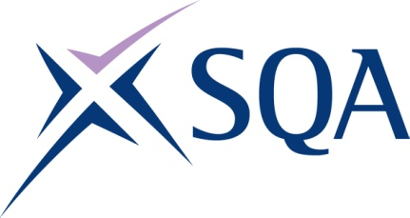

Qualification structure for SQA Level 2 Certificate in Maritime Studies: Efficient Deck Hand

SQA Qualification Code: GP8J 54

Ofqual’s Qualification Code: 603/4892/6 (Pathway 1)

Total Qualification Time: 158 hours
Minimum Guided Learning Hours: 142

Credit value: 16

To gain the qualification, learners must complete the FOUR Mandatory Units to achieve a total of 16 credits (158 hours TQT)

Please note: It is important that the SQA Unit codes are used in all your recording documentation and when your results are communicated to SQA.

Mandatory Units: Learners must complete the FOUR Mandatory units to achieve all 16 credits

SQA Unit Code | Unit Title | Regulator’s Unit code | Level | Credit value | GLH | TQT
FA69 54 | Maritime Sector Overview | R/616/6777 | 2 | 3 | 26 | 30
FA60 54 | Vessel Ropework, Anchoring and Mooring Operations | K/602/3897 | 2 | 5 | 46 | 50
FA61 54 | Securing a Vessel for Passage | H/602/3901 | 2 | 3 | 26 | 28
FA62 54 | Vessel Construction and  Stability | T/602/3904 | 2 | 5 | 44 | 50

Continued ………………….
Additional Optional Unit: Learners may complete this unit, however, credit from it does not count towards achievement of the qualification

SQA Unit Code | Unit Title | Regulator’s Unit code | Level | Credit value | GLH | TQT
FF2D 57 | Control operation of survival craft and rescue boats | T/616/6870 | 3 | 3 | 26 | 30

