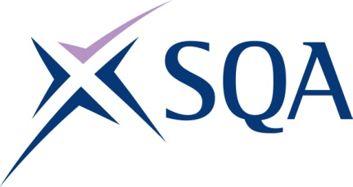

Group Award Title: SVQ Dental Nursing at SCQF Level 7

Group Award Code: GV94 23

SCQF overall credit: Minimum: 129 Maximum: 129

To attain the qualification, candidates must complete 10 Units. This consists of:

* **10 Mandatory Units**

Please note the table below shows the SSC identification codes listed alongside the corresponding SQA unit codes. It is important that SQA unit codes are used in all your recording documentation, and when your results are communicated to SQA.

# Mandatory units: Candidates must complete all 10 units

| **SQA code** | **SSC code** | **Title** | **SCQF**  **level** | **SCQF**  **credits** | **SQA**  **credits** |
| --- | --- | --- | --- | --- | --- |
| J8VY 04 | SFHOH34 | Maintain Personal and Professional Practice for Dental Care Professionals | 7 | 10 | 1 |
| J8W0 04 | SFHCHS36 | Provide Basic Life Support | 7 | 7 | 1 |
| J8W1 04 | SFHOH1 | Prepare and Maintain Safe Working Practices in Clinical Dental Environments | 7 | 17 | 1 |
| J8W2 04 | SFHOH2 | Provide Information and Support to Individuals on Oral Health | 7 | 13 | 1 |
| J8W3 04 | SFHOH3 | Provide Chairside Support During Oral Health Assessment Procedures | 7 | 10 | 1 |
| J8W4 04 | SFHOH4 | Contribute to Producing Dental Radiographic Images | 7 | 11 | 1 |
| J8W5 04 | SFHOH5 | Provide Chairside Support During Periodontal and Restorative Procedures | 7 | 26 | 1 |
| J8W6 04 | SFHOH6 | Provide Chairside Support During Prosthetic Procedures | 7 | 15 | 1 |
| J8W8 04 | SFHOH7 | Provide Chairside Support During Endodontic Procedures | 7 | 10 | 1 |
| J8W9 04 | SFHOH8 | Provide Chairside Support During Extraction and Minor Oral Surgery Procedures | 7 | 10 | 1 |

Template version: December 2022.