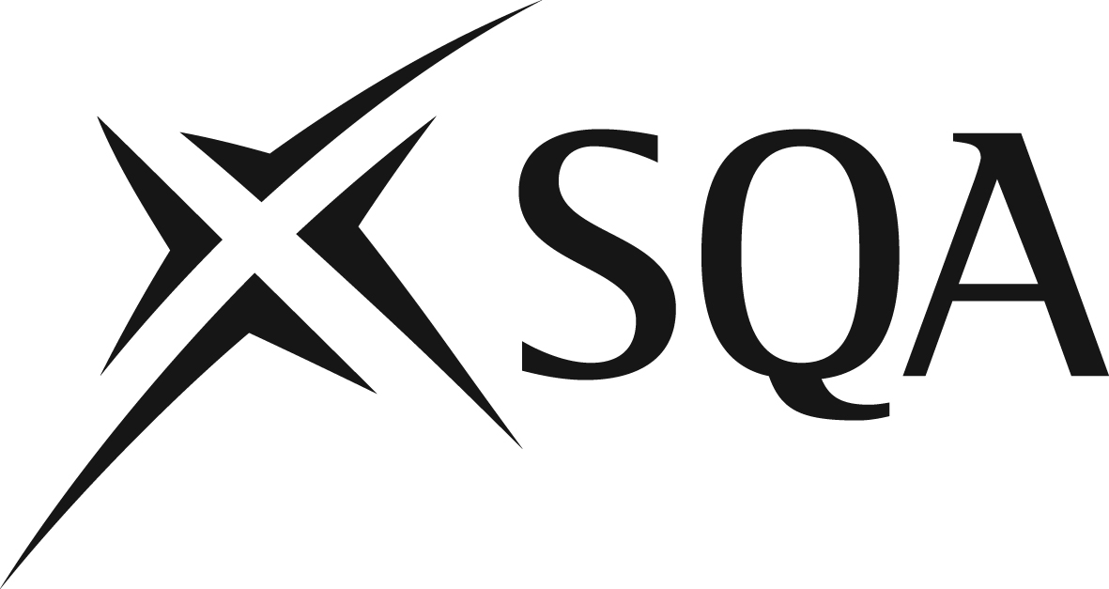

Webinar Questions & Answers

New group awards in HN Music, HN Music Business and HN Sound Production

Are secondary teachers able to offer a unit to S6 pupils?
Yes. Secondary schools can apply to deliver HN units - more details about this process is available from the How to deliver another qualification section on the SQA website.

If an HN unit is delivered in schools, how is this assessed?
The unit is internally assessed by centres and subject to verification by SQA.

How long does it take to deliver and assess an HN unit?
A single credit unit takes a notional time of 40 hours to deliver and assess. A double credit unit takes a notional time of 80 hours to deliver and assess.

How many SCQF level 8 credits can a centre deliver on the HNC Music award?
There are no restrictions on the number of level 8 units that centres can deliver from the optional section in the HNC Music award.

Our centre is able to offer students a choice of Music: 1st Study Instrument or Music: 1st Study composition. Can we run both, but learners have to choose one?
Yes, both can be offered, but learners have to choose one.

Is there support material for delivery and assessment of these units?
Unit specifications which contain full details about the requirements for each unit can be located using the HN unit search – available on the SQA website.

Assessment support materials, where available, can be found in the Performing Arts section of SQA Secure site.

Where can I find the Subject Update which is referred to in the webinar?
The subject update is available from the HN Music page of the SQA website.

