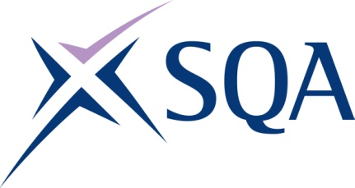
GK74 22 | SVQ 2 Hairdressing at SCQF 5

To attain the qualification candidates must complete 8 Units in total. This comprises:

- 7 mandatory Units
- 1 optional Units

Please note the table below shows the SSC identification codes listed alongside the corresponding SQA Unit codes. It is important that the SQA Unit codes are used in all your recording documentation and when your results are communicated to SQA.

Mandatory Units: Candidates must complete 7 Units from this group
SQA code | SSC code | Title | SCQF level | SCQF credits
H9C9 04 | SKACH1 | Style and Finish Hair | 5 | 6
H9CA 04 | SKACH2 | Set and Dress Hair | 5 | 7
H9CC 04 | SKACH3 | Cut Hair using Basic Techniques | 5 | 13
H9CD 04 | SKACH4 | Colour and Lighten Hair | 6 | 14
H9CE 04 | SKACHB9 | Advise and Consult with Clients | 5 | 8
H9CF 04 | SKACHB11 | Shampoo, Condition and Treat the Hair and Scalp | 5 | 5
H9CG 04 | SKACHB12 | Develop and Maintain your Effectiveness at Work | 5 | 3

Optional Units: Candidates must complete 1 Unit from this group
SQA code | SSC code | Title | SCQF level | SCQF credits
H9CH04 | SKAAH2 | Relax Hair | 6 | 8
H9CJ04 | SKACH5 | Perm and Neutralise Hair | 6 | 9
H9CK04 | SKACH6 | Plait and Twist Hair | 5 | 5
H9CL04 | SKACH7 | Temporarily Attach Hair to Enhance a Style | 5 | 3
H9C704 | SKACHB8 | Remove Hair Extensions | 5 | 5
H9CM04 | SKACHB13 | Fulfil Salon Reception Duties | 5 | 5

