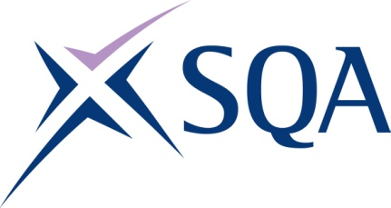
GK76 23 | SVQ 3 Hairdressing at SCQF 6

To attain the qualification candidates must complete 7 Units in total. This comprises:

- 4 mandatory Units
- 3 optional Units

Please note the table below shows the SSC identification codes listed alongside the corresponding SQA Unit codes. It is important that the SQA Unit codes are used in all your recording documentation and when your results are communicated to SQA.

Mandatory Units: Candidates must complete 4 Units from this group
SQA code | SSC code | Title | SCQF level | SCQF credits
H9CN 04 | SKACH8 | Creatively Style and Dress Hair | 6 | 7
H9CP 04 | SKACH9 | Creatively Cut Hair using a Combination of Techniques | 6 | 13
H9CR 04 | SKACH10 | Creatively Colour and Lighten Hair | 7 | 14
H9CT 04 | SKACHB14 | Provide Client Consultation Services | 6 | 7

Optional Units: Candidates must complete 3 Unit from this group
SQA code | SSC code | Title | SCQF level | SCQF credits
H9CV 04 | SKAAH7 | Provide a Variety of Relaxing Services | 7 | 10
H9DA 04 | SKACH11 | Hair Colour Correction Services | 7 | 15
H9CW 04 | SKACH12 | Provide Creative Hair Extension Services | 6 | 8
H9CX 04 | SKACH13 | Create a Variety of Permed Effects | 7 | 10
H9DC 04 | SKACHB15 | Develop, Enhance and Evaluate your Creative Hairdressing Skills | 6 | 9
H9DD 04 | SKACHB16 | Provide Specialist Hair and Scalp Treatments | 7 | 15
H9CY 04 | SKACHB17 | Contribute to the Planning, Implementation and Evaluation of Promotional Activities | 6 | 10
H9D0 04 | SKACHB18 | Contribute to the Financial Effectiveness of the Business | 6 | 7

