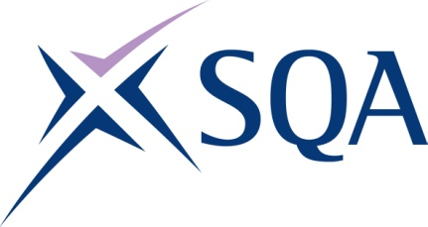
GK73 21 | SVQ 1 Hairdressing and Barbering at SCQF 4

To attain the qualification candidates must complete 6 Units in total. This comprises:

- 4 mandatory Units
- 2 optional Units

Please note the table below shows the SSC identification codes listed alongside the corresponding SQA Unit codes. It is important that the SQA Unit codes are used in all your recording documentation and when your results are communicated to SQA.

Mandatory Units: Candidates must complete 4 Units from this group
SQA code | SSC code | Title | SCQF level | SCQF credits
H9AX 04 | SKACHB1 | Prepare for Hair Services and Maintain Work Areas | 3 | 2
H9AY 04 | SKACHB2 | Contribute to the Development of Effective Working Relationships | 4 | 3
H9C0 04 | SKACHB5 | Blow Dry Hair | 4 | 5
H9C1 04 | SKACHB10 | Shampoo and Condition Hair | 4 | 4

Optional Units: Candidates must complete 2 Units from this group
SQA code | SSC code | Title | SCQF level | SCQF credits
H9C2 04 | SKAAH1 | Assist with Relaxing Services | 4 | 5
H9C3 04 | SKACHB3 | Assist with Salon Reception Duties | 3 | 4
H9C4 04 | SKACHB4 | Assist with Hair Colouring and Lightening Services | 4 | 5
H9C5 04 | SKACHB6 | Plait and Twist Hair using Basic Techniques | 4 | 5
H9C6 04 | SKACHB7 | Assist with Perming Hair Services | 4 | 4
H9C7 04 | SKACHB8 | Remove Hair Extensions | 5 | 5
H9C8 04 | SKACB1 | Assist with Shaving Services | 4 | 5

