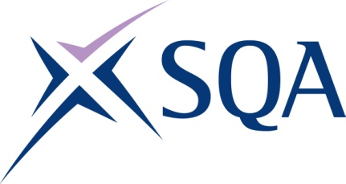
GN2A 44 | Health and Safety in a Construction Environment at SCQF Level 4

To attain the qualification candidates must complete 1 unit in total. This comprises:

- 1 mandatory unit

Please note the table below shows the SSC identification codes listed alongside the corresponding SQA unit codes. It is important that the SQA unit codes are used in all your recording documentation and when your results are communicated to SQA.

Mandatory units: Candidates must complete all 1 unit from this group
SQA code | SSC code | Title | SCQF level | SCQF credits
HX12 04 | - | Health and Safety in a Construction Environment | 4 | 6

