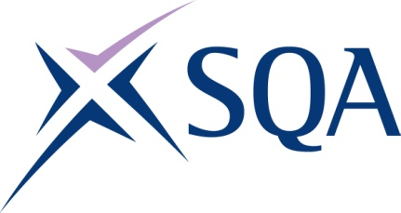
GK9J 23 | SVQ 3 Heating and Ventilating: Industrial and Commercial Installation at SCQF Level 6

To attain the qualification candidates must complete 10 Units in total. This comprises:

- 10 mandatory Units

Please note the table below shows the SSC identification codes listed alongside the corresponding SQA Unit codes. It is important that the SQA Unit codes are used in all your recording documentation and when your results are communicated to SQA.

Mandatory Units: Candidates must complete 10 Units from this group
SQA code | SSC code | Title | SCQF level | SCQF credits
H94X 04 | SUMBSE01 | Apply Health and Safety and Environmental Legislation in the Building Services Engineering Sector | 6 | 44
H94Y 04 | SUMBSE02 | Establish and Maintain Relationships in the Building Services Engineering Sector | 6 | 16
H950 04 | SUMBSE03 | Coordinate a Work Site in the Building Services Engineering Sector | 6 | 16
H98E 04 | SUMBSE04 | Perform Electrical Work on Mechanical Building Services Systems | 7 | 31
H9LJ 04 | SUMHV04 | Install and Test Industrial and Commercial Heating and Ventilating Pipework Systems | 6 | 25
H9LD 04 | SUMHV06 | Inspect and Pre-commission Industrial and Commercial Heating and Ventilating Systems | 6 | 22
H9LE 04 | SUMHV07 | Commission Industrial and Commercial Heating and Ventilating Systems | 7 | 32
H9LF 04 | SUMHV08 | Decommission Industrial and Commercial Heating and Ventilating Systems | 6 | 25
H9LG 04 | SUMHV10 | Weld Industrial and Commercial Heating and Ventilating Pipework | 6 | 28
H9LH 04 | FCAHVICI | Final Competence Assessment: Heating and Ventilating - Industrial and Commercial Installation | 6 | 10

