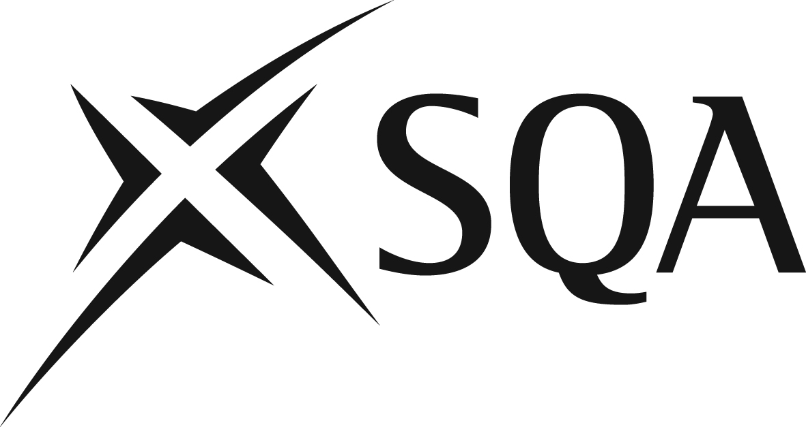

Internal Prior Verification of Assessment Record

Qualification
Level
Unit name
Unit code
Outcomes covered by assessment
Adapted version of SQA assessment or new centre-devised assessment
Assessor (who wrote assessment)
Internal verifier

Approaches to assessment should be valid, reliable, practicable, equitable and fair. Each of these principles is explained briefly below.

Validity — this is a measure of the accuracy of the approach to assessment; that it is appropriate for its purpose and does what it is intended to do in terms of measuring attainment against Outcomes.

Reliability — this is concerned with the extent to which the approach to assessment ensures judgements will be consistent from one candidate to the next; from one assessor to the next and from one occasion to the next (eg with a different assessor). Information for assessors on judging evidence supports reliability.

Practicability — the approach to assessment is designed so that it is relatively easy to set up and conduct without undue demand on centres, assessors and candidates in terms of, for example, context and required resources.

Equitability and fairness — assessments must be accessible to all candidates who have the potential to succeed in them and offer candidates equal opportunities to succeed.

Checklist questions | Yes/No | Comments
Will the assessment allow candidates to achieve the Outcomes?
Does the assessment ensure that candidates are not over-assessed?
Have sample solutions/marking scheme been provided?
Will the assessment allow consistent assessment judgements to be made?
Will sample solutions/marking scheme provide clear and accurate guidance to assessors?
Will the assessment be practicable to implement with the available resources?
Are there any barriers to assessment for any groups (eg language used, cultural bias, adaptable format)?

Outcome
Assessment accepted (see note below)
Assessment not accepted (see action points below)

NB SQA strongly recommends that centre-devised assessments are also submitted to SQA for prior verification. This is not required for an adapted assessment which is not significantly different from an assessment on SQA’s secure site.

Send assessment to SQA for prior verification: Yes/No

Actions to be taken | Action by | Action completed

Copied to assessor

Signed: ______________________________________ (Internal verifier)

Date: ____________________________

