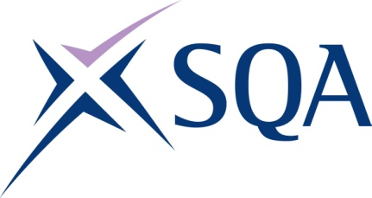
Qualification Structure for SQA Level 4 Diploma in Conveyancing Law and Practice

SQA Code: GL7H 53

Ofqual Code: 603/0173/9

Qualifications Wales Code: C00/1243/2

Total Qualification Time: 500 hours

Guided Learning Hours: 250

Credit Value: 50

To attain the qualification, learners must complete all five mandatory units to achieve a total of 50 credits (500 hours TQT).

Please note: It is important that the SQA Unit codes are used in all your recording documentation and when your results are communicated to SQA.

Mandatory units: Learners must achieve all 50 credits
SQA Unit Code | Unit Title | Credit value | Level | GLH | TQT | Regulator’s unitcode
HG12 53 | The English Legal System | 6 | 4 | 32 | 64 | A/615/0542
HG13 53 | Law of Contract | 12 | 4 | 60 | 120 | T/615/0541
HG14 53 | Land Law | 12 | 4 | 60 | 120 | F/615/0543
HG17 53 | Understanding Accounting Procedures for Conveyancing Transactions | 8 | 4 | 38 | 76 | M/615/0635
HG19 53 | Standard Conveyancing Transactions | 12 | 4 | 60 | 120 | T/615/0636

