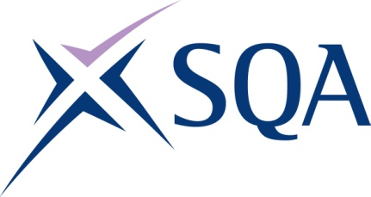

Qualification structure for SQA Level 4 Diploma in Licensed Asbestos Removal for Contract Managers

SQA Qualification Code: GR0X 53

Ofqual’s Qualification Code: 603/5309/0
Total Qualification Time: 519 hours
Minimum Guided Learning Hours: 285

Credit value: 52

To gain the qualification, learners must achieve a minimum total of 52 credits (519 TQT)

This comprises:
- 52 credits from the Mandatory Core Units

Please note: It is important that the SQA Unit codes are used in all your recording documentation and when your results are communicated to SQA.

Mandatory Core Units: Learners must achieve all 52 credits

SQA Unit Code | Unit Title | Regulator’s Unit code | Level | Credit value | GLH | TQT
J3RB 53 | Health and Safety of Licensed Asbestos Removal for Contract Managers | L/617/8846 | 4 | 14 | 75 | 140
J3RC 53 | Principles of Licensed Asbestos Removal for Contract Managers | R/617/8847 | 4 | 10 | 65 | 97
J3RD 53 | Principles of Licensed Asbestos Removal Site Management | Y/617/8848 | 4 | 14 | 70 | 142
J3RE 53 | Development of a suitable and sufficient plan of work for licensed asbestos removal | D/617/8849 | 4 | 14 | 75 | 140

