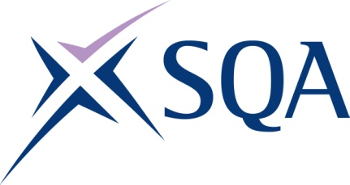

Qualification structure for SQA Level 2 Award in Maritime Studies: Deck Rating

SQA Qualification Code: GC6K 62

Ofqual’s Qualification Code: 603/4822/7 (Pathway 2)

Total Qualification Time: 115 hours
Minimum Guided Learning Hours: 105

Credit value: 12
To gain the qualification, learners must achieve a total of 12 credits (115 TQT) by completing all EIGHT Mandatory units

Please note: It is important that the SQA Unit codes are used in all your recording documentation and when your results are communicated to SQA.

Mandatory Units: Learners must complete the EIGHT Mandatory units to achieve all 12 credits

SQA Unit Code | Unit Title | Regulator’s Unit code | Level | Credit value | GLH | TQT
FA5M 54 | Maritime Employment, Environmental and Health and Safety Practice | D/616/6877 | 2 | 2 | 18 | 20
FA5N 54 | Survival in the Water during Maritime Emergencies | Y/602/3071 | 2 | 1 | 8 | 8
FA5T 54 | Vessel Fire Prevention and Firefighting (STCW) | T/502/5920 | 2 | 2 | 20 | 22
FA5P 54 | Maritime Security | K/602/3866 | 2 | 1 | 8 | 8
FA5R 54 | Emergency First Aid in Response to Maritime Accidents or Medical Emergencies | A/602/3872 | 2 | 1 | 7 | 7
FN04 62 | Basic Navigational Watchkeeping | R/503/2146 | 2 | 2 | 18 | 20
FN02 62 | Vessel Ropework, Anchoring and Mooring Activities | D/503/2148 | 2 | 2 | 18 | 20
FN03 62 | Assisting with Securing a Vessel for Passage | Y/503/2147 | 2 | 1 | 8 | 10

