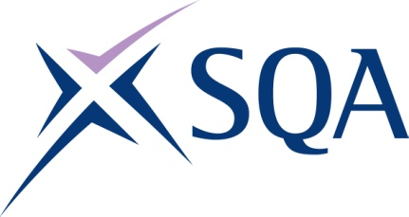

Qualification structure for SQA Level 3 Award in Maritime Studies: Use of Radar and Electronic Chart Systems for Code Vessels

SQA Qualification Code: GK9V 69

Ofqual’s Qualification Code: 601/7697/0

Total Qualification Time: 44 hours
Minimum Guided Learning Hours: 40

Credit value: 4

To gain the qualification, learners must complete the TWO Mandatory Units to achieve a total of 4 credits (44 hours TQT)

Please note: It is important that the SQA Unit codes are used in all your recording documentation and when your results are communicated to SQA.

Mandatory Units: Learners must complete the TWO Mandatory units to achieve all 4 credits (44 hours TQT)

SQA Unit Code | Unit Title | Regulator’s Unit code | Level | Credit value | GLH | TQT
H6RB 57 | Use of Radar for Safe Navigation and Collision Avoidance on Domestic and Code Vessels | K/506/0079 | 3 | 2 | 20 | 22
H9R2 69 | Operate non-ECDIS Marine Electronic Chart Systems | K/506/4620 | 3 | 2 | 20 | 22

