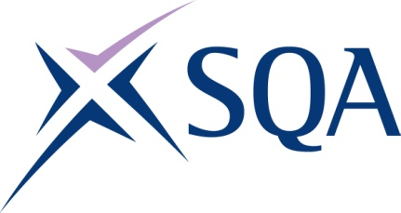

SVQ in Managing Individuals in a Custodial Environment at SCQF Level 7 (GN7W 24) – structure
To attain the qualification candidates must complete 8 Units in total. This comprises:
- 4 Mandatory Units
- 4 Optional Units

Please note the table below shows the SSC identification codes listed alongside the corresponding SQA Unit codes. It is important that the SQA Unit codes are used in all your recording documentation and when your results are communicated to SQA.

Mandatory Units: Candidates must complete 4 Units from this group
SQA code | SSC code | Title | SCQF level | SCQF credits
F9R2 04 | SFJEC8 | Support and Encourage Individuals in Addressing their Problematic Behaviour | 7 | 8
F9R3 04 | SFJEC9 | Address the Challenging Behaviour of Individuals | 7 | 8
DR67 04 | SFJHA2 | Manage your own Resources and Professional Development | 7 | 8
DR5J 04 | SFJNHF1 | Manage a Project | 8 | 11

Optional Units: Candidates must complete 2-4 Units from this group
SQA code | SSC code | Title | SCQF level | SCQF credits
D8P3 04 | SFJAD3 | Represent One's Own Agency at Other Agencies' Meetings | 9 | 9
HA5V 04 | - | Prepare and Set Up Mediation | 8 | 12
F9PW 04 | SFJEA8 | Assess Individuals for the Principal Types and Levels of Risk Associated with their Problematic Behaviour | 7 | 8
F29H 04 | SFJAJ1 | Help Individuals Address their Offending Behaviour | 9 | 9
B83M 04 | SFJAJ2 | Enable Individuals to Change their Offending Behaviour | 8 | 13
D8ND 04 | SFJEC7 | Reinforce Positive Behavioural Goals During Relationships with Individuals | 7 | 8
F9PY 04 | SFJED5 | Develop Intervention Plans for Individuals which Address Risk Factors and Enhance Protective Factors | 7 | 8
F29S 04 | SFJCCFB2 | Contribute to Planning and Reviewing How to Meet Individuals' Needs and Rights in the Custodial Environment | 7 | 6
FT4L 04 | SFJCCFB12 | Contribute to Plans for the Release and Resettlement of Offenders | 9 | 13
F9E2 04 | SFJGB3 | Enable Individuals to Understand and Address their Difficulties | 7 | 10
F2AC 04 | SFJCCGC5 | Develop Control for People who are a Risk to Themselves and Others | 7 | 10
F33C 04 | SFJHI1 | Plan, Implement and Manage the Sharing of Knowledge and Good Practice to Inform Innovation and Improve Service Delivery | 8 | 9

Optional Units: Candidates must complete 2 Units from this group
SQA code | SSC code | Title | SCQF level | SCQF credits
F9RR 04 | SFJDJ101 | Assess the Circumstances of an Incident Towards Identifying a Restorative Response | 7 | 8
F9RV 04 | SFJDJ204 | Facilitate Informal Restorative Processes | 7 | 8
F9RW 04 | SFJDJ205 | Evaluate the Outcomes from a Restorative Process | 6 | 8

