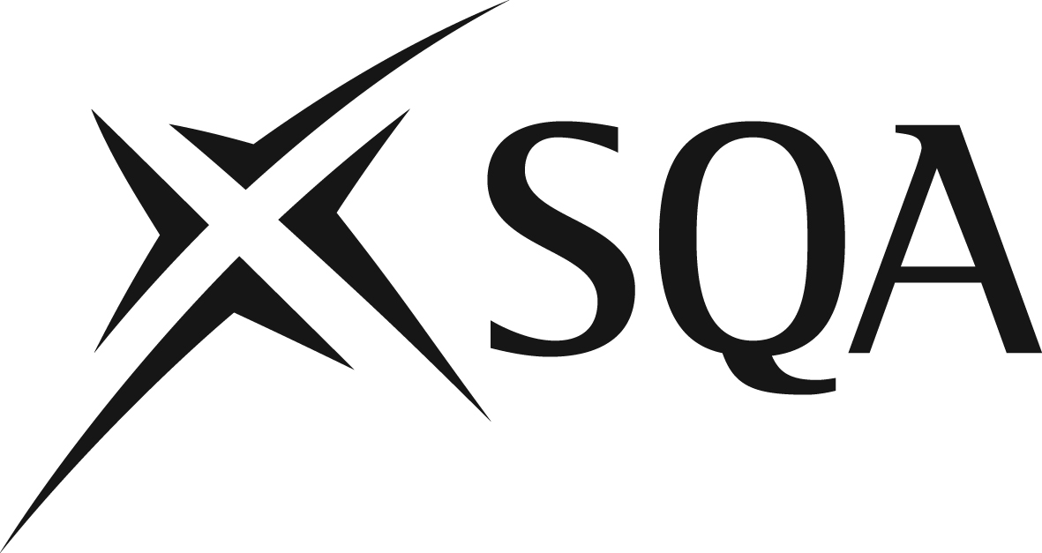

GG1M 47 Diploma in Waste Management Operations: Managing Physical and Chemical Treatment – Non-Hazardous Waste at SCQF level 7 - Structure

Diploma in Waste Management Operations: Managing Physical and Chemical Treatment – Non-Hazardous Waste at SCQF level 7 consists of 12 mandatory Units

Unit title | Code | SQA credit value | SCQF  level | SCQF  credit  points
Mandatory : 12 credits required
Manage the Movement, Sorting and Storage of Waste | H2LF04 | 1 | 6 | 7
Monitor Procedures to Safely Control Work Operations | H2LG04 | 1 | 6 | 4
Control Work Activities on a Waste Management Facility | H2LH04 | 1 | 6 | 9
Manage the Environmental Impact of Work Activities | H2LJ04 | 1 | 7 | 5
Manage Improvements to Waste Management Operations | H2LK04 | 1 | 7 | 7
Control Maintenance and Other Engineering Operations | H2LM04 | 1 | 7 | 13
Procedural Compliance | H2LN04 | 1 | 7 | 6
Manage and Maintain Effective Systems for Responding to Emergencies | H2M004 | 1 | 8 | 19
Manage Physical Resources | H2LP04 | 1 | 6 | 3
Manage the Reception of Non-Hazardous Waste | H2LV04 | 1 | 7 | 7
Manage the Transfer of Outputs and Disposal of Residues from Non-Hazardous Waste Treatment and Recovery Operations | H2LW04 | 1 | 7 | 4
Manage Site Operations for the Treatment of Non-Hazardous Waste | H2LX04 | 1 | 7 | 14

