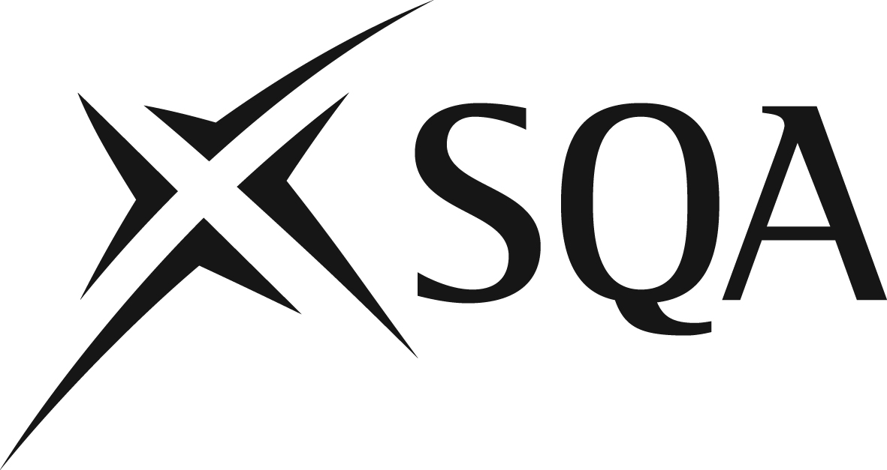

Questions & Answers

Changes to assessment in Higher Modern Languages

Performance-talking

Why has the presentation element of the performance-talking been removed?
The removal of the presentation and the extended scope of the discussion in the new approach serve to increase the element of unpredictability in the performance, strengthening challenge in this aspect of course assessment.

The move to a discussion-only format is also the result of feedback from Verification key messages and course reports. These have highlighted a lack of spontaneity or over-rehearsal in the conversation section of the Higher talking performance, with candidates often repeating language during the conversation that has already featured in the presentation.

In terms of the productive skills overall, an additional rationale is that the topic chosen for the assignment-writing could provide useful material for the discussion in the performance-talking, or vice versa.

Historically the eight word headings were for the presentation section of the performance. Since that no longer exists, why should we allow candidates to use five headings of up to eight words for performance-talking? Why are candidates not able to use the forty words as they wish?

The Course Specification states that candidates may refer to up to five headings of not more than eight words each to assist them and that these headings are prompts and are not to be read out word for word.

The headings remain despite the removal of the presentation format and this is to ensure candidates still have some support for the performance. These are in ‘heading’ format since the support is to serve as an aide-memoire only, otherwise there is a risk that candidates will write down whole sentences to be read out verbatim.

Why has the length of the performance-talking been increased to 10 minutes?

The Higher Modern Languages Course Specification indicates that the discussion is to last approximately 10 minutes. The length of the performance is recommended and no penalty is applied to performances that fall outwith this time.
It is worth noting that many Higher performances sampled at verification go beyond the current recommended length for the conversation 4 ½ to 6 minutes. There is no indication from talking performances sampled from centres that candidates have difficulty in talking for the recommended amount of time.

Given that the approximate length of the conversation at National 5 is 5-6 minutes (6-8 minutes in total for the performance), it is entirely appropriate that candidates at Higher should be asked to undertake a performance of approximately 10 minutes. It should also be remembered that at Higher there is an introductory settling-in period of up to 2 minutes.

Will pupils be penalised for the conversation being too short/too long?

The length of the performance is recommended and no automatic penalty is applied to performances that fall outwith this time. It should be noted, however, that performances which are significantly shorter than the recommended length may not afford the candidate the opportunity to demonstrate the content or language resource required to achieve the upper marks. Similarly, performances which are significantly longer may lead to an increase in the number of errors made.

What sort of questions can you use for the "settling-in" period?

At the start of the assessment, you should ask some general questions, for example what the candidates are studying, what they think of where they live, what they do in their free time, future plans but should avoid personal questions (family, etc). This is to settle them into the task and this initial section should last no more than 2 minutes.

Do the "settling-in" questions count towards the final mark?

The assessment of the performance-talking is based on content, accuracy and language resource and is judged on the performance as a whole.

How do we assess the initial “settling-in” period if the questions do not allow candidates to give answers using detailed and complex language?

As above, the performance-talking should be judged holistically. It should be remembered, however, that, while introductory questions may be more straightforward, candidates may still demonstrate detailed and complex language in their responses.

Should the performance be audio-recorded by centres?

The performance-talking is a single, one-off assessment event and should be audio or video recorded. Details of the assessment conditions and evidence to be gathered in centres can be found in the Course Specification, under the section on the performance-talking.

Are detailed marking instructions already available?

Detailed marking instructions for both the performance-talking and the assignment-writing are available in the Course Specification. See below details of where this is located.

Why are the pegged marks for the performance grouped in pairs?

The pegged marks are designed to give additional guidance on how best to assess candidates’ performance. Assessors should first decide on which row best matches each candidate’s performance-talking and then use the descriptors to allocate either the upper or lower category.

Will there be understanding standards materials to help us with internally verifying our marks for the new talking assessment?

Exemplars of the new performance-talking (discussion format) will be published on SQA’s secure website. Access to this can be gained via SQA co-ordinators.

2 Assignment-writing

What is the rationale behind the introduction of the assignment-writing?

The introduction of a new assignment-writing provides a broader range of contexts. It is based on a response to a less structured stimulus (devised by centres or provided by SQA) and allows candidates to demonstrate a wider range of vocabulary and structures, developed over time. The assignment-writing allows candidates to choose the context (society, learning, employability, culture) as a focus, depending on their preferences and in line with topics they are studying.

The activity encourages candidates to write in a more personalised way, expressing their own ideas and opinions relevant to the topic in the stimulus whilst demonstrating the development of discursive skills. The extended word count gives candidates the opportunity to demonstrate a wider range of vocabulary and structures. The task adds value by offering challenge while still providing candidates with the security of clear guidance in the form of the stimulus.

The requirement for candidates to present arguments and draw conclusions provides for better progression to Advanced Higher.

Is the process of producing the assignment-writing open to differing interpretations in centres?

As at National 5, the assignment-writing at Higher is to be conducted under a high degree of supervision and control, in the classroom.

The Course Specification sets out in detail the mandatory process and list of support materials to adhere to in the production of the assignment-writing (cf. ‘assessment conditions’ heading). This section equally highlights that teachers and lecturers are to exercise their professional responsibility in ensuring that evidence submitted by a candidate is the candidate’s own work.

Practitioners should also refer to the document ‘Guidance on conditions of assessment for coursework’
https://www.sqa.org.uk/sqa/files_ccc/Guidance_on_conditions_of_assessment_for_coursework.pdf.

This document defines what is meant by ‘access to defined resources’, ‘reasonable assistance’, ‘plagiarism’ and ‘collusion’. Examples of candidate and centre malpractice are provided in this document which also outlines that a centre’s failure to apply specified SQA assessment conditions in assessments, such as limits on resources or time available to candidates to complete their assessments, would be considered to be centre malpractice.

This document is in the public domain and colleagues may wish to share this with their candidates also.

Will the assignment-writing be completed in the centre under controlled conditions or are candidates able to take the feedback home and complete the assignment there?

The assignment-writing must be completed in the classroom, under the high degree of supervision and control discussed in the previous response.

Can centres create their own writing improvement code or must they use a standardised version?

Centres are free to use any writing improvement code with which their candidates are familiar; the version published in the Coursework Assessment Task document for the assignment-writing is simply an example.

Does the stimulus have to be in English?

The Course Specification contains mandatory information and the 'evidence to be gathered' section for assignment writing indicates the stimulus must be in English

Will candidates be penalised for not making any reference to the stimulus?

The detailed marking instructions (‘content’ column) make reference to how well the candidate has addressed the title, whether the content is relevant and whether the candidate presents different viewpoints and draws a conclusion. A piece of writing which does not make reference to the stimulus would therefore not achieve the upper pegged marks.

Do pupils have to give a word count?

No. The recommended length (200-250 words, 260-330 Chinese characters) is given for guidance purposes. Pieces of writing which fall outwith the recommended length will not incur any automatic penalty.

Are centres required to include candidate drafts in their submission to SQA?

No. The ‘Evidence to be gathered’ section of the Course Specification states:

The following candidate evidence is required for this assessment:

- one piece of writing in the modern language as a response to a stimulus provided in English, from one of the contexts of society, learning, employability, culture
- the stimulus
- candidate answer booklet, signed by the candidate

Will an electronic version of the booklet be available for AAA candidates?

As for National 5, electronic versions of the Higher assignment-writing booklets will be available on the Higher Modern Languages webpage. This is for AAA candidates or candidates who require to word process their assignment-writing. Publication dates of electronic versions of the booklets will be advertised in Centre News.

What is the date for submission of the assignment-writing?

The exact date for submission has not yet been finalised but will be in March or April. Information on submission of coursework will be available from your SQA co-ordinator.

Will there be exemplars of assignments in the same way these were provided for National 5?

Exemplars of Higher assignment-writing will be published in Autumn 2018. These will be available on the main understanding standards website https://www.understandingstandards.org.uk/

3 Question papers

Question paper 1 – Reading and Directed Writing

Why was the Directed Writing task retained?

Since the Directed Writing is the key aspect of the course assessment which assesses technical knowledge of the language (for example verb tenses), it would have been inappropriate to remove this component. It has also been strengthened to increase unpredictability.

How many words are required for the revised Directed Writing task?

150-180 words (180-240 Chinese characters)

What will the 6 bullet points look like?

The first bullet point will require two pieces of information and the remaining five one piece of information each.

When will the marking instructions for the Directed Writing be available?

The marking instructions will be made available with the publication of the revised Specimen Question Papers, due in Autumn 2018.
Will there be exemplification of the new Directed Writing?

Yes. SQA will publish exemplars of the Directed Writing by Autumn 2018. This will be available at http://www.understandingstandards.org.uk/

Question paper 2 - Listening

How many times will candidates hear the listening?

Candidates will hear the Listening texts twice.

Why is the use of a dictionary no longer permitted in the listening paper?

Candidates were previously allowed the use of a bilingual dictionary to assist them with the writing section of the listening paper. Since the writing section has been removed, the use of a dictionary is no longer appropriate.

Why has the writing section been removed from the listening paper?

The writing currently associated with the listening has tended to source a limited number of topics and this has encouraged some candidates to learn ‘topic essays’ off by heart.

4 General points

Why do we have scaled marks in the Higher Modern Languages course?

The scaling of marks in course assessment is not specific to Modern Languages. The need to scale marks has arisen due to the addition of 20 marks in the course assessment, and the desirability of balancing the weighting across the four skills assessed.

Will the webinar presentation be made available?

Yes. It will be available on the SQA website at http://www.sqa.org.uk/sqa/75796.html

What further support is available to teachers/lecturers?

Please refer to the main Higher Modern Languages webpage at:
https://www.sqa.org.uk/sqa/47909.html

The following documents appear on the ‘session ‘2018-19 session’ tab on this page:

- the Course Specification which contains all the mandatory information for the Higher Modern Languages course, including the conditions of assessment and marking instructions for the assignment-writing and the performance-talking;

- the Course Support Notes (appendix of the Course Specification, June 2018) which contains non mandatory information on approaches to learning and teaching and suggested activities for developing the skills for the course and course assessment;

- the Coursework Assessment Task documents (June 2018), one for performance-talking and one for assignment–writing).

Each of these tasks contain instructions for candidates. The performance-talking document also provides the recording documentation (candidate assessment record).The assignment-writing document provides examples of assignment-writing stimuli, an example of a writing improvement code and examples of how to apply a writing improvement code to candidates’ drafts during the process of the assignment-writing.

