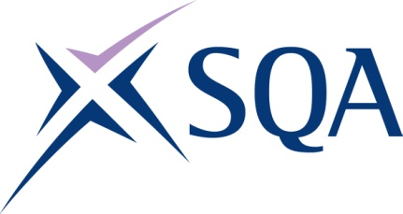
GK78 23 | SVQ 3 Personal Training

To attain the qualification candidates must complete Units in total. This comprises:

- 6 mandatory Units
- 2 optional Units

Please note the table below shows the SSC identification codes listed alongside the corresponding SQA Unit codes. It is important that the SQA Unit codes are used in all your recording documentation and when your results are communicated to SQA.

Mandatory Units: Candidates must complete X Units from this group
SQA code | SSC code | Title | SCQF level | SCQF credits
H9A4 04 | SKAEF1 | Health, Safety and Welfare Promotion in Active Leisure and Recreation | 5 | 4
H9A5 04 | SKAEF13 | Assist Participants to Maintain Long-term Adherence to Exercise and Physical Activity | 7 | 4
H9A6 04 | SKAEF14 | Evaluate Exercise and Physical Activity Programmes | 6 | 3
H9A7 04 | SKAEF15 | Design, Manage and Adapt a Personal Training Programme with Participants | 7 | 7
H9A8 04 | SKAEF16 | Deliver Exercise and Physical Activity as Part of a Personal Training Programme | 7 | 11
H9A9 04 | SKAEF17 | Apply the Principles of Nutrition to Support Participant Goals as Part of an Exercise and Physical Activity Programme | 7 | 6

Additional Unit — Candidates may take the additional Unit
SQA code | SSC code | Title | SCQF level | SCQF credits
H9AA 04 | SKAEF18 | Plan, Market and Sell Services in Active Leisure | 6 | 5

