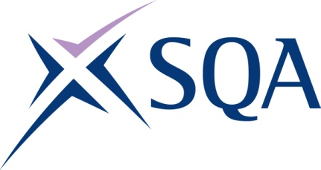
Qualification Structure for SQA Level 6
Diploma in Probate Law and Practice

SQA Qualification Code: GL7L 86
Ofqual Code: 603/0172/7

Qualifications Wales Code: C00/3352/2
Total Qualification Time: 430
Guided Learning Hours: 211

Credit value: 43

To attain the qualification, learners must complete all three mandatory units to achieve a total of 43 credits (430 hours TQT.)

Please note: It is important that the SQA Unit codes are used in all your recording documentation and when your results are communicated to SQA.

Mandatory units: Learners must achieve all 43 credits.
SQA Unit Code | Title | Credit value | Level | GLH | TQT | Ofqual unit code
HG1A 86 | Wills, Succession and Grants of Representation | 14 | 6 | 68 | 140 | J/615/0673
HG1C 86 | The Administration of Estates | 14 | 6 | 68 | 140 | K/615/0679
HG1D 86 | Managing Client and Office Accounts (Probate) | 15 | 6 | 75 | 150 | D/615/0680

