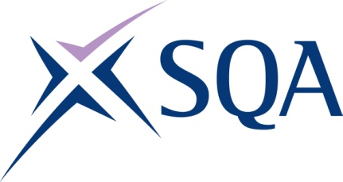

G8M8 23 Processing Operations: Hydrocarbons at

Level 3 – Structure

To attain the qualification candidates must complete 7 Units in total. This comprises:
- 7 Mandatory Units

Please note the table below shows the SSC identification codes listed alongside the corresponding SQA Unit codes. It is important that the SQA Unit codes are used in all your recording documentation and when your results are communicated to SQA.

Mandatory Units: Candidates must complete 7 Units
SQA code | SSC code | Title | SCQF level | SCQF credits
F22D 04 | C2 | Monitor and Maintain Health, Environment and Safety Systems | 6 | 19
B1AV 04 | C5 | Control Emergencies and Critical Situations | 7 | 19
F228 04 | C7 | Create, Maintain and Enhance Productive Working Relationships | 6 | 7
F22K 04 | PT3.1 | Prepare and Start Up Integrated Process Systems | 6 | 15
AY1G 04 | PT3.2 | Operate and Monitor Integrated Process Systems | 6 | 16
F22G 04 | PT3.3 | Prepare and Shut Down Integrated Process Systems | 6 | 16
D7SB 04 | PT3.4 | Isolate and Reinstate Process Plant and Equipment | 6 | 16

