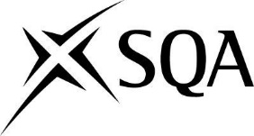

Expression of interest in participating in the work of the
Qualification Support Team (QST) for
Hospitality

Name:
Centre:
Telephone:
Email Address:
Please state what qualifications/units and the levels that you are currently involved in delivering?
Levels:
NPA Hospitality
NC Hospitality Operations
Award in Barista Skills
HNC Hospitality Operations
HND Hospitality Management
PDA Hospitality
Specific Units

Please provide a brief supporting statement detailing relevant qualifications and industry experience.
Are you interested in being the chairperson for the Hospitality QST? If yes, please provide a brief statement on the experience/skills you have for this role.
Please give the name and email address of the person who has given approval for you to join the QST:
Name:
Email Address:
Date Submitted:

Please email completed forms to:
carol.mcevoy@sqa.org.uk by Wednesday 25th November 2020

