SOLAR User Guide for teaching staff

Digital Technologies for Administrators HH82 34

Date of publication: 5th June 2018.

Introduction

SQA has provided an online assessment via SOLAR to support the delivery of the unit Digital Technologies for Administrators (HH82 34). This purpose of this document is to provide guidance on the delivery of this assessment and is based on the experience of teaching staff.

Registering as a User

- Contact the SOLAR co-ordinator within your centre in plenty of time
- Your centre’s SOLAR co-ordinator can register you as a user (this doesn’t have to be done by SQA)
- If you are unable to find your SOLAR co-ordinator, the following link will help you
https://www.sqasolar.org.uk/mini/33151.html
- If you still experience difficulty contact SOLAR at solar@sqa.org.uk / 0345 213 1213

Once registered as a user, you can log into Solar, www.sqasolar.org.uk using the Centre Login button on the right-hand side.

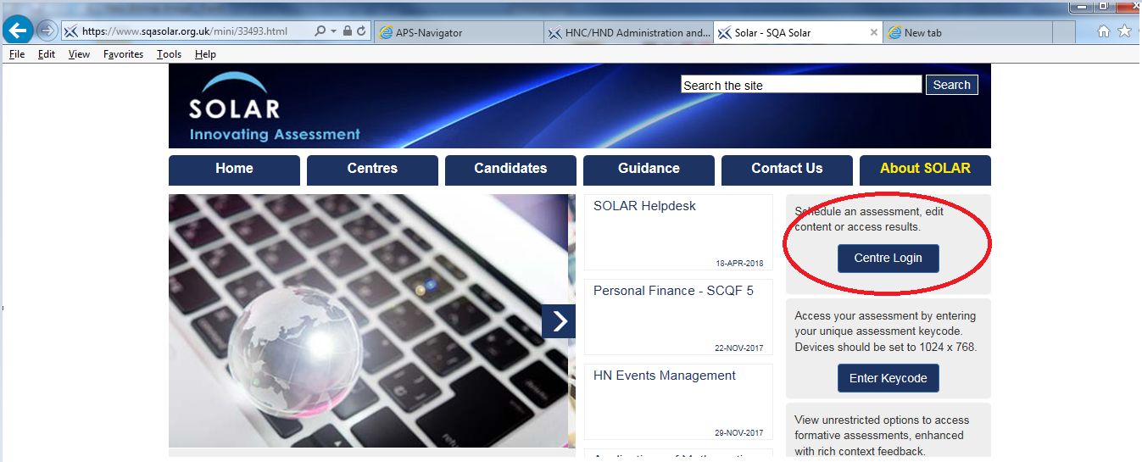

This presents the following log-in window:

Registering students

Once registered and logged in to the system you can begin scheduling groups of candidates as Cohorts. There are a few things to be aware of when doing this.

You will need the following information to create your Cohorts. This information may not be readily available so you should ensure that you seek it out well in advance of scheduling assessment.

Some centres have Administrative staff who can enter this information but you may have to do it yourself.

- Full name of Candidate
- Candidate’s Scottish Candidate (SCN) Number
- Candidate’s College Number
- Candidate’s Date of Birth

When you have this for all candidates, set up your Cohort (e.g. HNC AIT) by selecting the Cohort tab. You should see your College folder – double click to open then select Create Cohort.

You are now ready to input your candidate list. Select the Candidate tab and complete accordingly.

Tip: Add yourself as a candidate. This will allow you to “walk through” the assessment as a candidate to familiarise yourself with it.

Scheduling Assessment

To schedule an assessment - select the Assessment Schedule tab, then Create Assessment on the bottom right-hand side of the page and follow the instructions from there.

Paper 1 Multiple Choice/Response Assessment

Tip: When allocating a date for this assessment it is recommended you take into account the possibility of candidate absence.

Rather than schedule for a specific day, consider setting the finish date to span several weeks. This allows the candidate to sit the assessment in another allocated time slot within that period if they are unable to attend the original date. If scheduled for one specific date, you must reallocate a new assessment and key code for any individuals who were absent which will be more time consuming for you.

Allocating additional time for Additional Support Needs

Additional time can be allocated for students with additional support needs. To set this up, instructions are provided below.

- Follow the Wizard until you reach the window below – select the name of the student who requires additional time:

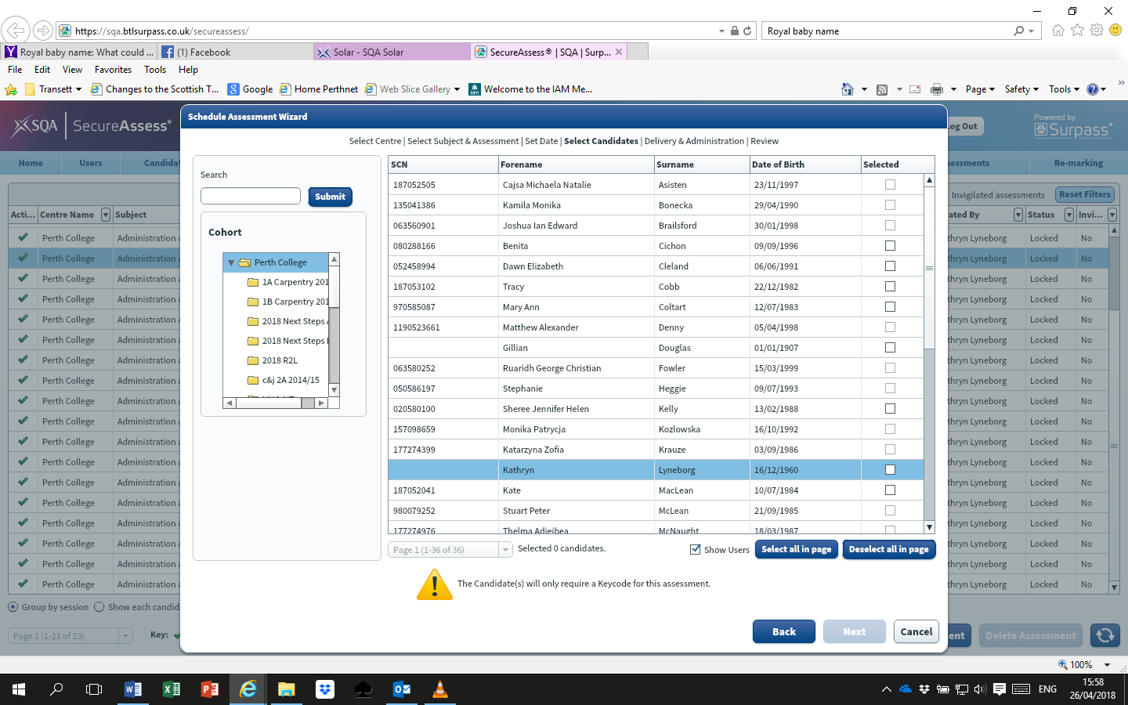

- Select Next, then Next again.

- You will now see the following window:

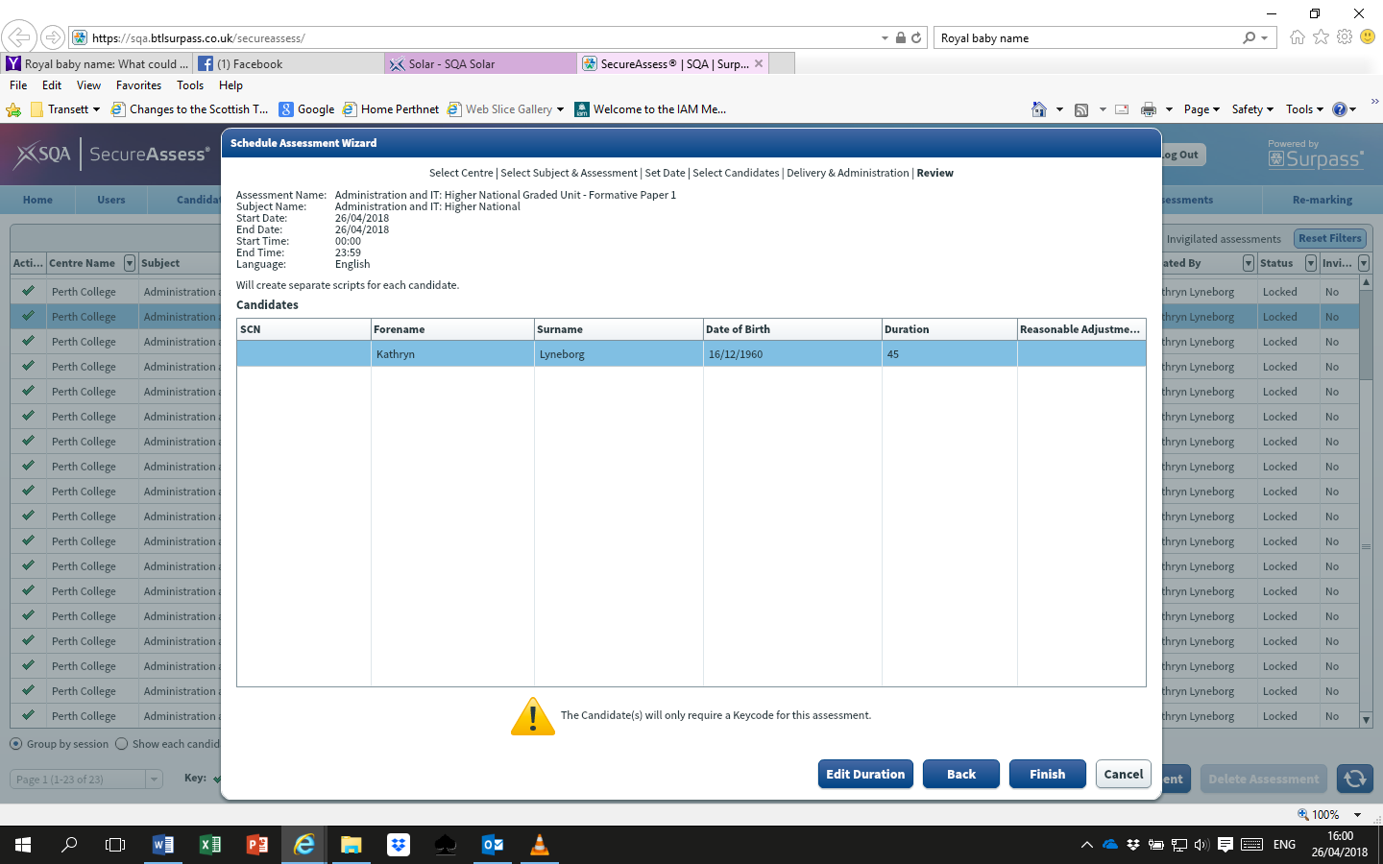

- Select the candidate, then select the Edit Duration button.

You will be presented with an Edit Candidate Assessment Duration window as below:

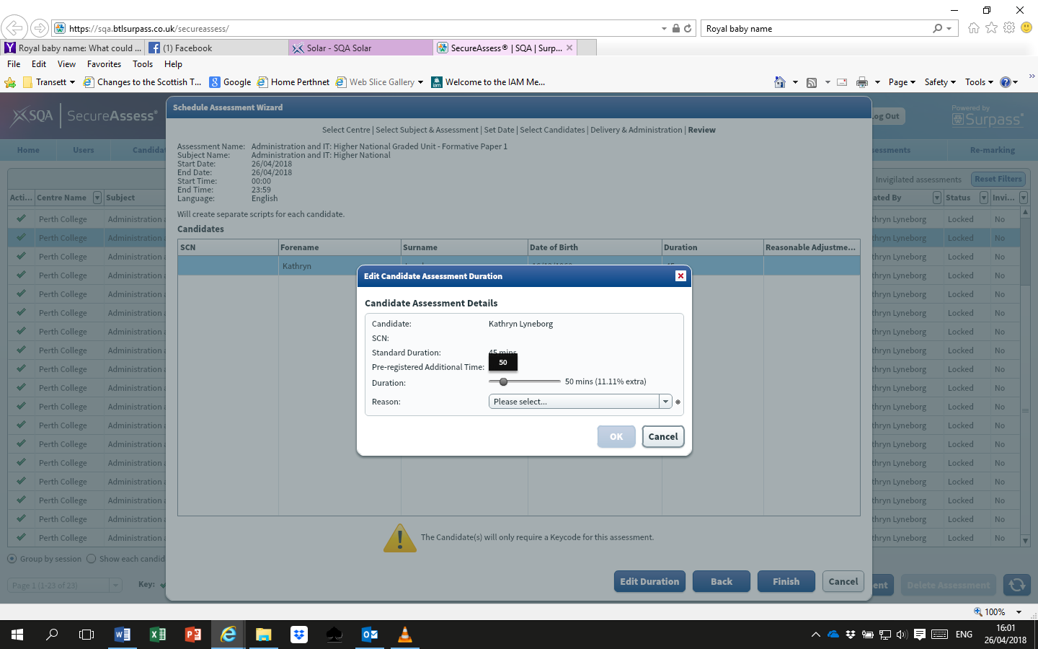

The Duration slider can be used to alter the time of the assessment as required. A rationale should be provided by selecting the relevant option from the Reason drop-down menu.

Paper 2 Portfolio-based Project Assessment

When allocating finish dates for the project in SOLAR it is recommended that adequate time is included for marking and for candidates to upload any additional/missing evidence.

Tip: Set the unit finish date 8 weeks or more after the completion date of the unit.

The Lecturer cannot access the candidate evidence until the student has submitted their entire project; this makes the marking end loaded.

Similarly, once the project is submitted, candidates can no longer access their evidence. This means if further evidence is needed following marking, the Lecturer has to upload it which can be time consuming.

During Assessment

Paper 1 Multiple Choice/Response Assessment

Overview

Paper 1 is an online test consisting of a sample of 30 questions dynamically generated from a larger bank. This means it is unlikely that any two students in the same Cohort will complete the same questions. The assessment is designed such that questions are drawn from the bank covering all Outcomes of the Unit. The assessment is prior-verified and automatically marked with a cut-off score of 60% (18/30).

Key codes

SOLAR generates a unique key code for each student which identifies them as a candidate for a specific assessment. This key code is then used by the student to log-in and complete their assessment.

How the key codes are distributed to students is the centre’s choice, however in the interests of security, one option is to send by email. As a backup it has been suggested that students take a photo of their key code with their mobile phone (if they have one). Students should not have access to any mobile devices during the assessment, so it may be that the centre or student prints a hard copy for use on the day of the assessment.

Paper 2 Portfolio-based Project Assessment

Overview
This is a project consisting of a number of tasks. Evidence for the tasks is uploaded digitally to SOLAR. When evidence for all tasks is complete it can be submitted by the student. The evidence is marked and verified manually.
Guidance for managing delivery and assessment of the Project
- Consider integrating delivery of software/apps across the HNC AIT as much as possible to consolidate learning and maximise efficiency of delivery. For example, a LinkedIn profile could be used for evidence towards the Personal Development Planning unit as well as for this assessment.
- Ask students to create a Digital Technologies folder on their home drive then split it into subfolders for the tasks. This simplifies the process of uploading evidence to SOLAR as the evidence is already mapped to the tasks. This is especially useful for tasks completed over a period of weeks.
- Important: All documents uploaded must be in Word, file type – docx.
- URLs (e.g. Google Doc links) should be pasted into Word as a hyperlink and uploaded as a Word document with a description.
- Screenshots from mobiles (e.g. Whatsapp, LinkedIn) can be sent in PDF format using an email app on the device, then downloaded on PC, copied and pasted into a Word document and then uploaded to SOLAR.

- Where screenshots are used, an accompanying narrative description/reflective account underneath the image can provide context about the actions the student took and therefore strengthen and clarify the evidence.

- Important: Setting up a Web Feed – compatibility with browsers and settings can be an issue. It is recommended that this is checked as early as possible so that any problems can be resolved before they impact on assessment.

- Encourage students to combine evidence relating to the same task in a single Word document, or as few separate documents as possible. This will save time at marking as you will have fewer documents to open (e.g. 2 or 3 instead of 5 or 6). Important: There is a maximum file size of 10MB that SOLAR can accept so this will limit how much can be included in a single Word document.

- Important: Impress on your students how critical it is that during the project they select only close assessment and finish later. The option of finish assessment and submit answers should only be selected when they have checked and are satisfied that all evidence covering the entire project assessment is complete. As mentioned previously, selecting finish assessment and submit answers means students can no longer access their project evidence.

- Lecturers can add themselves as contributors to group work. This may be a good idea particularly if the group numbers are low or students leave or fail to participate fully. It is also a good way of monitoring the individual contributions of students and allows you to facilitate and provide impetus if necessary.

- Important: The Assessment requires students to be placed into groups to work with collaborative software. The unit specification requires students to demonstrate use of collaborative software competently, the emphasis is on the use of the software not working collaboratively per se. It is therefore not necessary for students to work collaboratively on every task.

- To meet the criteria – Use a web service or software to obtain relevant feedback relating to the work completed – in Outcome 3 of the Unit specification, generating meaningful data is likely to be a barrier as a fictitious case study is used. To overcome this the Lecturer could produce/provide a data set containing certain characteristics that would allow students to identify and comment meaningfully. Please note that there is unlikely to be one definitive correct answer to this, student responses may be accepted provided their conclusions are rational and supported by the data.
Important: The case study in the assessment is based on 100 delegates attending an event. This does not mean that the feedback must include 100 responses. The unit specification does not specify a minimum number of responses. The meeting or event (whether real of fictional) must involve at least three participants. The critical aspect is there is sufficient data to allow meaningful conclusions to be drawn.

Marking

Paper 1 Multiple Choice/ Response Assessment

Select Results to access students’ results.

Tip: There is a default setting that archives results after 30 days. After this timeframe results can be accessed by selecting the filter Completed and setting to off. You may wish to print results in hard copy also.

Paper 2 Portfolio-based Project Assessment

Important: When marking, comments are only saved if you allocate a mark for each task. If a student has not submitted sufficient evidence and/or requires remediation, enter a temporary mark and comments will be saved.

Tip: Mark students’ work according to the groups they were placed in.

The evidence of students in the same group is likely to be very similar which means marking the groups together as batches will potentially be more straightforward.

Important: Ensure sufficient time is allocated for marking. The process may take longer than for other comparable assessments, particularly for those marking in SOLAR for the first time.

Resulting students

Important: Centres must enter and result students via the normal channels. SOLAR is not interfaced with SQA’s Certification System, therefore this will not happen automatically.

Support

A short video is available on SOLAR website www.sqasolar.org.uk providing step by step instructions on how to use the system.

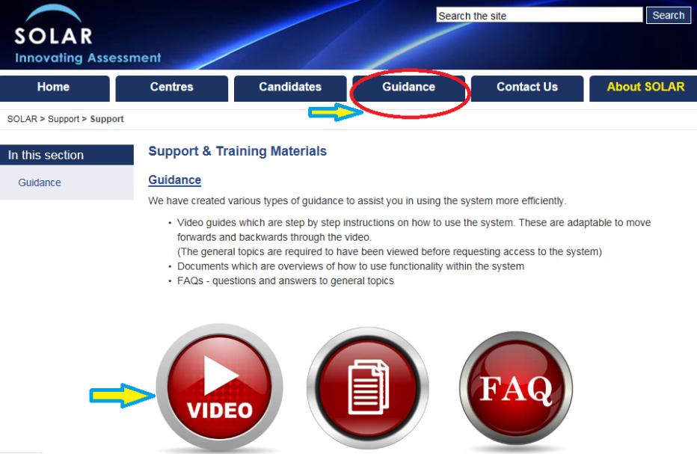

The SOLAR team can be contacted at solar@sqa.org.uk or 0345 213 1213 to provide support on any queries or issues you may have.

SQA/QD/ELBC/HAB6/TH
5 June 2018

