ADMINISTRATION AND INFORMATION TECHNOLOGY: GRADED UNIT 1 (HH9M 34)

GUIDANCE ON USE OF SOLAR ASSESSMENTS

What is SOLAR?
SOLAR is SQA’s secure quality assured e-assessment system. It is an online assessment tool that provides both summative and formative assessments. These e-assessments cover a wide range of subject areas from SCQF Levels 2-9 and can take the form of Computer Based Tests and Projects.
https://www.sqa.org.uk/mini/33147.1598.1601.html

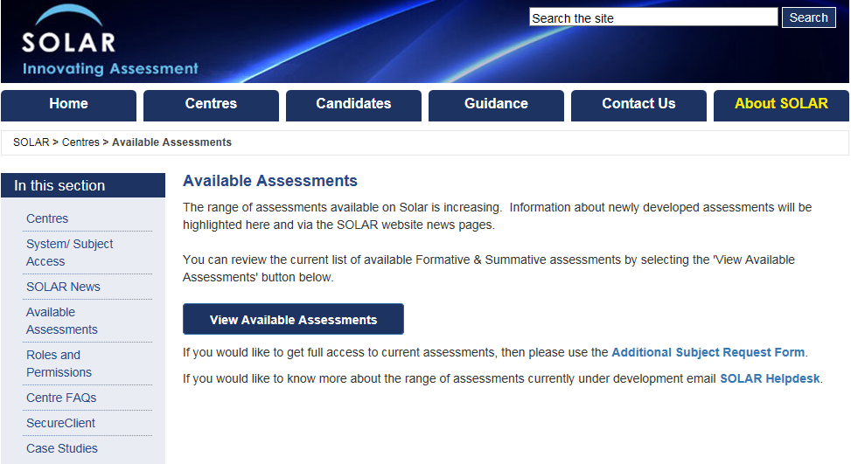

Why use SOLAR?
- System is free to centres
- Summative assessments are prior-verified
- Automatic marking for multiple choice/response content
- Delivery/marking/internal and external verification can all be done from any location
- Evidence is stored digitally reducing storage and management of paper documents
- Reduces plagiarism risk – unique user codes/dynamically generated assessment
- A range of secure delivery options – including offline if required
- Comprehensive reporting and analysis available
- Formative content available 24/7

How to get Access?
You can check if your centre has existing contacts who can create an account for you and request access here.
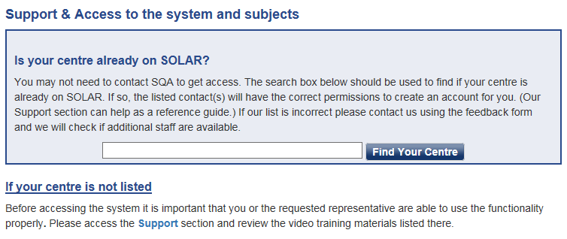
Support and Training Materials
New users must view the training materials before requesting access. This includes interactive ‘how to’ videos which provide a good overview on all aspects of the system. It may be useful to refer back to these periodically and they can be accessed here.
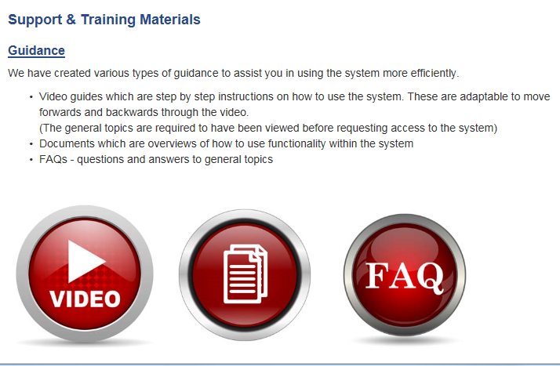

Minimum PC Specification Requirements
Adobe Flash Player is required (version 12 minimum). To check your device meets the requirements to use SOLAR software effectively, please use the link below:
- Minimum Specification Requirements
Marking

Annotation
There is now no restriction to the number of input characters to both the general comments box and the individual comments box. There are additional in-built symbols to the marking options that are outlined below:

- correct
- incorrect
BOD - benefit of doubt
Max - maximum marks reached
Int - interpretation
SPG - spelling, punctuation and grammar

These are just common examples and there is no limit to the amount of symbols that can be added to a candidate response. For example, in the marking of the Paper 2 mandatory question, centres may wish to use the designation 1p for the identification of a problem, and 1c for the development of a consequence.

Approaches to marking

The method of marking is at the centre’s discretion. Multiple markers can login and access the marking tab at the same time. There is no restriction on the number that can do so.

Marking can be done by candidate script or by question. Whatever method is chosen, effective communication and co-ordination between markers prior to, and throughout marking activity will be critical to ensure this is achieved successfully.

Marking by question

Marking by question can be done in the same way as with paper copies. Only one assessor can access a candidate script at any one time, therefore scripts would need to be split into batches and allocated between the marking team. Once all assessors have marked their assigned question within the first batch, each can move onto the same question within the next batch and so on until all questions within all scripts are marked.

Important: After marking a question it is essential to “Assign marks” to save what has been done. Otherwise any marking will be lost on exit.

It is also critical that assessors leave the scripts within the marking tab and do not submit prior to all assessment and internal verification being completed.

There is a maximum time limit of 9 months for leaving assessments in the marking tab after which time they will be deleted.

Formative Assessment

A formative assessment for Graded Unit 1 has been provided to allow students the opportunity to use the software prior to summative assessment. This is accessible on the OpenAssess section of SOLAR website by selecting the ‘OpenAssess’ tab from the homepage as illustrated below. The HN Administration and IT Graded Unit 1 formative assessment will then be available from a dropdown menu. No login is required to access this material.

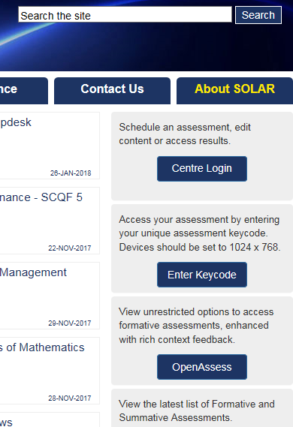

Candidate Registration

There is a facility for upload of multiple candidates at one time to the SOLAR system (e.g. 25 candidates at a time). From here they can be scheduled for assessments. Please refer to the training video (link above) for guidance on how to do this.
Please note: SOLAR is not linked to the SQA’s certification database. This means that candidate entries and results need to be submitted to SQA to update candidate records as is the case with other methods of assessment.

