 | Dual certification of:  SQA Food Hygiene Intermediate Higher National Unit  (F4TL 34)  REHIS Intermediate Award |  |  |  |  | 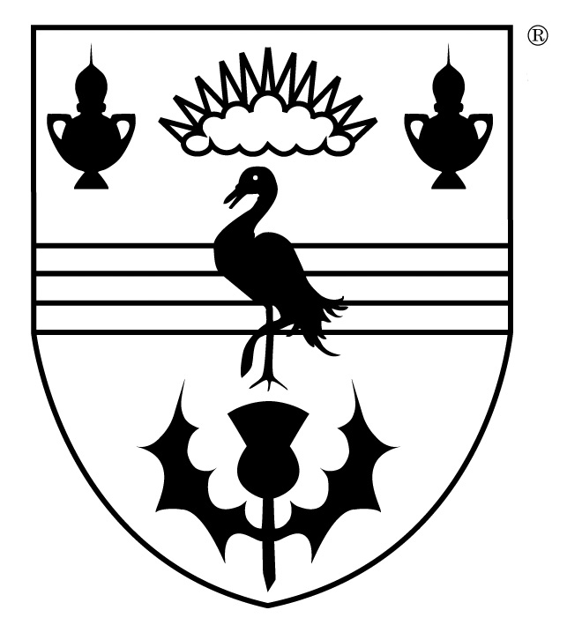
This form should be completed by the person wishing to claim the REHIS Intermediate Award on the basis of successful achievement of the SQA Food Hygiene Intermediate Higher National Unit (F4TL 34).
SECTION A | CANDIDATE DETAILS
NAME
ADDRESS
TELEPHONE
EMAIL
SECTION B | CONFIRMATION
I confirm that I have successfully achieved the SQA Food Hygiene Intermediate Unit (F4TL 34) at (name of institution) and wish to apply for the REHIS Food Hygiene Intermediate Certificate.

I have enclosed a copy of my SQA Unit Achievement certificate and payment for the appropriate fee*

Signature
Date
Please attach a copy of your SQA certificate and send to:  The Royal Environmental Health Institute of Scotland (REHIS)  19 Torphicen Street,  Edinburgh,  EH3 8HX. |  |  |  |  | FOR OFFICE USE
 |  |  |  |  | Checked
 |  |  |  |  | Certificate number
 |  |  |  |  | Certificate sent
*please contact REHIS on 0131 229 2968/ contact@rehis.com for information on how to make the payment.

