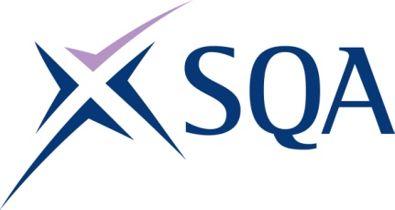
Group Award Title: SVQ in Barbering at SCQF level 6
Group Award Code: GV3X 23
SCQF overall credit: Minimum: 74 Maximum: 96
To attain the qualification, candidates must complete a total of 8 units. This consists of:

- 5 mandatory units
- 3 further units from Group B

Please note the table below shows the SSC identification codes listed alongside the corresponding SQA unit codes. It is important that SQA unit codes are used in all your recording documentation, and when your results are communicated to SQA.

Mandatory units: Group A (candidates must complete all five units)
SQA code | SSC code | Title | SCQF  level | SCQF  credits | SQA  credits
J7N5 04 | SKAHDBRBNS1 | Consult, Assess, Plan and Prepare for Hair, Barbering, Beauty, Nails, Wellbeing and Holistic Services | 6 | 7 | 1
J7N7 04 | SKAHDBRBNST1 | Implement and Maintain Safe, Hygienic and Effective Working Practices | 6 | 7 | 1
J7NN 04 | SKABR2 | Design and Create Facial Hair Shapes using Advanced Techniques | 6 | 8 | 1
J7NM 04 | SKABR4 | Provide Shaving Services using a Straight Razor with Single Use Blades | 6 | 12 | 1
J7NK 04 | SKAHDBR21 | Combine Barbering Cutting and Clipper Techniques to Create a Bespoke Restyled Look | 6 | 16 | 1

Optional group:

Group B — a minimum of three units must be selected
SQA code | SSC code | Title | SCQF  level | SCQF  credits | SQA  credits
J7PB 04 | SKABR3 | Design and Create Hair Designs and Shapes in the Hair using Advanced Clipper and Razor Techniques | 6 | 9 | 1
J7NV 04 | SKAHDBR6 | Creatively Colour and Lighten the Hair using Advanced Techniques | 7 | 21 | 1
J7NX 04 | SKAHDBR8 | Cultivate, Maintain and Repair Locks | 5 | 7 | 1
J7P1 04 | SKAHDBR13 | Relax Hair Permanently | 6 | 13 | 1
J7P3 04 | SKACHB15 | Develop, Enhance and Evaluate your Creative Hairdressing Skills | 6 | 10 | 1
J7P4 04 | SKAHDBRBNST3 | Plan, Implement and Evaluate Promotional Activities | 7 | 12 | 1
J7P5 04 | SKAHDBRBNST2 | Contribute to the Financial Effectiveness of the Business | 6 | 8 | 1
J7P6 04 | SKAHDBMN1 | Plan, Prepare and Participate in Competitions in the Hair, Barbering, Beauty, Make-up and Nail Sectors | 7 | 12 | 1
J7P7 04 | SKAHDBRBNT1 | Undertake Freelance Work | 7 | 12 | 1

Template version: December 2022.

