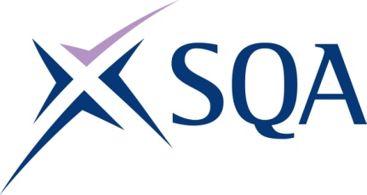

G9EC 21 SVQ 1 Hairdressing and Barbering at SCQF level 4 – Structure
To achieve the qualification candidates must complete 6 Units in total. This comprises:
- 4 Mandatory Units
- 2 Optional Units

Please note the table below shows the SSC identification codes listed alongside the corresponding SQA Unit codes. It is important that the SQA Unit codes are used in all your recording documentation and when your results are communicated to SQA.

Mandatory Units: Candidates must complete 4 Units
SQA code | SSC code | Title | SCQF level | SCQF credits
F470 04 | G20 | Make Sure Your Own Actions Reduce the Risks to Health and Safety (ENTO Unit HSS1) | 5 | 8
F7B6 04 | G3 | Contribute to the Development of Effective Working Relationships | 4 | 3
F7B7 04 | GH1 | Shampoo and Condition Hair | 4 | 4
F7B9 04 | GH3 | Prepare for Hair Services and Maintain Work Areas | 4 | 2

Optional Units: Candidates must complete 2 Units from this group
SQA code | SSC code | Title | SCQF level | SCQF credits
F7BA 04 | G2 | Assist with Salon Reception Duties | 4 | 4
F7BB 04 | GH2 | Blow Dry Hair | 4 | 4
F7BC 04 | GH4 | Assist with Hair Colouring Services | 4 | 4
F7BD 04 | GH5 | Assist with Perming Hair Services | 4 | 3
F7BE 04 | GH6 | Plait and Twist Hair using Basic Techniques | 4 | 4
F7BF 04 | GH7 | Remove Hair Extensions | 4 | 3
F7BG 04 | GB1 | Assist with Shaving Service | 4 | 2

