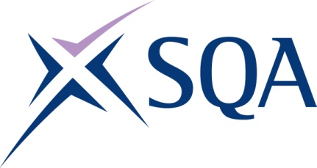
GM37 22 | SVQ in Steelfixing Occupations (Construction) at SCQF level 5

To attain the qualification candidates must complete 5 units in total. This comprises:

- 3 mandatory units
- 2 optional units

Please note the table below shows the SSC identification codes listed alongside the corresponding SQA unit codes. It is important that the SQA unit codes are used in all your recording documentation and when your results are communicated to SQA.

Mandatory units: Candidates must complete all units from this group
SQA code | SSC code | Title | SCQF level | SCQF credits
HL7R 04 | COSVR641v2 | Conform to General Workplace Health, Safety and Welfare | 6 | 12
HL7T 04 | COSVR642v1 | Conform to Productive Work Practices | 5 | 5
HM15 04 | COSVR643v1 | Move, Handle or Store Resources | 5 | 5
Plus optional units (any two units from the following required)
HL7V 04 | COSVR166v3 | Cut and Bend Reinforcement Steel to Shape | 5 | 18
HL85 04 | COSVR534v2 | Fix Steel In Situ | 5 | 24
HL8K 04 | COSVR535v2 | Prefabricate Reinforcement Steel Sections | 5 | 25

