Using PSR (Problem Steps Resolver) with Windows 10

Please note that this is a utility within Windows but it may have been disabled by the IT department of your organisation.

Start by clicking on the windows symbol in the taskbar.

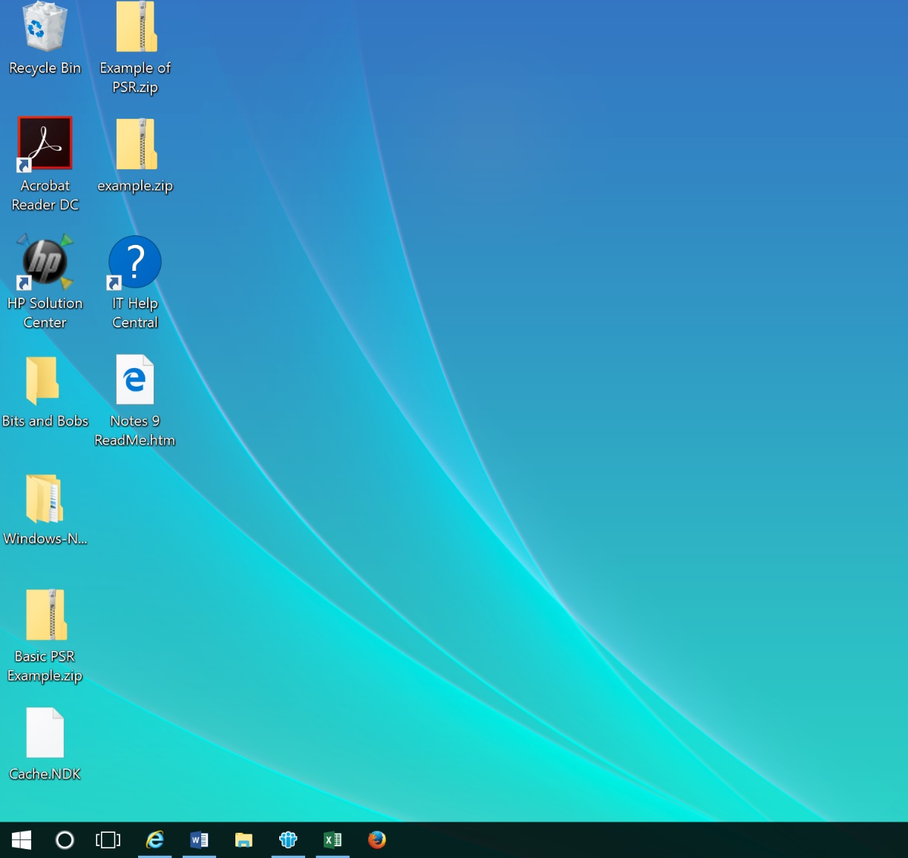

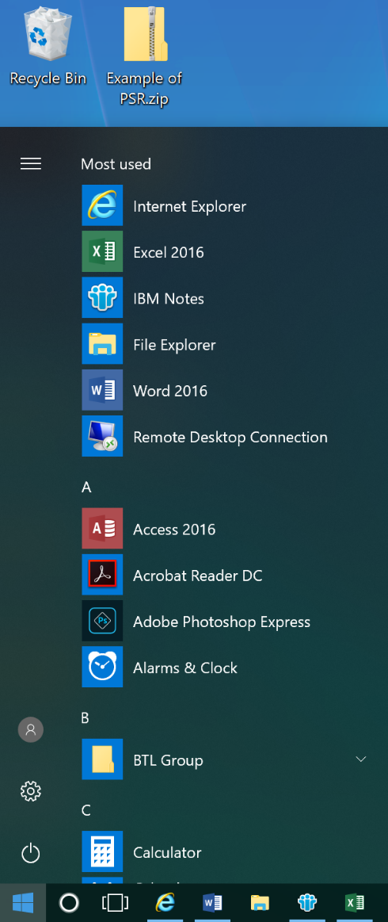

Now type in PSR, (as I’ve already used PSR on my laptop, as soon as I type in P it automatically pops up as the top option). You may need to type run PSR if you are using it for the first time.

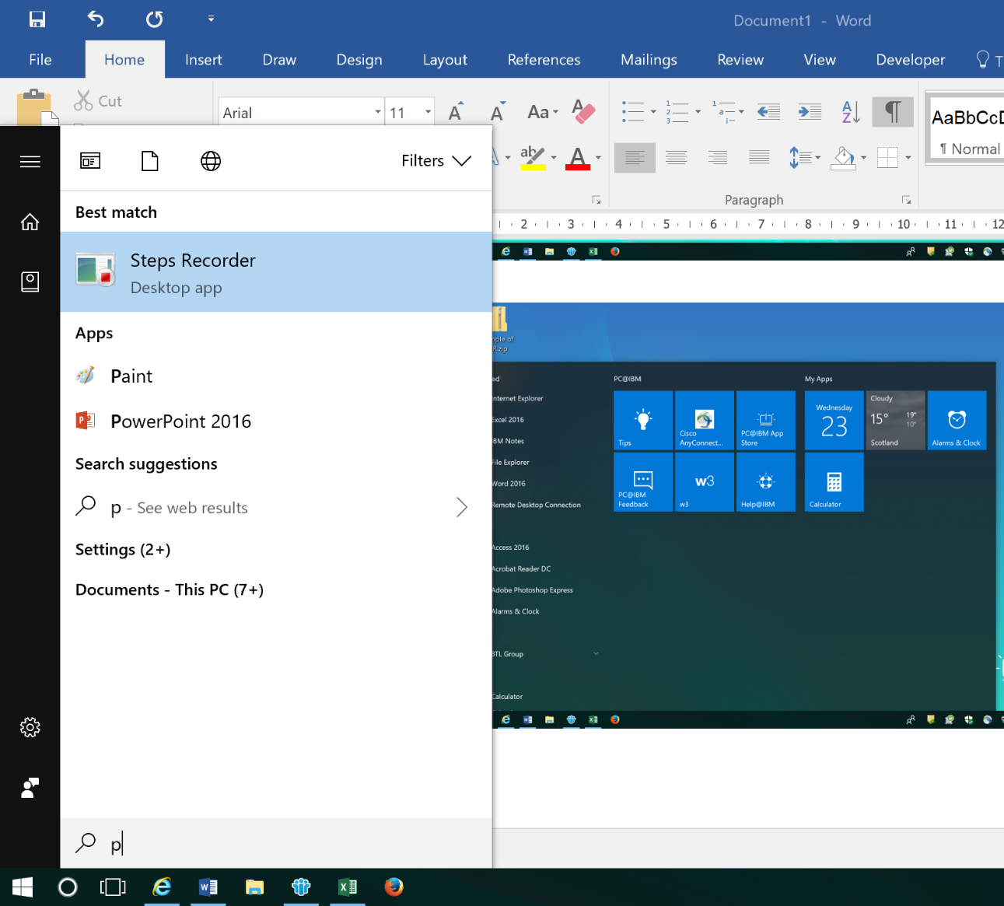

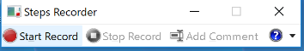
The PSR recording window pops up on screen.

To use it right away, click on Start Record

but if you want to change the default settings, click on the

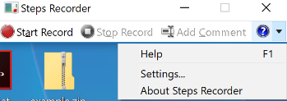
and select settings from the pull down menu.

Ensure the ‘Enable screen capture’ is set to Yes. You can amend the number of screen captures from the default setting of 25 to 100.

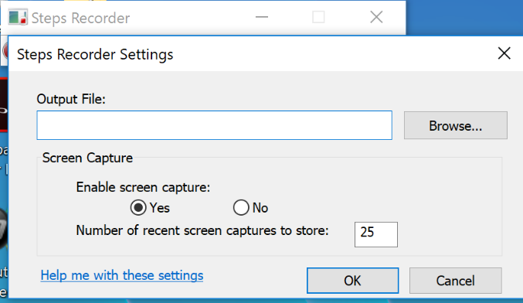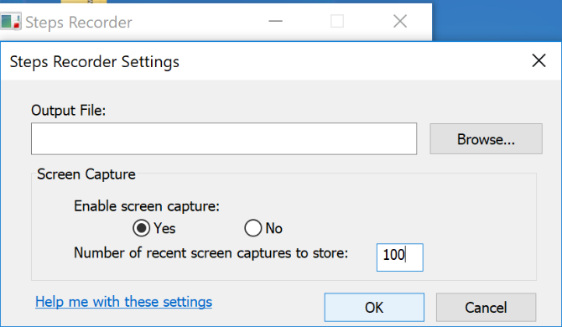

You can now click on Start Record

PSR is now capturing all the keystrokes you are making. To capture the screen, click the PrintScreen button on your keyboard, this will automatically insert a capture of your screen into the PSR report you are producing.

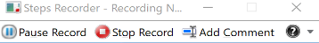
At any point, you can highlight an area of the screen and explain what you are doing by clicking on the Add Comment button.

Clicking on the Add Comment button, gives you the opportunity to select part of your screen and enter text to contextualise what you are doing and why.

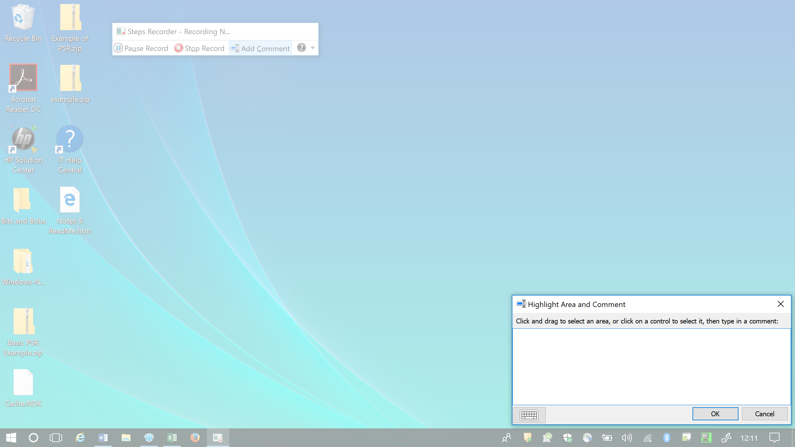

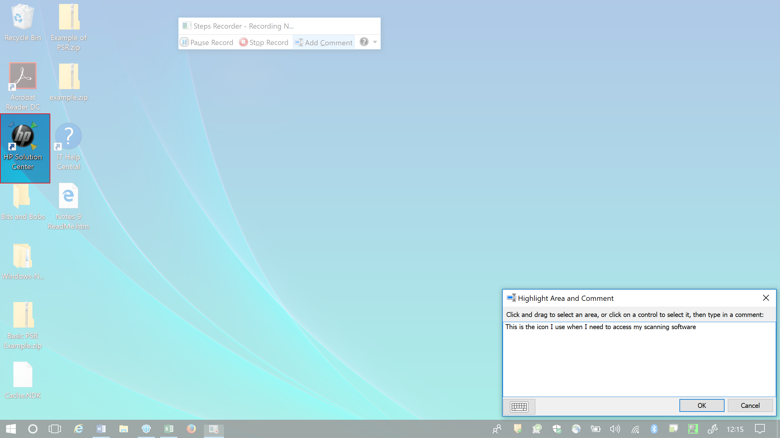

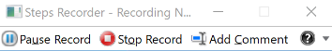
If you don’t want to capture the full process, you can use the Pause Record button to pause the recording. This is useful when passwords, userIDs or sensitive information is on the screen.

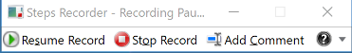
When the recording is paused, the menu looks slightly different. To start recording again when you are ready, click on the Resume Record button.

When you have finished, click on the Stop Record button.

PSR will give you the following screen:

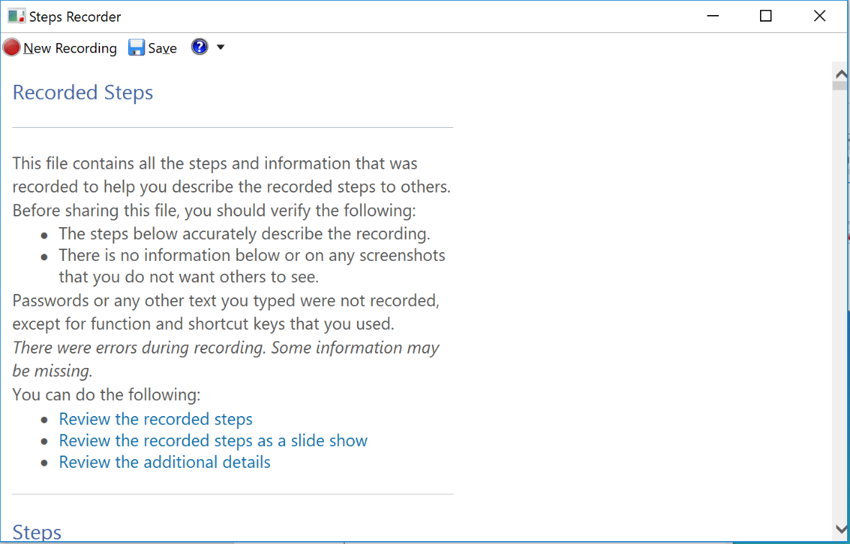

You can now click on Save to save your report.

You will then be prompted for a filename and a location to save the file.

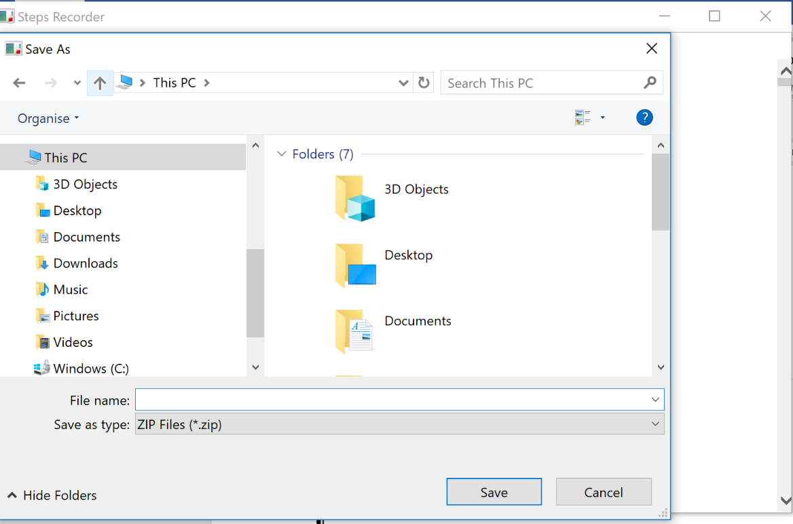

The file is saved as a zip file. Example below:

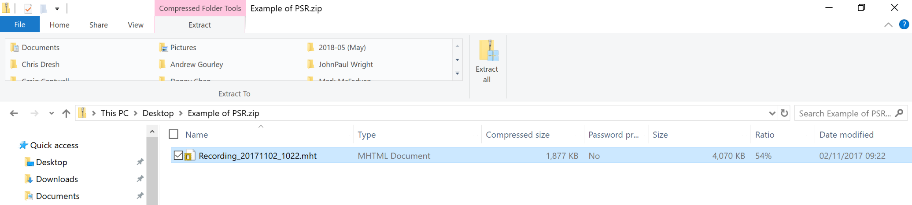

Double clicking on the recording file will open the PSR report, an example is shown below. You can either view the file by scrolling through it or by viewing it as a slide show

