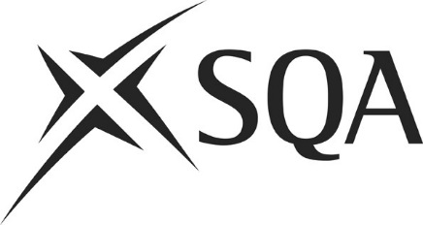
Assessment Arrangements
Learner Agreement Form

Details
Learner’s name:
Learner’s SCN:
Subject(s):
Requested assessment arrangements:

As part of the process of requesting your assessment arrangements, we need to share the following information about you with SQA:
- your name, SCN, date of birth, and the name of this centre (usually a school or college)
- an indication of your disability or identified difficulty
- details of the assessment arrangement(s) you need
SQA will only use this information to process your request for assessment arrangements. This information is not shared with anyone outside of SQA, and is only kept for as long as it is needed to support your request.

Learner’s agreement
I confirm that I have been involved in discussions about and agree to the assessment arrangements being requested.
Print name:
Signature:
Date:

Parent or carer confirmation (if applicable)
I confirm that I have been involved in discussions about the assessment arrangements requested for my child.
Print name:
Signature:
Date:

There’s more information about how SQA uses your information in their Privacy Statement https://www.sqa.org.uk/sqa/45397.html

