Scottish Baccalaureate Inter- disciplinary Projects (IP):

A Guide to Quality Assurance Processes for Centres

Contents

- Introduction

- Overview of IP Quality Assurance Processes

- Detailed Guidance on Quality Assurance Processes Appendix A: IP External Verification Reports
Appendix B: Candidate Result Report
Appendix C: IP Result Amendment Form
- Introduction

The nature of the Scottish Baccalaureate Interdisciplinary Project (IP) is such that a collaborative approach between centres and SQA is necessary to quality assure assessments in a valid and reliable way. This is particularly the case when quality assuring the assessment of generic and cognitive skills (eg Interpersonal Skills and Independent Learning). For this reason, IPs are internally assessed and graded by centres and their partners. Grading decisions are then externally verified by SQA External Verifiers (EVs).

The purpose of this Guide is to provide centres, with a detailed overview of the processes involved in quality assuring the assessment of IPs. The SQA Guide to Assessment, which includes general information on assessment processes and the quality assurance of assessment, will also be of value to centres. This can be downloaded from SQA’s website http://www.sqa.org.uk/sqa/files_ccc/25GuideToAssessment.pdf.

Throughout this guide, reference will be made to templates and candidate guidance where you might normally expect to see the term Instrument/s of Assessment. This is because the phrase templates and candidate guidance more accurately reflects the assessment methodology for the IP.

Overview of IP Quality Assurance Processes

The following stages are involved in the quality assurance of the IP:

  - Internal quality assurance by centres – managed and participated in by centres and their partners

  - Centre Submission of Proposed Grades and Materials for Verification

  - Central Verifier Event – managed by SQA and attended by EVs and supporting SQA Officers

  - Publication of reports and verification outcomes

  - Follow-up verification procedures

Detailed guidance on each of these stages follows below.

Detailed Guidance on Quality Assurance Processes

  - Internal quality assurance in your centre

Purpose
Internal quality assurance carried out in your centre and in collaboration with your partners, is the first stage in the quality assurance processes for the IP. The purpose of internal verification is to ensure, as far as possible, that:
    - all those involved in delivering and assessing the IP in your centre, including partners, develop a common and appropriate understanding of the national standards of competence.
    - the templates and candidate guidance you use with candidates are capable of generating sufficient evidence to allow them to demonstrate that they have reached the national standard of competence at particular grades. If you use the templates and candidate guidance contained in the Assessment Support Pack (ASP), this should be a straightforward process.
    - all those involved in assessing the IP in your centre have made appropriate and consistent grading decisions for all candidates, in line with the national standard of competence.

The effective management of internal verification processes is vitally important in the context of the IP.

Internal Verification Models

SQA’s IV toolkit (www.sqa.org.uk/ivtoolkit) offers useful guidance on different models of quality assurance. The model you use will depend on several factors such as the number of assessors, partners and candidates involved, the location of your centre and the prior experience of assessors. However, any effective internal quality assurance model will normally involve the following:

    - a standardisation process
    - verification of the templates and candidate guidance you are going to use with candidates
    - verification of internal assessment decisions.

The standardisation process: It is important that all those involved in delivering and assessing the IP in your centre work together at the planning stage to develop a common understanding of the IP Unit requirements and the standards of competence needed to achieve specific grades. Discussion of the Statement of Standards in the Unit, along with the templates and candidate guidance and exemplification contained in the ASP, is important to help minimise any differences in the interpretation of standards. Such discussion might involve, for example, identifying the key features of specific grades and/or matching grade criteria to aspects of exemplified materials.

It is also important that the standardisation process is on-going throughout delivery and assessment. This could be achieved by, for example:
    - discussing and agreeing the appropriateness of each candidate’s chosen project topic
    - holding collective discussions of each candidate’s skills development at each stage in the IP, to ensure a common understanding of the progress each candidate has made
    - reviewing the same piece of mandatory evidence for all candidates then discussing any differences in assessor judgements.
    - Discussing materials and information gathered at Centre Support events.

Verification of templates and candidate guidance to be used: The templates and candidate guidance in the ASP are generic in nature and have been designed to be suitable in a wide variety of contexts. They have also been quality assured by SQA which means that you can be confident that they will give your candidates the opportunity to demonstrate that they have reached the national standard of competence at any grade. It is therefore strongly recommended that centres use these to help their candidates generate the evidence required.

However, it is recognised that there may be an occasion and/or a context in which you/your centre think alternative templates and candidate guidance would be appropriate. In these circumstances, it is important that the proposed alternatives are quality assured within your centre before being used with candidates. To do this, you will need to work with other assessors to verify that the alternative templates and candidate guidance:
    - cover the context, all stages, all generic and cognitive skills, and all aspects of the Evidence Requirements as stated in the Unit Statement of Standards
    - are of a comparable standard to those contained in the ASP
    - do not present any barriers to achievement for candidates
    - will give all your candidates the opportunity to demonstrate that they have reached the national standard of competence at any grade, in a valid and reliable way.

Whichever templates and candidate guidance you use, it will be important that all assessors develop a common understanding of their nature and purpose before candidates start to use them to generate evidence.

Verification of assessment decisions: Once candidates have completed their IPs, it is important that all those involved in delivery also contribute to the final grading decisions. Part of this involvement will include ensuring that grade criteria are applied consistently across all candidates and in line with the national standard of competence for the IP.

Consistency can be reached in a variety of ways and the most suitable way for your centre will depend on the number of candidates, partners and assessors involved. Approaches might include:

    - assessors reviewing the same piece of mandatory evidence for each candidate independently, then discussing any differences in their findings before reaching a consensus on how well each piece meets the relevant grade criteria. This would be most appropriate at an early stage to promote a common understanding of standards before each candidate’s evidence is considered as a whole.
    - one assessor initially grading the candidate evidence then another assessor taking the role of internal verifier, i.e. verifying the original grading decision. Where discrepancies arise these can be discussed to allow a consensus to be reached.
    - a group of assessors reviewing all candidate evidence along with initial grading decisions, then collectively discussing discrepancies between assessors’ judgements before reaching a consensus on the overall grade for each candidate.
    - assessors from different presenting centres discussing a sample of graded candidate evidence to check that they have all applied grade criteria consistently across candidates and with a common understanding of the national standard of competence. This approach might be particularly useful to centres in which there are only one or two internal assessors.

With all of these approaches Expressive Arts, Languages, Science and Social Science IP assessors could work together to quality assure each other’s assessment decisions. Again, this might be particularly useful for centres with only one or two assessors.

Whichever method you use in your centre, it is important to remember that a key feature of any reliable method is that it must involve more than one assessor.

  - Submission of Proposed Grades and Materials for Verification

Once all involved in the assessment, grading and checking process are
confident that each candidate’s evidence has been graded appropriately, proposed grades should be submitted to SQA in the normal way. This must be done by the 31st March in the year of certification. Due to the criticality of SQA having this information by this date, extensions will only be possible in very exceptional circumstances. If an unexpected situation has occurred which means it will not be possible to submit the grades by this date, please email national.qualifications@sqa.org.uk immediately.

By mid-April SQA will notify you of the candidates from your centre who have been selected for external verification. If you have more than six candidates entered for the IP, six will be selected. The selection will cover the range of grades awarded by the centre: where possible, this will be the full range of grades (A – C and Fail). If you have fewer than six candidates, all will be selected.

Centres must provide the following evidence for verification:

Evidence required for external verification
For the centre | 1 | Evidence of the centre’s internal verification processes.
Mandatory evidence for each candidate in the sample | 2 | The candidate’s project proposal
 | 3 | The candidate’s project plan
 | 4 | The record of the candidate's presentation of his/her project findings/product
 | 5 | The candidate's evaluation of the project
 | 6 | The candidate's evaluation of his/her generic and cognitive skills development.
 | 7 | The Assessor Report with the associated assessor and internal verifier comments

It is important that centres submit all of this evidence for verification for the full sample of candidates.
This evidence must be packaged and ready for uplift by SQA from your centre on the published date of the year of certification. We will provide you with detailed instruction about the uplift in a communication nearer the time. As with the submission of candidate grades, it is vital that we receive your materials by the deadline date and extensions will therefore only be possible in very exceptional circumstances. Please email script.management@sqa.org.uk immediately if an unexpected circumstance means you will not be able to meet this date.

The Assessor Report and comments and information on your centre’s internal quality assurance processes will be important in the quality assurance of IPs.
EVs will consider these closely, along with the mandatory candidate evidence, when reviewing your centres’ grading decisions.

  - The Central Verifier Event

At this event, EVs will have the opportunity to review the materials submitted by the centres. The EV will either agree or disagree with the centre’s grading of the sampled candidates and will note their grade decision on the Candidate Result Report (Appendix B).
The EV will also complete and external verification report which will provide the centre with feedback and highlight any development opportunities.

  - Publication of verification reports and outcomes

After the verification event, SQA will email the External Verification Report to your centre. The External Verification Report will clearly indicate the result of external verification, give detailed feedback and provide advice, where appropriate (see Appendix A for examples of these reports). You will also receive a copy of the Candidate Results Report indicating any recommended changes in grading.

There are two possible outcomes of IP external verification.
These are:
- Accepted – this indicates that all your centre’s grading decisions are all accepted with no issues, or only minor issues, being identified.
- Not Accepted – this means either:
- an issue has been identified with your centre’s judgement.
or
- an issue has been identified with your centres approach. The templates and candidate guidance used in your centre which has meant that the candidates have been unable to generate the evidence which would demonstrate that they had met the national standard of competence or the IP.

  - Follow-up verification procedures

If a centre has had a not accepted outcome, they are required to undertake an assessment review. Required actions will have been specified within the external verification report.

If the centre requires follow-up support or clarification, we will arrange for guidance and support to be provided directly to you, usually in the form of a telephone call. Requests for further follow-up support should be emailed to nqverification@sqa.org.uk.

Where requested in the external verification report centres will resubmit materials to SQA with documentation stating the required actions that have been undertaken.

If, after the internal review, your centre confirms that it has revised grading decisions in line with EV recommendations then your centre submits the IP Result Amendment Form, provided with the Not Accepted email, to nqverification@sqa.org.uk, (See Appendix C for copy of IP Result Amendment Form). Where there is no amendment to candidate evidence, follow-up activity will be progressed by SQA without further involvement from an external verifier. If additional candidate evidence is provided, this will be reviewed by an external verifier and the decision will be confirmed by email.

If your centre does not accept the advice contained in the External Verification Report,(or any subsequent follow up decision) and all internal assessors remain confident in the original grading decisions, it should follow the normal external verification appeals process.

3.5 A Final Note
SQA values feedback from all centres involved in delivering and assessing the IP. Feedback from centres is welcome at any stage in the process and will be used to inform evaluation of the IP, its assessment and quality assurance.

Appendix A: Reports

Appendix A: IP External Verification Reports
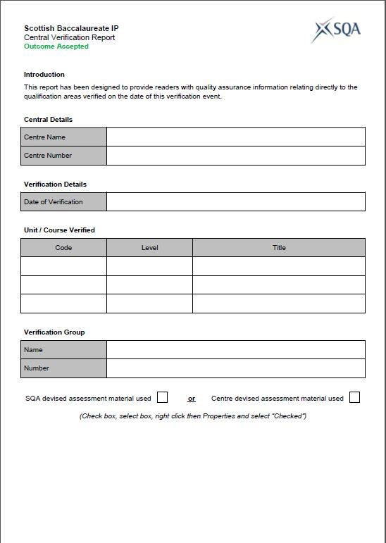

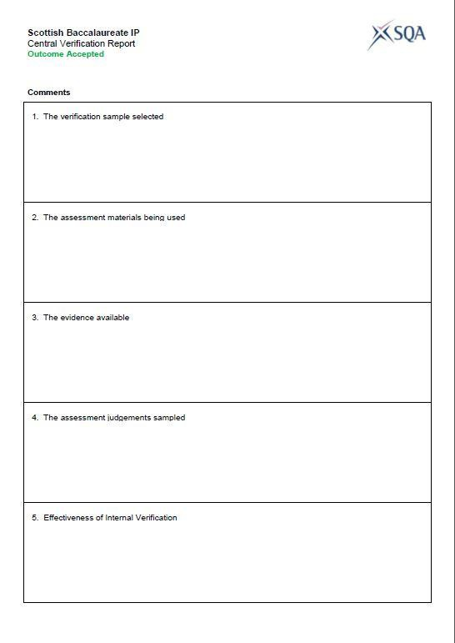

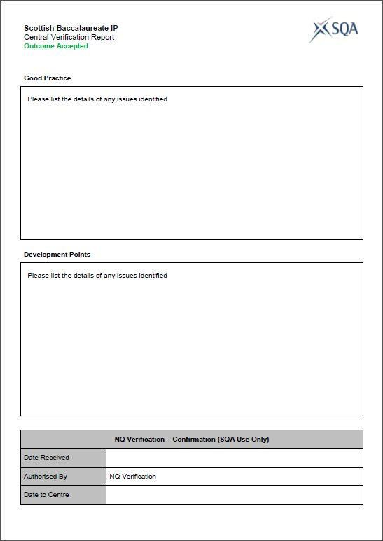

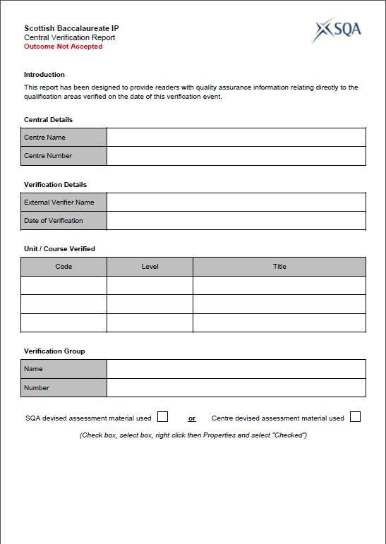

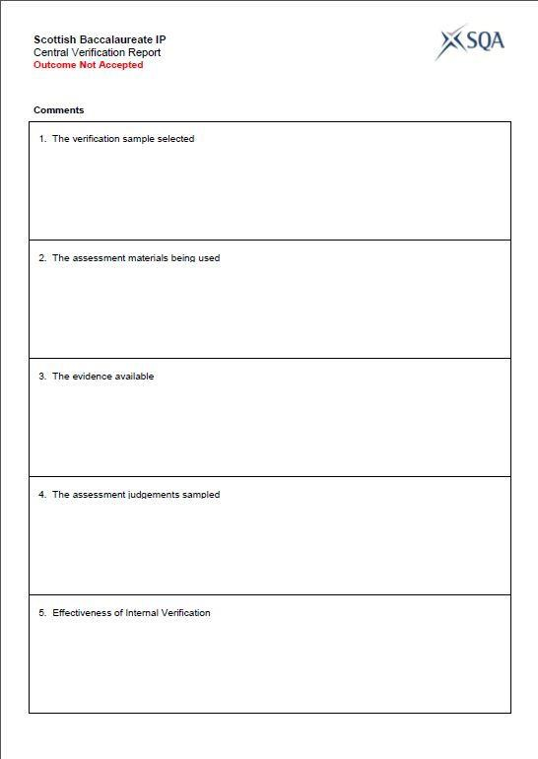

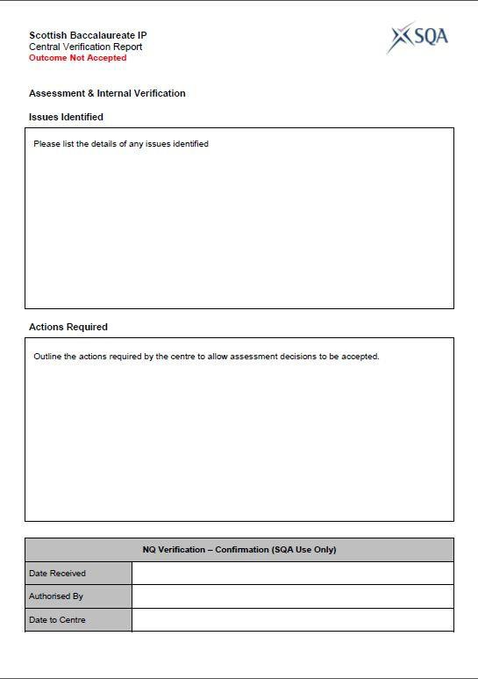

Appendx B:  IP Entries: 7  Baccalaureate Entries: 7 | Centre Code: |  | 5100000
 | Centre Name: |  | Anyother College
 | IP Unit Code/Prod Level: |  | F785 47
 | IP Title: |  | Science: Interdisciplinary Project
Candidate | SCN | Surname | Forename | DOB | Result | Result Date | Bacc Entry | IP Verification Result
1 | 0623904120 | Baxter | Andrew | 01.01.2000 | A | 27.03.2018 | N
 | 062316758 | McKeenan | Jen | 19.10.2000 | A | 27.03.2018 | N
2 | 062425454 | Smith | Simon | 01.03.2000 | A | 27.03.2018 | Y
3 | 062291515 | MacDonald | Ronald | 01.05.2000 | A | 27.03.2018 | Y
4 | 062401111 | Norman | Billy | 01.07.2000 | B | 27.03.2018 | Y
5 | 062441666 | Nunn | Harry | 10.09.2000 | A | 27.03.2018 | Y
6 | 062327755 | Owens | David | 16.11.2000 | A | 27.03.2018 | N
 |  |  |  |  |  | IP Entries: |  | 7
 |  |  |  |  |  | Baccalaureate Entries: |  | 4

Appendix C
