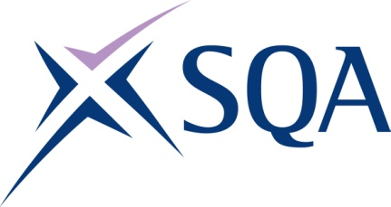
GL62 45 | Certificate in Maritime Studies: Able Seafarer (Deck)

To attain the qualification candidates must complete 5 Units in total. This comprises:

- 5 mandatory Units

Please note the table below shows the SSC identification codes listed alongside the corresponding SQA Unit codes. It is important that the SQA Unit codes are used in all your recording documentation and when your results are communicated to SQA.

Mandatory Units: Candidates must complete all 5 Units from this group
SQA code | SSC code | Title | SCQF level | SCQF credits
H0JA 04 | MSA 2 | Maritime Sector Overview | 4 | 4
H0JB 04 | MSA 3 | Vessel Ropework, Anchoring and Mooring Operations | 5 | 9
H0JC 04 | MSA 4 | Securing a Vessel for Passage | 5 | 2
H0JD 04 | MSA 5 | Vessel Construction and Stability | 5 | 3
H0JM 04 | MSA 29 | Control Operation of Survival Craft and Rescue Boats | 6 | 5

