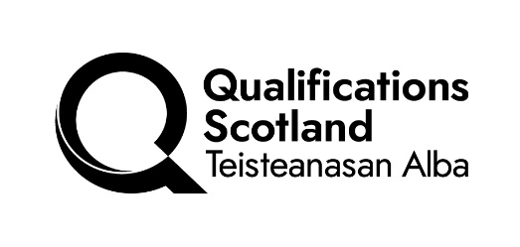

As a valued employer / former student / stakeholder (delete as appropriate) please could you take a few minutes to read about a proposed new qualification in (insert subject) and complete this short questionnaire to give us your opinion. Your response will be anonymous
This qualification is intended to provide the skills and knowledge for employment as a (insert possible job roles here) or to progress to further study in (insert higher level qualifications here). The aims of the qualification are to: (insert principal, general and specific aims from Business Case here).
The qualification is made up of two sections, one mandatory – which all students will complete, and one optional section where students will choose up to (insert number of units) subjects from a possible list of (insert number of options).
We would be grateful if you could find the time to do this to help us to develop a well-designed qualification that will be of benefit to future candidates.
Q1
The following units will be taken by students completing this qualification. Please tell us how important you think these units are using the following scale:
1 - Essential 2 - Useful but not essential 3 -Not useful
Mandatory Section
Unit Title | Unit Purpose/Summary | Importance
Unit 1
Unit 2
Unit 3
Unit 4
Unit 5
Unit 6

Optional Section

Unit Title | Unit Purpose/Summary | Importance
Unit 1
Unit 2
Unit 3
Unit 4
Unit 5
Unit 6

Q2
The following Core Skills should be developed by students completing this qualification. Please tell us how important these Core Skills are for employment as a (insert possible job roles here) or to progress to further study in (insert higher level qualifications here).
Core Skill | Very High | High | Moderate | Low
Written Communication
Spoken Communication
Numeracy
Working with others
Using IT
Problem Solving

Q3
Are there any additional skills or knowledge which should be included in this qualification which have not been covered in Q1 or Q2
Free text box

Q4
How useful would this qualification be in helping students into work?
Very Useful | Useful | Not Very Useful | Not Useful at All

How useful would this qualification be in helping students into further study?
Very Useful | Useful | Not Very Useful | Not Useful at All

Or
How easy would your centre find recruiting candidates for this qualification? (centres)
Very Easy | Easy | Not Very Easy | Not Easy at All

Q5

How important is it that the (Course/Group Award) achieves professional body recognition?

Very important
Quite important
Not very important
Not at all important

Q6

If you think it is important, please indicate the appropriate professional body and level at which it should be recognised.

Q7

If you have any other relevant comments on this proposed qualification, please record them here.

Please e-mail completed questionnaire to e-mail address:
By: DD/MM/YY

Many thanks for your help

Template: February 2026

