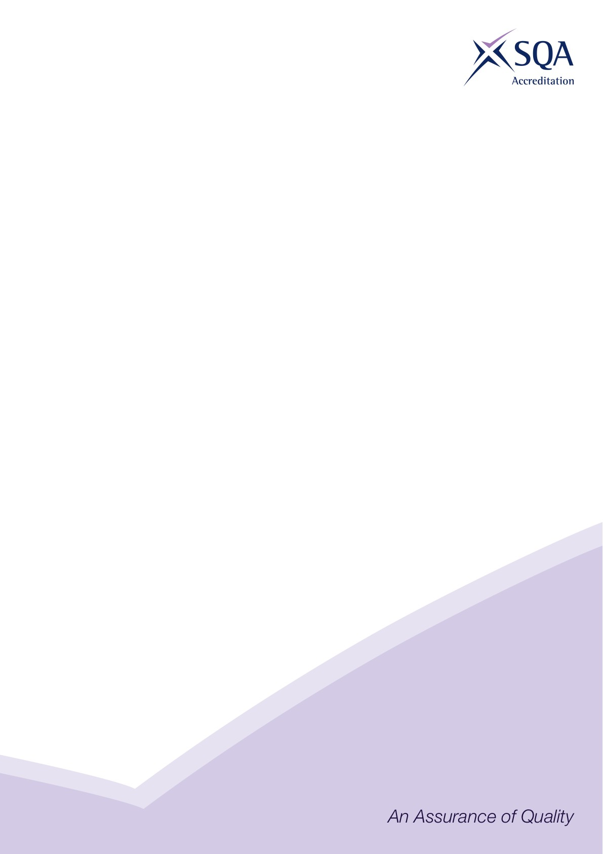

Core Skills Signposting
Qualification Title | SVQ in Formwork (Construction) at SCQF Level 5
Developed by | CITB
Approved by ACG | 30 April 2025
Version | 1

Introduction

Core Skills signposting indicates if there are opportunities within units to develop Core Skills in the workplace to a specified SCQF level. The signposting document should also acknowledge where there are no opportunities to develop Core Skills. This signposting can be used by providers and assessors to plan the development and assessment of Core Skills.

The five Core Skills are:
◻ Communication
◻ Information and Communication Technology
◻ Numeracy
◻ Problem Solving
◻ Working with Others

Core Skills Signposting

SVQ in Formwork (Construction) at SCQF Level 5
URN | Unit title | Communication | ICT | Numeracy | Problem Solving | Working with Others
COSVR641 v2 | Conform to general workplace health, safety and welfare | Level 4 |  |  | Level 4 | Level 4
COSVR642 v1 | Conform to productive work practices | Level 4 |  |  |  | Level 4
COSVR643 v1 | Move, handle or store resources | Level 3 |  | Level 4 | Level 4 | Level 4
COSVR509 v3 | Fabricate and maintain timber and proprietary formwork | Level 4 |  | Level 4 | Level 4 | Level 4
COSVR510 v3 | Erect and strike timber and proprietary formwork | Level 4 |  | Level 4 | Level 4 | Level 4
COSVR787 v3 | Maintain timber and proprietary formwork | Level 4 |  | Level 4 | Level 4 | Level 4
COSVR392 v2 | Operate plant or machinery used as work platforms | Level 4 |  | Level 4 |  | Level 4

All numbers refer to SCQF level – any blanks indicate no opportunity.

