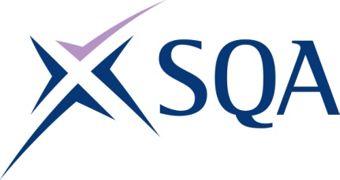

GA TITLE: Award in Emergency Paediatric First Aid at SCQF Level 6
GA CODE: GT7V 46

To attain the qualification candidates must complete the unit.

Please note: It is important that the SQA unit codes are used in all your recording documentation and when your results are communicated to SQA

Mandatory units: Candidates must complete the unit.
SQA code | Title | SCQF level | SCQF credits | SQA credits
J6N2 46 | Emergency Paediatric First Aid | 6 | 1 | 0.25

