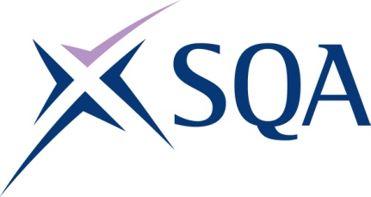

GA TITLE: Award in First Aid at Work at SCQF Level 6
GA CODE: GT7X 46

To attain the qualification candidates must complete both units.

Please note: It is important that the SQA unit codes are used in all your recording documentation and when your results are communicated to SQA

Mandatory units: Candidates must complete the 2 units.
SQA code | Title | SCQF level | SCQF credits | SQA credits
J6N0 46 | Emergency First Aid in the Workplace | 6 | 1 | 0.25
J6N1 46 | Recognition and Management of Illness and Injury in the Workplace | 6 | 2 | 0.50

