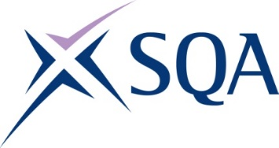

Qualification structure for SQA Level 2 NVQ Diploma in Controlling Lifting Operations – Slinger/Signaller (Construction)

SQA Qualification Code: GT6R 68

Ofqual’s Qualification Code: 610/0942/8
Minimum Total Qualification Time: 430 hours
Minimum Guided Learning Hours: 217

Credit value: 43

To gain the qualification, learners must achieve a minimum total of 43 credits (430 TQT)

This comprises:
- 43 credits from the Mandatory Core Units

Please note: It is important that the SQA Unit codes are used in all your recording documentation and when your results are communicated to SQA.

Mandatory Core Units: Learners must achieve all 43 credits

SQA Unit Code | Unit Title | Regulator’s Unit code | Level | Credit value | GLH | TQT
FX74 81 | Conforming to General Health, Safety and Welfare in the Workplace | D/616/6569 | 1 | 2 | 17 | 20
FX6X 68 | Conforming to Productive Working Practices in the Workplace | R/616/6570 | 2 | 3 | 20 | 30
J6G3 68 | Slinging, Signalling and the Movement of Suspended Loads in the Workplace | Y/650/2625 | 2 | 38 | 180 | 380

