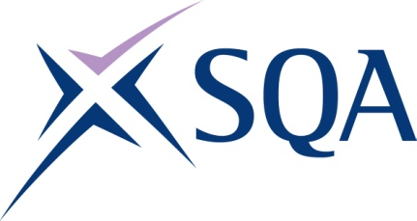

Qualification structure for SQA Level 4 NVQ Diploma in Controlling Lifting Operations – Supervising Lifts (Construction)

SQA Qualification Code: GT6T 80

Ofqual’s Qualification Code: 610/0965/9
Minimum Total Qualification Time: 860
Minimum Guided Learning Hours: 437

Credit value: 86

To gain the qualification, learners must achieve a minimum total of 86 credits (860 TQT)

This comprises:
- 86 credits from the mandatory Core Units

Please note: It is important that the SQA Unit codes are used in all your recording documentation and when your results are communicated to SQA.

Mandatory Core Units: Learners must achieve all 86 credits

SQA Unit Code | Unit Title | Regulator’s Unit code | Level | Credit value | GLH | TQT
J617 79 | Developing and Maintaining Good Occupational Working Relationships in the Workplace | T/650/2642 | 3 | 8 | 37 | 80
J6G4 79 | Supervising Lifting Operations using Lifting Equipment in the Workplace | H/650/2638 | 3 | 20 | 120 | 200

SQA Unit Code | Unit Title | Regulator’s Unit code | Level | Credit value | GLH | TQT
J6G5 80 | Implementing, Maintaining and Reviewing Systems for Health, Safety, Welfare, Wellbeing and Environmental Protection in the Workplace | F/650/2637 | 4 | 9 | 50 | 90
J6G6 80 | Co-ordinating Work Control in the Workplace | D/650/2636 | 4 | 12 | 50 | 120
J6G7 80 | Allocating and Monitoring the use of Plant, Equipment or Machinery in the Workplace | M/650/2640 | 4 | 10 | 50 | 100
J6G8 80 | Maintaining the Dimensional Accuracy of the Work in the Workplace | R/650/2641 | 4 | 10 | 50 | 100
J6G9 80 | Co-ordinating Preparation for Site Operations in the Workplace | A/650/2635 | 4 | 8 | 30 | 80
J6GA 84 | Allocating Work and Monitoring People’s Performance in the Workplace | J/650/2639 | 6 | 9 | 50 | 90

