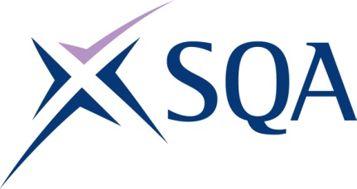

SVQ Occupational Health and Safety at SCQF Level 7
GA CODE: GT5N 23

SCQF overall credit: Minimum 39 Maximum 48
To attain the qualification candidates must complete 6 units. This comprises:
- All 4 mandatory units
- 2 units from the ‘Optional Units’ section

Please note the table below shows the SSC identification codes listed alongside the corresponding SQA unit codes. It is important that the SQA unit codes are used in all your recording documentation and when your results are communicated to SQA
Mandatory units: Candidates must complete all 4 units
SQA code | SSC code | Title | SCQF level | SCQF credits
J677 04 | PROHSS1 | Make Sure Your Own Actions Reduce Risks to Health and Safety | 5 | 8
J678 04 | PROHSS3 | Control Work Operations Safely | 7 | 9
J67A 04 | PROHSP2 | Promote a Positive Health and Safety Culture | 7 | 4
J67B 04 | PROHSS6 | Conduct Health and Safety Risk Assessments of a Workplace | 7 | 8

OPTIONAL UNITS
Candidates must complete 2 units from this group
SQA code | SSC code | Title | SCQF level | SCQF credits
J67C 04 | PROHSS2 | Develop Procedures to Safely Control Work Operations | 7 | 10
J67D 04 | PROHSS5 | Investigate and Evaluate Health and Safety Incidents and Complaints at Work | 7 | 8
J67E 04 | PROHSS8 | Review Health and Safety Procedures at Workplaces Other Than Your Own | 6 | 7
J67F 04 | PROHSS9 | Supervise Health, Safety and Welfare of Individuals at Work | 6 | 6
J67G 04 | PROHSP14 | Develop, Implement and Monitor Behavioural Safety in the Workplace | 6 | 7
J67J 04 | PROHSP15 | Manage Contractors to Ensure Compliance with Health and Safety | 8 | 9
J67K 04 | PROHSP16 | Develop and Implement Health and Safety Induction Processes | 7 | 9
H8W5 04 | CFAM&LEB4 | Manage the Environmental and Social Impacts of Your Work | 8 | 4

