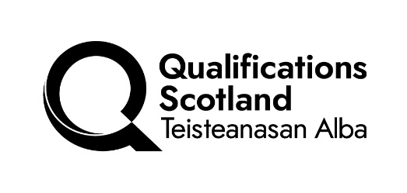

Change request to an existing Group Award and/or Unit (DAVAL 2)

Section A: Alterations to the structure of an existing Group Award
Centre name: |  | Centre contact:
E-mail address: |  | Telephone number:
Title of existing Group Award: |  | Code of existing Group Award:
Please detail proposed alteration.

Please detail the reasons for alteration. (If appropriate attach evidence, eg information from articulating organisations.)

Section B: Alterations to the content of an existing Unit
Title of existing Unit: |  | Code of existing Unit:
Please detail proposed alteration — this should give exact details of which part of the Unit is being changed (for example, Outcome 1, Evidence Requirements for Outcome 2 and the proposed wording.

Please detail the reasons for alteration. (If appropriate attach evidence, eg information from articulating organisations.)

Please return this form to: qualificationsadmin@qualifications.gov.scot

Section C: to be completed by Qualifications Scotland
Qualifications Manager: |  |  | Date sent to Qualifications Manager:
Proposed alteration agreed: | Yes | No
Comments:

Please provide statement to be added to the Notification of Change spreadsheet and the History of Changes table in the Unit specification and /or Group Award Specification:

In addition to “QPM’” Notification of Change spreadsheet, please state how and when change will be notified to centres:

Relationship Type – do any of below apply to the Unit/Group Award:

HN/ACD equivalent? | Yes | No | Replicated without re-code? (HN only) | Yes | No | Foundation Apprenticeship component? | Yes | No

If you have ticked “Yes” to any of the above a change request form must be completed and e-mailed to QPM.
Where change is to a Group Award - please e-mail a copy of the existing framework printed from APS and identify where change is to be made. In addition, please e-mail a copy of the framework from the Group Award Specification and identify where changes are to be made.

Where change is to a Unit specification:
- please supply either a paper copy with amendments/additions/deletions marked up, or an electronic version with changes tracked in coloured font.
- is there an ASP/NAB/Exemplar for the Unit(s)? – if yes - please supply Support Materials with either a paper copy with amendments/additions/deletions marked up, or an electronic version with changes tracked in coloured font.

Qualifications Manager’s signature: |  | Date:
Please return this form to: QPMTeam@qualifications.gov.scot

Form: February 2026

