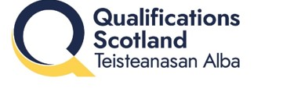

Qualification Part C- Decisions

Equality Review Form

Title:
Level/s:
1: Please detail any potential impacts (positive or negative) of the changes to the qualification on learners with protected characteristics (age, sex, race, disability, religion/belief, sexual orientation, gender reassignment).
2: Detail any other equality and inclusion issues that arise from any of the changes above. e.g. have you considered how this related to decolonising the curriculum, learning for sustainability or LGBT+ inclusive education?
3: Consultation

Please detail (or provide a link) any engagement you have had with the sector, centres, higher education institutions, regulators or support teams.
Did the participants reflect diverse communities?

Sign Off
I confirm that there are no outstanding issues
Head of Service Signature |  | Date
Director of Qualification Development and Chief Examining Officer |  | Date

