

National
Qualifications
RESOURCE

2021 Chemistry

National 5

Finalised Marking Instructions

© Scottish Qualifications Authority 2021

These marking instructions have been prepared by examination teams for use by SQA appointed markers when marking external course assessments.

The information in this document may be reproduced in support of SQA qualifications only on a non-commercial basis. If it is reproduced, SQA must be clearly acknowledged as the source. If it is to be reproduced for any other purpose, written permission must be obtained from permission@sqa.org.uk.


General marking principles for National 5 Chemistry

This information is provided to help you understand the general principles you must apply when marking candidate responses to questions in this paper. These principles must be read in conjunction with the detailed marking instructions, which identify the key features required in candidate responses.

- Marks for each candidate response must always be assigned in line with these general marking principles and the detailed marking instructions for this assessment.

- If a specific candidate response does not seem to be covered by either the principles or detailed marking instructions, and you are uncertain how to assess it, you must seek guidance from your team leader.

- Marking should always be positive. This means that, for each candidate response, marks are accumulated for the demonstration of relevant skills, knowledge and understanding: they are not deducted from a maximum on the basis of errors or omissions.

A guiding principle in marking is to give credit for correct chemistry rather than to look for reasons not to award marks.

Example 1: The structure of a hydrocarbon found in petrol is shown below.

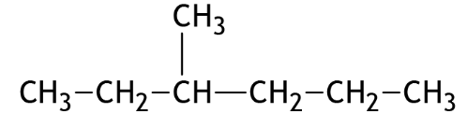

Name the hydrocarbon.

Although the punctuation is not correct, ‘3, methyl-hexane’ should gain the mark.

Example 2: A student measured the pH of four carboxylic acids to find out how their strength is related to the number of chlorine atoms in the molecule.

The results are shown in the table.

Structural formula | pH
CH₃COOH | 1·65
CH₂ClCOOH | 1·27
CHCl₂COOH | 0·90
CCl₃COOH | 0·51

State how the strength of the acids is related to the number of chlorine atoms in the molecule.

Although not completely correct, an answer such as ‘the more Cl₂, the stronger the acid’ should gain the mark.

- There are no half marks awarded.

- Candidates must respond to the ‘command’ word as appropriate and may be required to write extended answers in order to communicate fully their knowledge and understanding.

- Marks should be awarded for answers that have incorrect spelling or loose language as long as the meaning of the word(s) is conveyed. Example: Answers like ‘distilling’ (for ‘distillation’) and ‘it gets hotter’ (for ‘the temperature rises’) should be accepted.

However, the example below would not be given any credit, as an incorrect chemical term, which the candidate should know, has been given.

Example: If the correct answer is ‘ethene’, and the candidate’s answer is ‘ethane’, this should not be accepted.

- A correct answer followed by a wrong answer should be treated as a cancelling error and no marks should be awarded.

Example: State what colour is seen when blue Fehling’s solution is warmed with an aldehyde.

The answer ‘red, green’ gains no marks.

If a correct answer is followed by additional information which does not conflict, the additional information should be ignored, whether correct or not.

Example: State why the tube cannot be made of copper.

If the correct answer is related to a low melting point, ‘Copper has a low melting point and is coloured grey’ would not be treated as having a cancelling error.

- Unless a numerical question specifically requires evidence of working to be shown, full marks should be awarded for a correct final answer (including units if required) on its own.

The partial marks shown in the marking scheme are for use when working is given but the final answer is incorrect. An exception is when candidates are asked to ‘Find, by calculation’, when full marks cannot be awarded for the correct answer without working.

- In most questions units are not required. However, if the candidate writes units then they must be correct. An incorrect unit would not be acceptable and one mark would not be awarded.

This marking instruction must only be applied a maximum of once per paper.

- Where the marking instructions specifically allocate a mark for units in a calculation, this mark should not be awarded if the units are incorrect or missing. Missing or incorrect units at intermediate stages in a calculation should be ignored.

- As a general rule, where a wrong numerical answer (already penalised) is carried forward to another step, credit will be given provided the result is used correctly. The exception to this rule is where the marking instructions for a numerical question assign separate ‘concept marks’ and an ‘arithmetic mark’. In such situations, the marking instructions will give clear guidance on the assignment of partial marks.

- Ignore the omission of one H atom from a full structural formula provided the bond is shown or one carbon to hydrogen bond missing provided the hydrogen is shown.

- A symbol or correct formula should be accepted in place of a name unless stated otherwise in the marking instructions.

- When formulae of ionic compounds are given as answers it will only be necessary to show ion charges if these have been specifically asked for. However, if ion charges are shown, they must be correct. If incorrect charges are shown, no marks should be awarded.

- If an answer comes directly from the text of the question, no marks should be awarded.

Example: A student found that 0·05 mol of propane, C₃H₈ burned to give 82·4 kJ of energy.

Name the type of enthalpy change which the student measured.

No marks should be awarded for 'burning' since the word ‘burned’ appears in the text.

- Unless the question is clearly about a non-chemistry issue, eg costs in industrial chemical process, a non-chemical answer gains no marks.

Example: Suggest why the (catalytic) converter has a honeycomb structure.

A response such as ‘to make it work’ may be correct but it is not a chemical answer and the mark should not be awarded.

Marking instructions for each question
Section 1

Question | Answer | Mark
1. | B | 1
2. | A | 1
3. | C | 1
4. | B | 1
5. | C | 1
6. | A | 1
7. | D | 1
8. | C | 1
9. | D | 1
10. | B | 1
11. | C | 1
12. | A | 1
13. | C | 1
14. | A | 1
15. | C | 1
16. | D | 1
17. | D | 1
18. | B | 1
19. | D | 1
20. | A | 1
21. | B | 1
22. | B | 1
23. | C | 1
24. | D | 1
25. | D | 1

Section 2

Question |  |  | Expected response | Max mark | Additional guidance
1. | (a) | (i) | Same atomic number/protons AND different mass number/mass/ number of neutrons  Atoms of the same element with different mass number/mass/ number of neutrons  Candidate must specify either same atomic number or number of protons/positive charges or atoms of the same element AND different mass number/mass/number of neutrons | 1 | If electrons mentioned this  does not negate a correct  answer  Do not accept  Particles, molecules or same  atoms with …  Same element with different  mass number
 |  | (ii) | 120  OR  $${}_{\text{50}}^{\text{120}}{\text{Sn}}$$  OR  $${}_{}^{\text{120}}{\text{Sn}}$$  OR  Sn-120  OR  tin-120. | 1 | Accept amu or g if stated.
 | (b) |  | $${}_{\text{50}}^{\text{124}}{\text{Sn}}$$ | 1
 | (c) |  | Covalent | 1 | Accept covalent molecular.  Molecular on its own is not acceptable.  Any mention of network or lattice or ionic or metallic negates a correct answer.

Question |  |  | Expected response | Max mark | Additional guidance
2. | (a) |  | Correctly drawn apparatus for either:  Upturned measuring cylinder in water  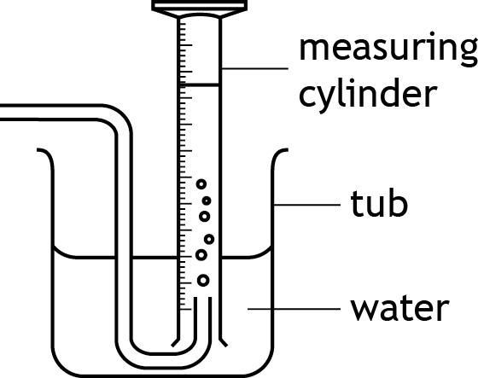  OR  Gas syringe  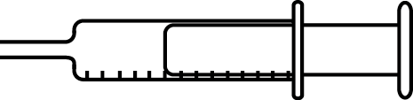  Graduation marks must be shown. | 1 | A graduated test tube would be acceptable.  The apparatus set-up must work; delivery tube cannot enter measuring cylinder through side wall.  Gas syringe must not be closed by bi-secting line.  See additional exemplification guidance.
 | (b) | (i) | Curve should be steeper and should plateau at same height. | 1
 |  | (ii) | Reactants are being used up. | 1
 | (c) | (i) | 0·2174/0·217/0·22/0·2 (2 marks)  Partial marking:  1 mark awarded for concept of change in volume/change in time.  50/230 with an incorrect answer  OR  50/145 = 0·345 or 0·34  OR  50/76 = 0·658 or 0·66 | 2 | If working is shown then it must demonstrate the concept of change in volume over time.  If wrong concept of change in time divided by change is volume is used, zero marks are awarded.  eg 230/50
2. | (c) | (ii) | As the temperature (of acid) increases the time taken decreases.  OR  As the temperature (of the acid) decreases the time taken increases.  OR  The time taken increases as the temperature decreases.  OR  The time taken decreases as the temperature increases. | 1 | Must have correct cause and effect.  eg As the time decreases, the temperature increases.  -Zero marks would be awarded.  As temperature increases, rate increases.  -Zero marks would be awarded.
 |  | (iii) | Greater number/concentration/ moles of hydrogen ions/H⁺  OR  more H⁺ ions.  OR  H₂SO₄ is diprotic. | 1 | Award zero marks for ‘more hydrogen’/more hydrogen atoms/  more ‘H’/more acid/more moles of acid.  Award zero marks for mention of stronger/weaker acid but this does not negate a correct answer.

Question |  |  | Expected response | Max mark | Additional guidance
3. | (a) |  | Catalysts are substances that speed up chemical reactions (but can be recovered chemically unchanged at the end of the reaction). | 1
 | (b) | (i) | Phosphorus/P  OR  Potassium/K | 1
 | (b) | (ii) | Soluble | 1
 | (c) | (i) | 46·67/46·7/47 (%) (3 marks)  Partial marking:  GFM = 60 (1 mark)  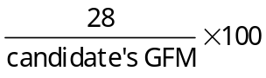 (1 mark)  This step on its own is worth 2 marks if the candidate’s GFM is 60.  Calculation of final answer using the relationship  % by mass = 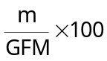 (1 mark) | 3 | No units required but a maximum of two marks can be awarded if an incorrect unit is given. This marking instruction must only be applied a maximum of once per paper.  Maximum 2 marks  (working must be shown)  Incorrectly calculated GFM-allow follow through using the mass of nitrogen from working  OR  Using total mass of N as 14-  14/60 × 100 = 23∙3%  The mark for the final answer can only be awarded if the correct relationship between total mass of element present divided by GFM × 100 is shown with working.  An incorrect GFM of urea must be supported by working.  See additional exemplification guidance.
 |  | (ii) | Thermometer/temperature probe | 1

Question |  |  | Expected response | Max mark | Additional guidance
4. | (a) |  | Triethylene glycol | 1
 | (b) |  | Diagram showing sulfur with two hydrogen atoms: each of the two overlap areas must have two electrons in or on overlap area.  Either the sulfur or both hydrogen symbols must be shown.  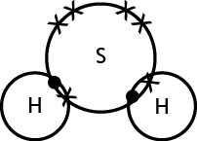 | 1 | The diagram does not need to show the angular shape.  Accept cross or dot or e or e- to represent electrons or a mixture of these.  Accept petal diagram. The non-bonding electrons in sulfur must be shown but do not need to be together/shown as two pairs.  Bonding electrons MUST be on the line or in the overlapping area.  If inner electrons on sulfur are shown they must be correct ie 2,8.  See additional exemplification guidance.
 | (c) |  | 131 | 1
 | (d) |  | hydroxyl | 1 | OH is not acceptable, but does not negate the correct answer.  Hydroxide is not acceptable.

Question |  |  | Expected response | Max mark | Additional guidance
4. | (e) | (i) | A correct shortened or full structural formula for 2,4-dimethylpentanoic acid.  eg CH₃CH(CH₃)CH₂CH(CH₃)COOH  HOOCCH(CH₃)CH₂CH(CH₃)CH₃  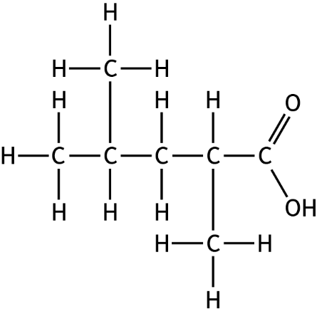  Or mirror images. | 1 | Accept CH₃ for branch in a full structural formula.  See additional exemplification guidance.
 |  | (ii) | A correct shortened or full structural formula for 2-methylpropane.  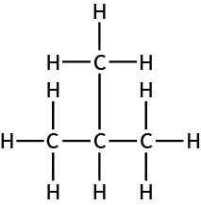 | 1 | 2-methylpropane (0 marks)  CH₃CH(CH₃)CH₃ would be acceptable.  See additional exemplification guidance for Question 4(e)(i)
 | (f) |  | Unsaturated | 1 | Carbon to carbon double bond or alkene 0 marks.

Question |  |  | Expected response | Max mark | Additional guidance
5. |  |  | This is an open ended question.  1 mark: The candidate has demonstrated a limited understanding of the chemistry involved. The candidate has made a/some statement(s) that is/are relevant to the situation, showing that at least a little of the chemistry within the problem is understood.  2 marks: The candidate has demonstrated a reasonable understanding of the chemistry involved. The candidate has made a/some statement(s) that is/are relevant to the situation, showing that the problem is understood.  3 marks: The candidate has demonstrated a good understanding of the chemistry involved. The candidate shows a good comprehension of the chemistry of the situation and has provided a logically correct answer to the question posed. This type of response might include a statement of the principles involved, a relationship or an equation, and the application of these to respond to the problem. This does not mean the answer has to be what might be termed an “excellent” answer or a “complete” one. | 3 | 0 marks: The candidate has demonstrated no understanding of the chemistry involved.  There is no evidence that the candidate has recognized the area of chemistry involved or has given any statement of a relevant chemistry principle.  This mark would also be given when the candidate merely restates the chemistry given in the question.

Question |  |  | Expected response | Max mark | Additional guidance
6. | (a) | (i) | 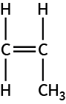 | 1 | Accept full or shortened structural formula.  See additional exemplification guidance.
 |  | (ii) | For appropriate format: bars (not points) (1 mark)  The ‘percentage’ axis of the graph has a suitable scale. For the graph paper provided within the question paper, the selection of a suitable scale will result in a graph (plotted bars) that occupies greater than half of the width and half of the height of the graph paper. (1 mark)  The axes of the graph have suitable labels and units. (1 mark)  All bars are plotted accurately (within a half box tolerance).  This mark can only be accessed if a linear scale for the y-axis has been provided. (1 mark) | 4 | If a scatter/line graph is drawn a maximum of 3 marks can be awarded.  Bars should be separate, however mark would still be awarded if bars are drawn together.  The last bar must finish beyond the mid-point of the graph paper.  If the scale is non-linear then the mark for accurate plotting can only be accessed if the error occurs out with the data-set.  See additional exemplification guidance.
 | (b) | (i) | They are unsaturated/contain a carbon to carbon double bond | 1 | If double bond is mentioned carbon to carbon must be included.
 |  | (ii) | 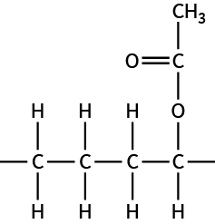 | 1 | Award mark if one end bond is missing.  Award mark if one end bond is shown with other end having a H in place of second end bond.  Allow dot or ~ to represent end bond.  Zero marks if both end bonds are missing/both ends have H/bond between two carbon missing.

Question |  |  | Expected response | Max mark | Additional guidance
7. | (a) | (i) | Sodium methanoate | 1
 |  | (ii) | Any value less than 7 | 1
 | (b) | (i) | Titration | 1
 |  | (ii) | Within 0·2 cm³ (of each other)  OR  The same | 1
 | (c) | (i) | Red | 1
 |  | (ii) | Ba²⁺SO₄²⁻ | 1 | Brackets, if included, must be in the correct place.

Question |  |  | Expected response | Max mark | Additional guidance
8. | (a) | (i) | Limewater | 1
 |  | (ii) | Same general formula  AND  Same/similar chemical properties | 1 | Award zero marks for - molecular formula - structural formula - chemical formula.  Award zero marks for - physical properties in place of chemical properties however, it does not negate if given in addition to chemical properties.
 |  | (iii) | C₄H₁₀ + 6∙5 O₂ → 4 CO₂ + 5H₂O | 1 | Accept correct multiples
 | (b) |  | Final temperature  70 with no working (4)  ----------------------------------  Partial marking  ∆T= correctly calculated  53 =76∙32/(0∙4 x 3∙6) (3)  -----------------------------------  Using the correct concept of  ∆T=E/mc  With both c = 3∙6 and Eh = 76∙32 correctly substituted (1)  0∙4 with or without concept (1)  Calculation of ∆T (1) provided concept mark has been awarded.  Calculation of final temperature T using incorrect ∆T (1) provided working is shown.  ----------------------------------- | 4 | No units required but a maximum of three marks can be awarded if wrong unit is given. (Wrong units are only penalised once in any paper)  76320 and 3600 can be used to together in the calculation.  See additional exemplification guidance.

Question |  |  | Expected response | Max mark | Additional guidance
9. | (a) | (i) | Ore/bauxite  filtration  aluminium hydroxide  aluminium oxide  All 4 for both marks  3 or 2 correct for 1 mark | 2 | Zero marks awarded for 1 correct entry.
 |  | (ii) | Arrow from bottom sodium hydroxide to top sodium hydroxide  OR  Arrow from lower aluminium hydroxide to upper aluminium hydroxide | 1 | See additional exemplification guidance.
 | (b) | (i) | Decomposition/breaking apart of an ionic compound (into its elements) using electricity | 1
 |  | (ii) | Allows the product(s) to be identified.  OR  To make sure that only one product is produced at each electrode.  OR  To separate the aluminium from the oxygen. | 1 | Award zero marks for  - allows ions to separate  - so each electrode stays the same charge  - so the electricity/current goes in the one direction
 |  | (iii) | Ions are free to move. | 1 | Award zero marks for electrons/ molecules/charged particles in place of ions.
 |  | (iv) | 4Al³⁺ + 6O²⁻ 4Al + 3O2  (or correct multiples)  All must be correct for 1 mark | 1 | Zero marks awarded for any electrons shown in equation. Ignore state symbols if given.

Question |  |  | Expected response | Max mark | Additional guidance
10. | (a) |  | Wolframite | 1
 | (b) |  | W₂O₃ | 1
 | (c) |  | Any temperature greater than or equal to 2870 ºC and lower than 6000 ºC | 1
 | (d) |  | 15∙785/15∙79/15∙8/16 (2 marks)  …………………………………………………………  Partial Marks  Density of titanium = 4∙51 (1 mark) | 2 | Density of tungsten × 3∙5  19∙3 × 3.5 = 67∙55 (1 mark)

Question |  |  | Expected response | Max mark | Additional guidance
11. | (a) |  | proton/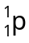/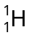/H/hydrogen | 1 | Zero marks for H₂
 | (b) | (i) | 5500-6000 years | 1 | Unit is not required however if the wrong unit is given do not award mark.  This marking instruction must only be applied a maximum of once per paper.
 |  | (ii) | 4 x candidate’s answer to (b) (i)  (2 marks)  ----------------------------------------  Partial marking:  1 mark can be awarded for either:  - 4 half-lives  OR  - number of years correctly calculated for an incorrect number of half-lives (provided the working supports the number of half-lives). | 2 | Allow follow through from (b) (i).  See additional exemplification guidance.  Unit is not required; however, a maximum of 1 mark can be awarded for the correct value with incorrect unit.  This marking instruction must only be applied a maximum of once per paper.
 |  | (iii) | There would be no C-14 left in the bone/levels of C-14 too small to measure/Half-life is too short | 1 | ‘It’ refers to C-14
12. | (a) |  | Hydrocarbons are compounds containing only hydrogen and carbon (atoms). | 1 | Must contain only.
 | (b) | (i) | Hydrogenation | 1
 |  | (ii) | Any acceptable alkene isomer. | 1 | See additional exemplification guidance.

Question |  |  | Expected response | Max mark | Additional guidance
12. | (c) |  | 115(g) (3 marks)  ----------------------------------------  Partial marks  Both GFMs  ie 23 and 70 (1 mark)  OR  Moles of cyclopentane  ie (175÷70) = 2∙5 mol (1 mark)  -----------------------------------  1 concept mark for either:  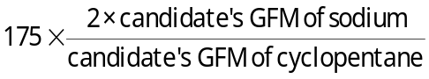  (1 mark)  OR  Moles of cyclopentane × (2 × candidate’s GFM of sodium)  (1 mark)  OR  Moles of cyclopentane × (1 × 23)  (1 mark)  ------------------------------------- -  Where the candidate has been awarded any concept mark, a further mark can be awarded for correct follow through to a final answer (1 mark) | 3 | No units required but a maximum of two marks can be awarded if an incorrect unit is given. This marking instruction must only be applied a maximum of once per paper.  Award zero marks if the candidate’s working does not use cyclopentane.  A maximum of two marks can be awarded where the candidate has carried out the calculation using cyclopentane and 1,5-dibromopentane provided working is shown.  An incorrect GFM, with no working shown, cannot be used to gain the concept mark and therefore arithmetical follow through cannot be accessed.  See additional exemplification guidance.
 | (d) |  | 4 | 1 | Unit is not required; however, a maximum of 1 mark can be awarded for the correct value with incorrect unit.  This marking instruction must only be applied a maximum of once per paper.

Question |  |  | Expected response | Max mark | Additional guidance
13. |  |  | This is an open ended question.  1 mark: The candidate has demonstrated a limited understanding of the chemistry involved. The candidate has made a/some statement(s) that is/are relevant to the situation, showing that at least a little of the chemistry within the problem is understood.  2 marks: The candidate has demonstrated a reasonable understanding of the chemistry involved. The candidate has made a/some statement(s) that is/are relevant to the situation, showing that the problem is understood.  3 marks: The candidate has demonstrated a good understanding of the chemistry involved. The candidate shows a good comprehension of the chemistry of the situation and has provided a logically correct answer to the question posed. This type of response might include a statement of the principles involved, a relationship or an equation, and the application of these to respond to the problem. This does not mean the answer has to be what might be termed an ‘excellent’ answer or a ‘complete’ one. | 3 | 0 marks: The candidate has demonstrated no understanding of the chemistry involved.  There is no evidence that the candidate has recognized the area of chemistry involved or has given any statement of a relevant chemistry principle.  This mark would also be given when the candidate merely restates the chemistry given in the question.

[END OF MARKING INSTRUCTIONS]

Exemplification of Marking Instructions

Marking – units in calculations
Where units are given in a question, there is no requirement for the candidate to include units in their answer.
If a candidate gives a wrong unit, this mark is not awarded only once per paper.
Centres are required to keep note of if and where this mark has not been awarded.

Scored out answers
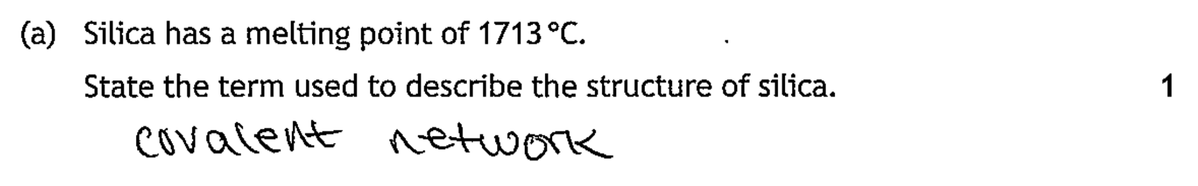
Although answer is scored out, a correct answer can be seen. There is nothing else written and so this mark can be awarded.

Formula writing
Symbols can be in any order. Numbers must be smaller than symbol or subscript. Symbols must be correct. Zero marks awarded for; e.g.
C35 H72
c₃₅ H₇₂
C35 h72
c35 h72

Open ended questions
In terms of best practice, allocation of marks to open-ended questions can be done in a collegiate manner where benchmarks can be set using the live candidate evidence. This will allow practitioners to have a better understanding of what a 1, 2 or 3 mark answer may look like. It is advisable to refer to SQA Understanding Standards materials for further exemplification.

Exemplification for Question 2(a)
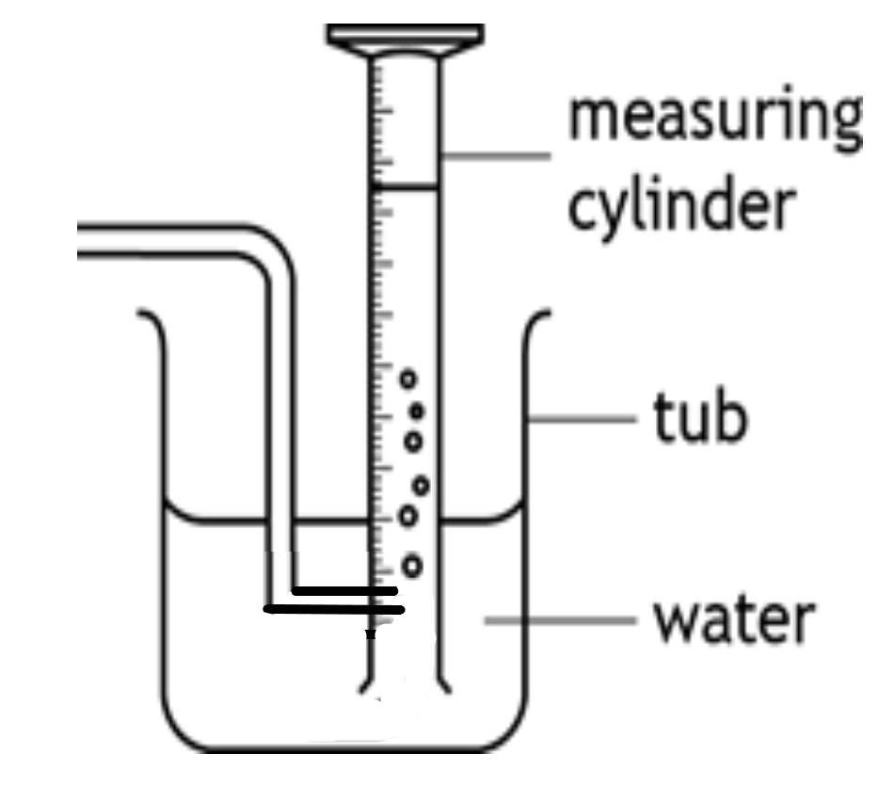Zero marks would be awarded as this experimental set up would not work.
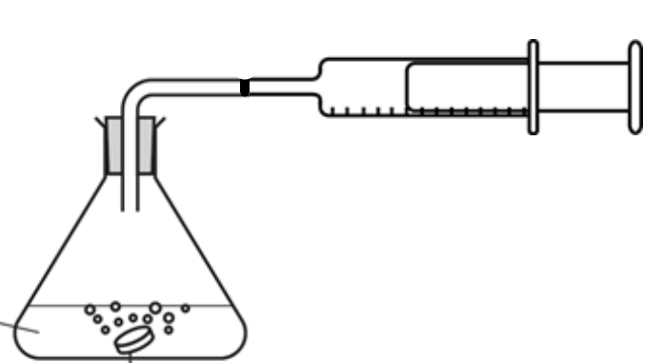Zero marks would be awarded as delivery tube is bi-sected.

Exemplification of Question 3 (c) (i)

Example 1
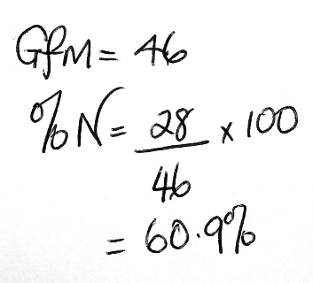
2 marks
0 mark for incorrect GFM
1 mark for $\frac{\text{28}}{\text{candidat}{\text{e}}^{\text{'}}\text{s GFM}}$ x 100
1 mark for the final answer as they have used the relationship
% by mass =

Example 2
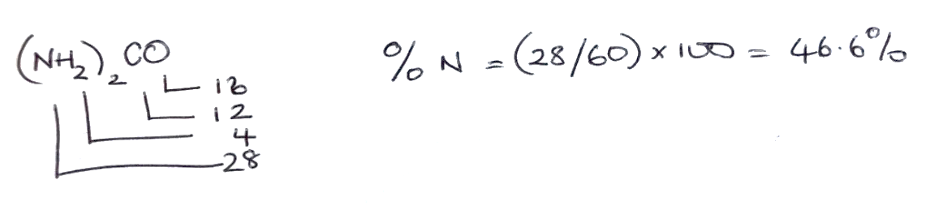

2 marks
1 mark for correct GFM
1 mark for
0 mark for answer due to incorrect rounding

Example 3
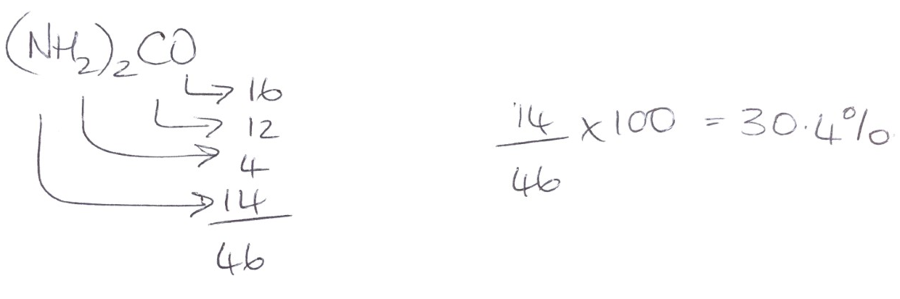
2 marks
0 marks for incorrect GFM
1 mark for $\frac{\text{14}}{\text{46}}$ x 100 as incorrect mass of N from GFM working has been used correctly
1 mark for final answer as concept correctly used.

Exemplification of Question 4(b)
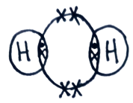 | 1 mark. Symbol is missing for sulfur, but as hydrogen atoms have symbols the mark can be awarded.
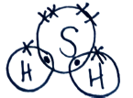 | 0 marks. Bonding electrons are out-with the overlap region and therefore the mark would not be awarded.
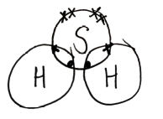 | 1 mark. Both pairs of bonding electrons are within the overlap region and the mark would therefore be awarded.
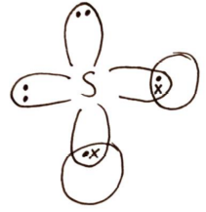 | 1 mark. Petal diagram is an acceptable format, and as symbol for one of the elements, sulfur, has been given.
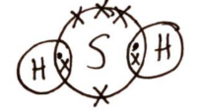 | 1 mark. Non-bonding electrons are unpaired; this is acceptable.
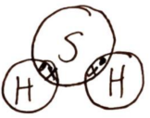 | 0 marks. Non-bonding electrons on sulfur have not been shown. No mark can be awarded.
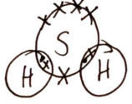 | 0 marks. Sulfur has an extra electron so mark cannot be awarded

Exemplification for Question 4 (e) (i)
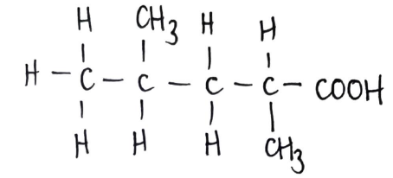 | 1 mark. A mixture of full and shortened structural formula is acceptable.
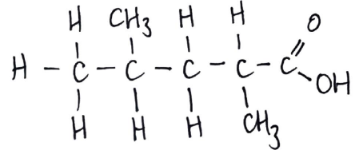 | 0 marks. The bond connectivity of the methyl group on carbon number 4 is incorrect and the mark would therefore not be awarded.
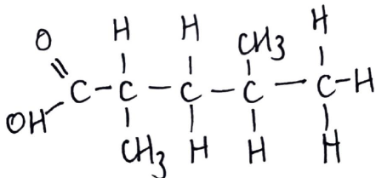 | 0 marks. The bond connectivity of the hydroxyl of the carboxyl group is incorrect.
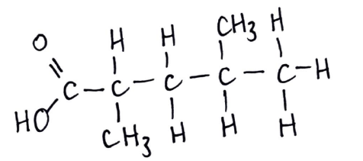 | 0 marks. The bond connectivity of the methyl group on carbon number 2 is questionable. It is closer to the hydrogen than the carbon.

Exemplification of Question 6 (a) (i)

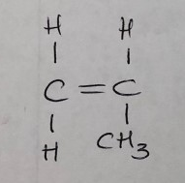

0 marks. Bond to CH₃ group not going to C of CH₃.

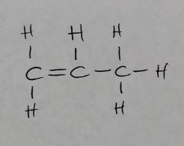

1 mark. Correctly drawn structure of propene
although not in usual monomer format.
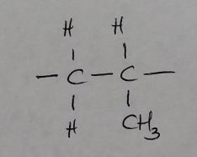

0 marks. A repeating unit is not acceptable. The
monomer must be shown with the C=C.

Exemplification of Question 6 (a) (ii)

Graph 1
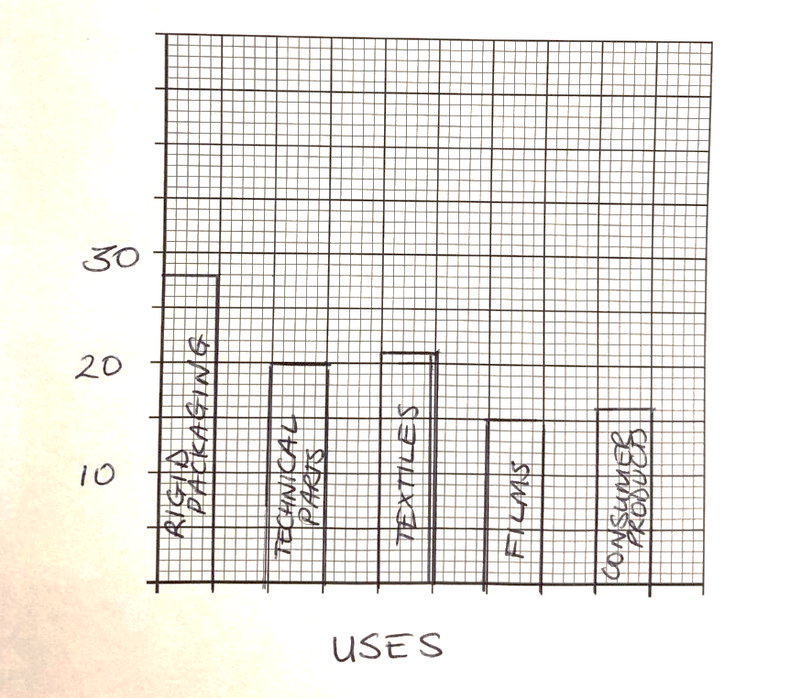
2 marks

1 mark for correct type – bars plotted.
1 mark for scales
0 mark for labels (missing y-axis label)
0 mark for plotting (films and consumer packaging wrongly plotted)
Graph 2
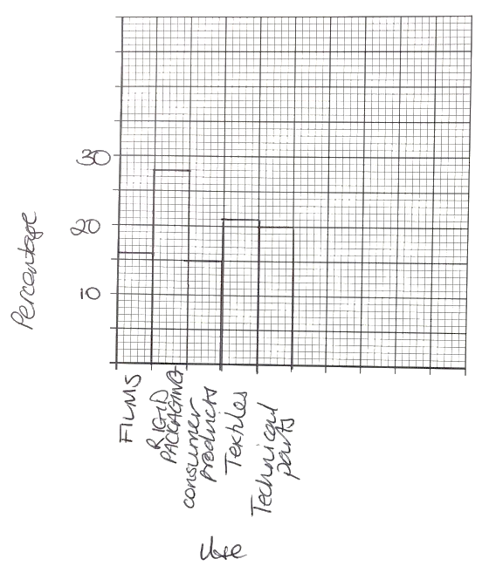
3 marks

1 mark for correct type – bars plotted.
0 mark for scales – last bar is not past the midway point of the graph paper
1 mark for labels
1 mark for plotting

Graph 3
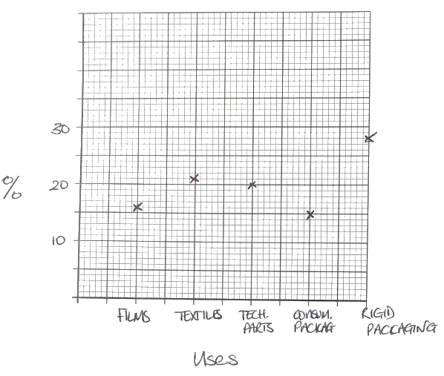

3 marks

0 mark for correct type – points plotted rather than bars
1 mark for scales
1 mark for labels
1 mark for plotting

Exemplification of Question 8 (b)
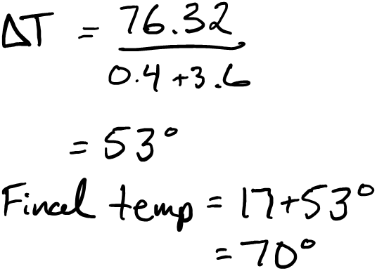
Example 1
3-marks.
1 mark deducted for incorrect unit (applied once in paper)

Example 2
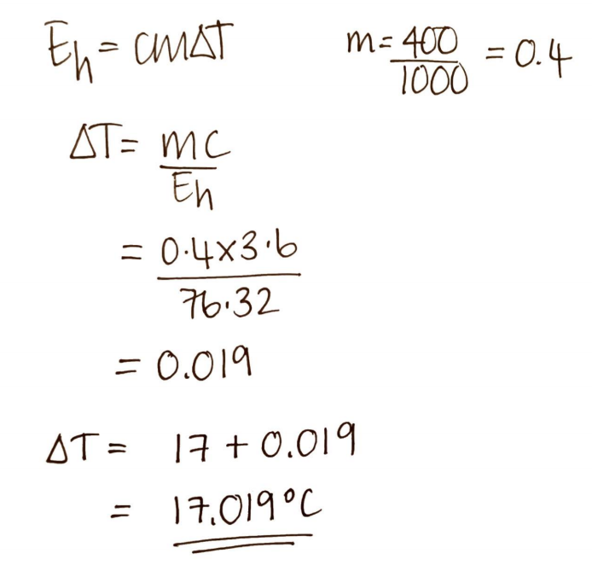
2 marks.
1 mark for correct mass in kg and 1 mark for correct final temperature calculation using incorrect delta T. Concept mark not awarded.

Example 3

3 marks.
Correct mass, concept and correct final temperature calculation using incorrect ΔT value.

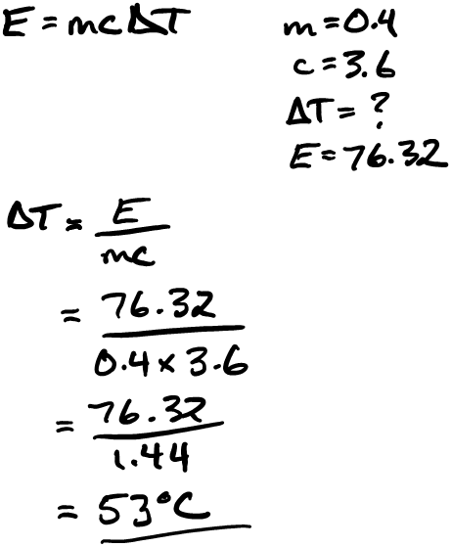
Example 4

3 marks.
Final temperature not calculated.

Example 5
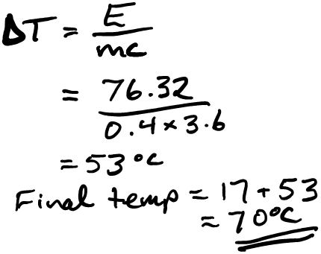
4 marks.

Example 6
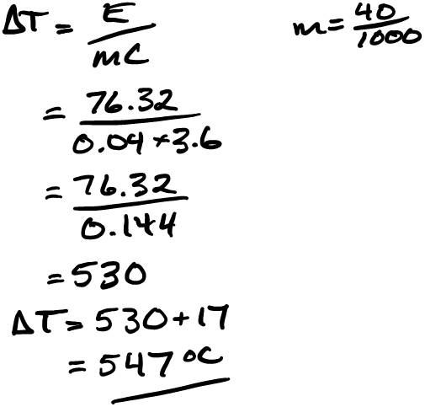
3 marks.
Incorrect mass used but concept and calculations are correct.

Example 7
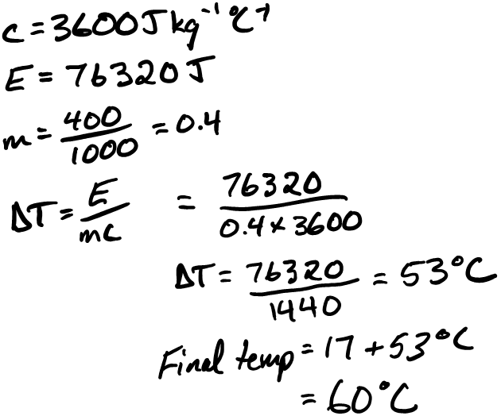
3 marks.
Final temperature calculation incorrect.

Exemplification of Question 9 (a) (ii)
Example 1
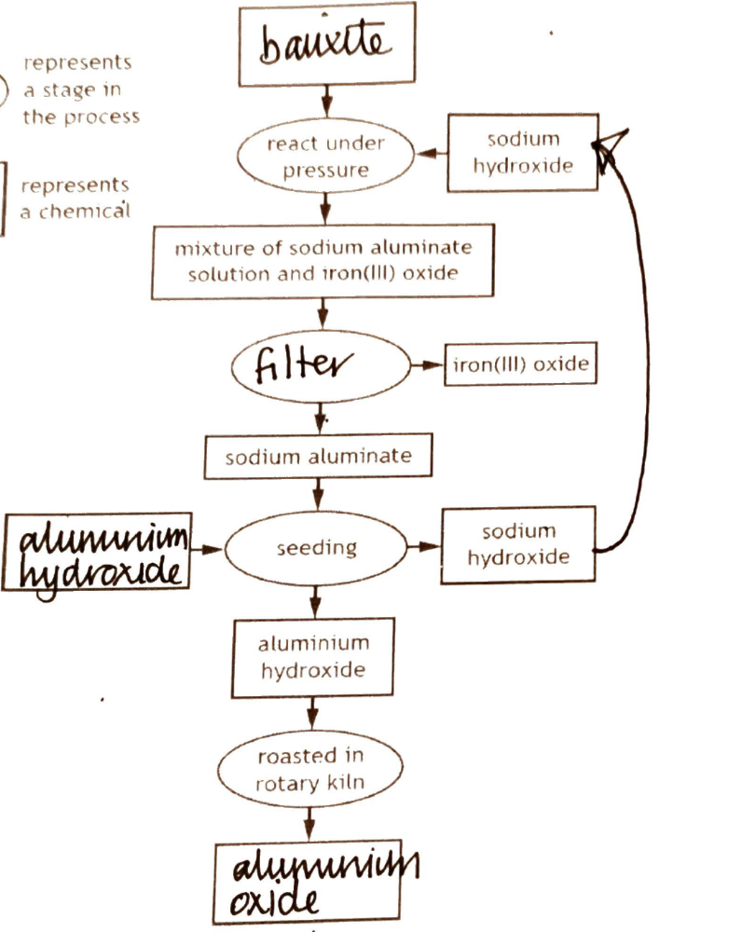

1 mark.

Example 2
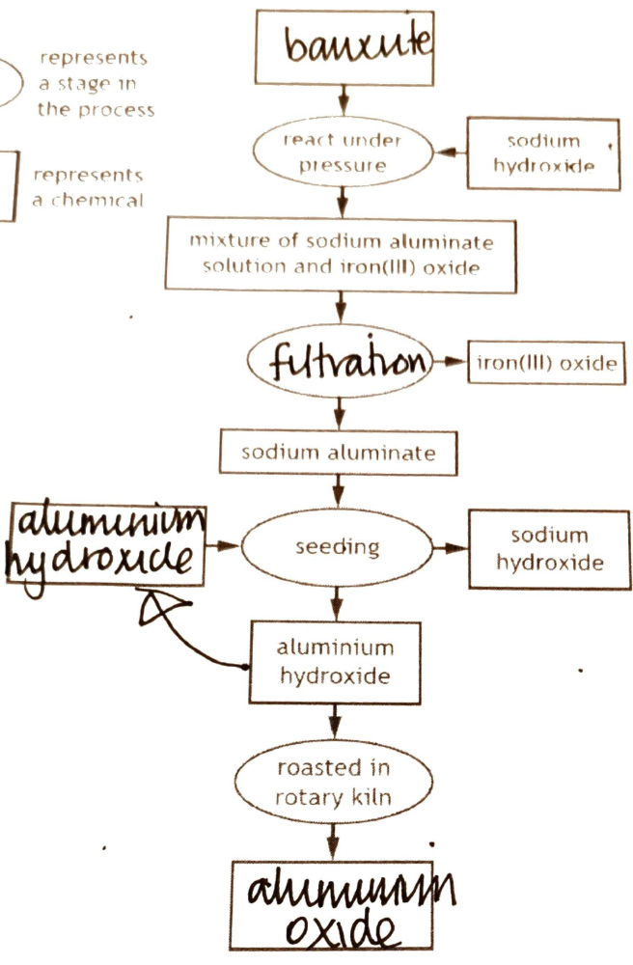

1 mark.

Exemplification of Question 11 (b) (i) and (ii)
Example 1
11(b) (i)
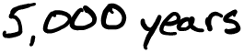
0 marks

11(b) (ii)
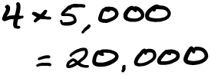
2-marks. Follow through of incorrect value with correct number of half-lives.

Example 2
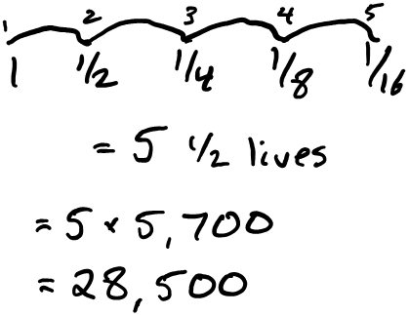
1mark. Incorrect number of half-lives used.

Example 3
11(b) (i)
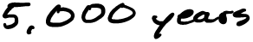
11(b) (ii)
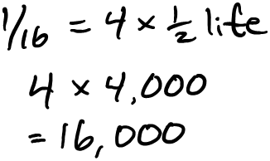
1 mark. Correct number of half lives, incorrect half-life used from b(i) should be 5,000.
Exemplification of Question 12 b (ii)
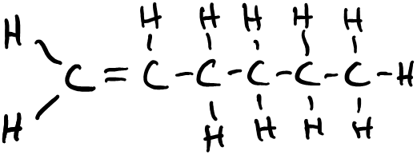
1 mark

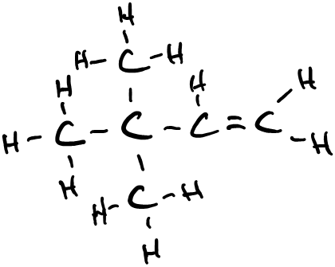
1 mark

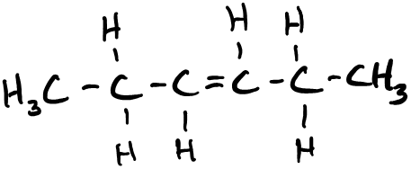
1 mark

Exemplification of Question 12 (c)
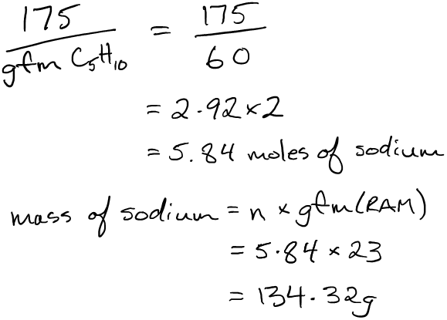
Example 1
2-marks. Incorrect GFM of cyclopentane used, all other calculations correct.

Example 2
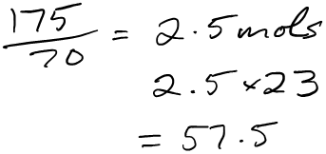
2-marks. Number of moles and concept mark but 2:1 ratio of sodium:cyclopentane not used. Unit not required.

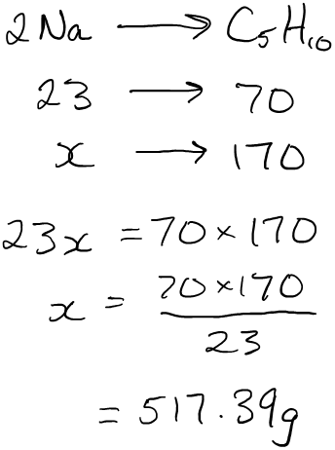
Example 3
1 mark.
Correct GFMs used. Incorrect concept.

Example 4
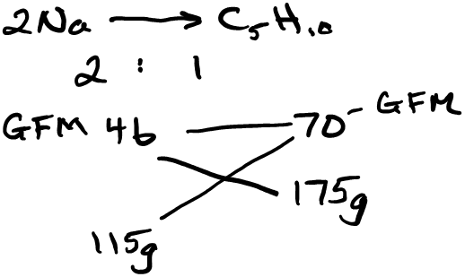
3 marks.

Example 5
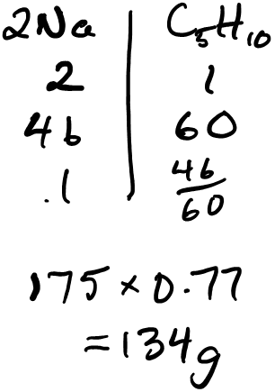
2 marks.
Incorrect GFM for cyclopentane used.
Concept mark awarded for applying concept of 174 x (2 x candidates GFM Na / candidates incorrect GFM of cyclopentane.)

2020 National 5 Chemistry Question Paper breakdown

This document provides the structure of the 2020 questions in Section 1 and Section 2 by Key Area; Knowledge/Skill; intended grade A marks.

Section 1
Question | Key Area of Course | Question Type | Grade A
1 | Periodic Table and atoms | Applying knowledge to new situations, interpreting, solving problems
2 | Periodic Table and atoms | Applying knowledge to new situations, interpreting, solving problems
3 | Covalent bonding | Applying knowledge to new situations, interpreting, solving problems
4 | Chemical formulae | Applying knowledge to new situations, interpreting, solving problems
5 | Chemical formulae | Applying knowledge to new situations, interpreting, solving problems
6 | Chemical formulae | Applying knowledge to new situations, interpreting, solving problems
7 | pH | Applying knowledge to new situations, interpreting, solving problems
8 | pH | Applying knowledge to new situations, interpreting, solving problems
9 | pH | Applying knowledge to new situations, interpreting, solving problems
10 | Reporting experimental work | Drawing conclusions and giving explanations
11 | Alkenes | Drawing conclusions and giving explanations | 1
12 | Systematic carbon chemistry | Applying knowledge to new situations, interpreting, solving problems
13 | Alkanes | Applying knowledge to new situations, interpreting, solving problems | 1
14 | Systematic carbon chemistry | Applying knowledge to new situations, interpreting, solving problems
15 | Non-specific | Drawing conclusions and giving explanations
16 | Alkenes | Applying knowledge to new situations, interpreting, solving problems
17 | Carboxylic acids | Applying knowledge to new situations, interpreting, solving problems
18 | Neutralisation reactions | Applying knowledge to new situations, interpreting, solving problems
19 | General practical techniques | Applying knowledge to new situations, interpreting, solving problems
20 | Non-specific | Drawing conclusions and giving explanations | 1
21 | Redox | Applying knowledge to new situations, interpreting, solving problems
22 | Electrochemical cells | Applying knowledge to new situations, interpreting, solving problems
23 | Radiation | Knowledge and understanding - making statements
24 | Haber and Ostwald processes | Knowledge and understanding - making statements | 1
25 | General practical techniques | Processing information (using calculations and units)

Section 2
Question | Area of Course | Question Type | Grade A
1a(i) | Periodic table and atoms | Knowledge and understanding - making statements
1a(ii) | Periodic table and atoms | Applying knowledge to new situations, interpreting, solving problems
1b | Periodic table and atoms | Applying knowledge to new situations, interpreting, solving problems
1c | Covalent bonding | Applying knowledge to new situations, interpreting, solving problems | 1
2a | General practical techniques | Planning or designing experiments
2b(i) | Rates of reaction | Applying knowledge to new situations, interpreting, solving problems
2b(ii) | Rates of reaction | Applying knowledge to new situations, interpreting, solving problems
2c(i) | Rates of reaction | Applying knowledge to new situations, interpreting, solving problems
2c(ii) | Rates of reaction | Drawing conclusions and giving explanations
2c(iii) | Rates of reaction | Knowledge and understanding - descriptions and explanations | 1
3a | Rates of reaction | Knowledge and understanding - making statements
3b(i) | Commercial production of fertilisers | Knowledge and understanding - making statements
3b(ii) | Commercial production of fertilisers | Applying knowledge to new situations, interpreting, solving problems
3c(i) | Percentage composition | Applying knowledge to new situations, interpreting, solving problems | 1
3c(ii) | Common chemical apparatus | Planning or designing experiments
4a | Non-specific | Selecting information
4b | Covalent bonding | Applying knowledge to new situations, interpreting, solving problems
4c | Calculations involving the mole and balanced equations | Processing information (using calculations and units) | 1
4d | Alcohols | Knowledge and understanding - making statements
4e(i) | Carboxylic acids | Drawing conclusions and giving explanations
4e(ii) | Alkanes | Drawing conclusions and giving explanations
4f | Alkenes | Knowledge and understanding - making statements
5 | Metallic bonding, reactions of metals, extraction of metals | Knowledge and understanding - descriptions and explanations | 2
6a(i) | Addition polymerisation | Applying knowledge to new situations, interpreting, solving problems
6a(ii) | Non-specific | Presenting information appropriately in a variety of forms | 1
6b(i) | Addition polymerisation | Knowledge and understanding - making statements

Section 2 | (continued)
Question | Area of Course | Question Type | Grade A
6b(ii) | Representation of the structure of monomers and polymers | Drawing conclusions and giving explanations | 1
7a(i) | Carboxylic acids | Applying knowledge to new situations, interpreting, solving problems
7a(ii) | Neutralisation reactions | Making predictions and generalisations based on evidence/information
7b(i) | Neutralisation reactions | Knowledge and understanding – making statements
7b(ii) | Analytical methods | Knowledge and understanding – making statements
7c(i) | Analytical methods | Selecting information
7c(ii) | Chemical formulae | Applying knowledge to new situations, interpreting, solving problems
8a(i) | Analytical methods | Knowledge and understanding - making statements
8a(ii) | Systematic carbon chemistry | Knowledge and understanding - making statements
8a(iii) | Calculations involving the mole and balanced equations | Applying knowledge to new situations, interpreting, solving problems, Presenting information appropriately in a variety of forms
8b | Energy from fuels | Applying knowledge to new situations, interpreting, solving problems | 2
9a(i) | Non-specific | Processing information (using calculations and units) | 1
9a(ii) | Non-specific | Suggesting improvements to experimental procedures
9b(i) | Extraction of metals | Knowledge and understanding - making statements | 1
9b(ii) | Extraction of metals | Knowledge and understanding - descriptions and explanations | 1
9b(iii) | Ionic compounds | Knowledge and understanding - making statements
9b(iv) | Redox | Applying knowledge to new situations, interpreting, solving problems | 1

Section 2 | (continued)

 | Question |  | Area of Course |  | Question Type |  | Grade A
10a |  | Non-specific |  | Selecting information
10b |  | Chemical formulae |  | Applying knowledge to new situations, interpreting, solving problems
10c |  | Non-specific |  | Drawing conclusions and giving explanations
10d |  | Non-specific |  | Selecting information, Processing information (using calculations and units) |  | 1
11a |  | Nuclear equations |  | Drawing conclusions and giving explanations |  | 1
11b(i) |  | Half-life |  | Processing information (using calculations and units)
11b(ii) |  | Half-life |  | Applying knowledge to new situations, interpreting, solving problems
11b(iii) |  | Use of radioactive isotopes |  | Drawing conclusions and giving explanations |  | 1
12a |  | Systematic carbon chemistry |  | Knowledge and understanding - making statements
12b(i) |  | Alkenes |  | Applying knowledge to new situations, interpreting, solving problems |  | 1
12b(ii) |  | Systematic carbon chemistry |  | Processing information (using calculations and units) |  | 1
12c |  | Calculations involving the mole and balanced equations |  | Applying knowledge to new situations, interpreting, solving problems |  | 1
12d |  | Cycloalkanes |  | Processing information (using calculations and units)
13 |  | Neutralisation reactions used to prepare soluble salts, analytical methods, reporting experimental work |  | Knowledge and understanding - descriptions and explanations |  | 2

