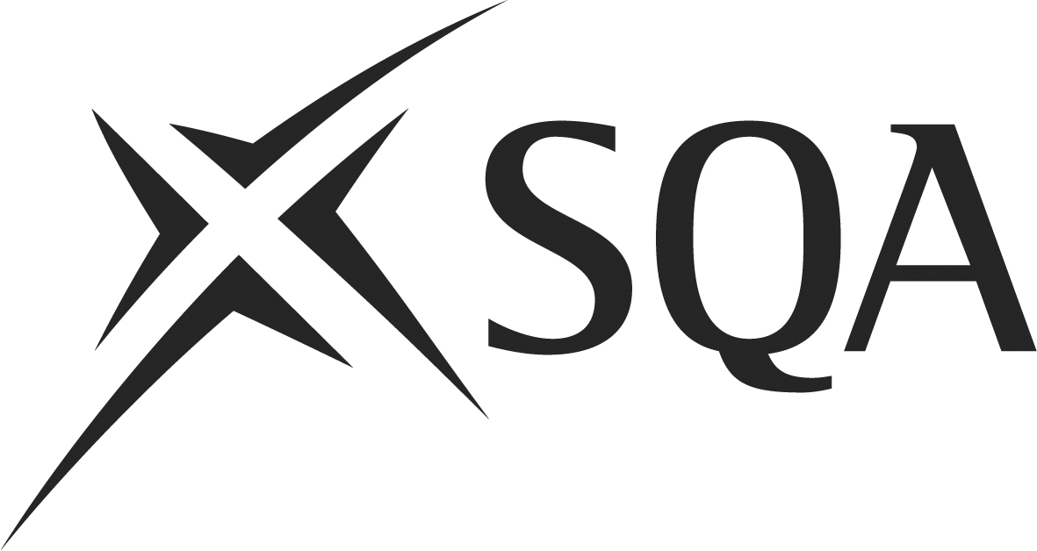

Unit DR7R 04 (281) Prepare and Clear Areas for Counter/Takeaway Service

Unit Summary

This Unit is about preparing work areas and service equipment, and displaying promotional materials and food properly. It also covers clearing these areas, including switching off service equipment, storing condiments, and disposing of rubbish.

In order to be assessed as competent you must demonstrate to your assessor that you can consistently perform to the requirements set out below. Your performance evidence must include at least one observation by your assessor.

Achievement of this Unit will provide you with opportunities to develop the following SQA Core Skills:

Communication Access 3
- Read and understand simple written communication.
- Produce simple written communication.

Numeracy Access 3
- Apply simple numerical skills in everyday contexts.

Problem Solving Access 3
- Analyse a simple situation or issue.
- Plan, organise and complete a simple task.

I have completed the requirements of this Unit.

Candidate name: |  | Date:
Candidate signature: |  | Date:
I can confirm the candidate has completed all requirements of this Unit.

Assessor signature: |  | Date:
IV signature: |  | Date:
Assessment centre:
Unit DR7R 04 (281) Prepare and Clear Areas for Counter/Takeaway Service

You must be able to |  | Evidence Requirements  In order to be assessed as competent you must demonstrate to your assessor that you can consistently perform to the requirements set out below. Your performance evidence must include at least one observation by your assessor.  Your evidence must be work-based, simulation alone is only allowed where shown in bold italics | Evidence/  Activity  Ref No.
1 | Prepare areas for counter/takeaway service  This means you:  (a) Check that the work area and service equipment are hygienic, free from damage and prepared ready for use.  (b) Check that sufficient stocks of service items are clean, free from damage and arranged ready for service.  (c) Switch on appropriate service equipment in time to reach the recommended operating temperature.  (d) Where appropriate, prepare and display condiments and accompaniments ready for service.  (e) Display promotional materials ready for customer use.  (f) Check that refuse and waste food containers are clean and ready for use.  (g) Display food immediately before service, in line with operational procedures. | Evidence of preparing areas for counter/takeaway service in accordance with workplace procedures.
2 | Clear areas for counter/takeaway service  This means you:  (a) Deal with service equipment according to your workplace procedures.  (b) Assemble for cleaning or store any reusable service items from the food service.  (c) Where appropriate, store condiments and accompaniments for future use in line with food hygiene legislation.  (d) Dispose of rubbish, used disposables and waste food following recommended procedures. | Evidence of clearing areas for counter/takeaway service in accordance with workplace procedures.

Unit DR7R 04 (281) Prepare and Clear Areas for Counter/Takeaway Service

 |  | Evidence Requirements (cont)
2 (cont) | (e) Check that the work area and service equipment are clean, free from damage and ready for future use.

Unit DR7R 04 (281) Prepare and Clear Areas for Counter/Takeaway Service

Evidence of Performance

Evidence of performance may employ examples of the following assessment:
- observation
- written and oral questioning
- evidence from company systems (eg Food Safety Management System)
- reviewing the outcomes of work
- checking any records of documents completed
- checking accounts of work that the candidate or others have written

Unit DR7R 04 (281) Prepare and Clear Areas for Counter/Takeaway Service

Candidate name: |  | Assessor initials/date
No | Activity | Assessor initials/date
1
2
Unit DR7R 04 (281) Prepare and Clear Areas for Counter/Takeaway Service

You need to know and understand  Evidence of knowledge and understanding should be collected during observation of performance in the workplace. Where it cannot be collected by observing performance, other assessment methods should be used. |  | Evidence
K1 | Safe hygienic working practices when preparing takeaway areas for counter/takeaway service and why these are important.
K2 | Why waste must be handled and disposed of correctly.
K3 | Why presentation standards must be maintained in the display of food.
K4 | How to display hot and cold food safely and why this is important.
K5 | Why it is important to check expiry dates on appropriate food and drink items
K6 | Why all promotional materials should be checked before use.
K7 | Why it is important to have the correct serving equipment available for service.
K8 | The types of unexpected situations that may occur when preparing areas and how to deal with these.
K9 | Safe and hygienic working practices when clearing areas for counter/takeaway and why these are important.
K10 | Why certain electrical and gas equipment should be turned off after service.
K11 | Why waste must be handled and disposed of correctly.
K12 | Why all perishable food and drink items should be returned to the kitchen and storage area immediately after service.
K13 | Why all service areas should be left clean after service.
K14 | The types of unexpected situations that may occur when clearing areas and how to deal with these.

Notes/Comments

Assessor signature: |  |  |  | Date:

