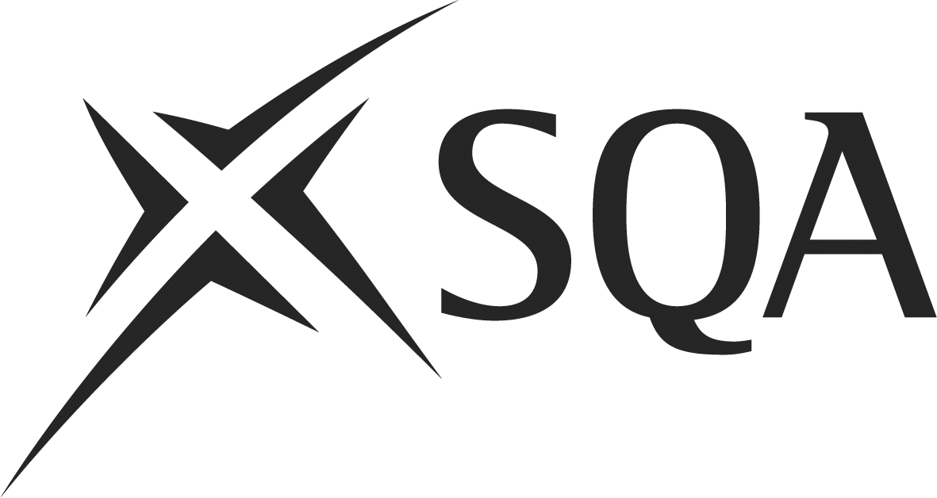

Unit F2JW 04 (534) Control and Monitor Safe Supply of Raw Materials and Ingredients in Food Manufacture

Unit Summary

ThisUnit is about ensuring that sources and supplies of food and drink products are safe. It involves controlling and monitoring the supply of raw materials and ingredients.

In order to be assessed as competent you must demonstrate to your assessor that you can consistently perform to the requirements set out below. Your performance evidence must include at least one observation by your assessor.

Achievement of this Unit will provide you with opportunities to develop the following SQA Core Skills:

Communication Intermediate 2
Read, understand and evaluate written communication.

Problem Solving Intermediate 2
- Analyse a situation or issue.
- Plan, organise and complete a task.
- Review and evaluate a problem solving activity.

I have completed the requirements of this Unit.

Candidate name: |  | Date:
Candidate signature: |  | Date:
I can confirm the candidate has completed all requirements of this Unit.

Assessor signature: |  | Date:
IV signature: |  | Date:
Assessment centre:
Unit F2JW 04 (534) Control and Monitor Safe Supply of Raw Materials and Ingredients in Food Manufacture

You must be able to |  | Evidence Requirements  In order to be assessed as competent you must demonstrate to your assessor that you can consistently perform to the requirements set out below. Your performance evidence must include at least one observation by your assessor.  Your evidence must be work-based, simulation alone is only allowed where shown in bold italics | Evidence/  Activity  Ref No.
1 | Take responsibility for the acceptance of supplies  This means you:  (a) Check that the supplies conform to your organisation’s specifications.  (b) Undertake all checks relating to packaging design and materials.  (c) Accept only those supplies which meet the specified criteria.  (d) Report and take relevant action if there are any deficiencies or discrepancies in the supplies. | Evidence of taking responsibility for the acceptance of supplies in accordance with workplace procedures.
2 | Keep accurate records  This means you:  (a) Check that all relevant documentation is complete and accurate.  (b) Record all information in line with supplier auditing requirements. | Evidence of keeping accurate records in accordance with workplace procedures.
3 | Contribute to improving the supply  This means you:  (a) Make recommendations, where appropriate, which will improve the quality and/or efficiency of supply. | Evidence of contributing to improving the supply in accordance with workplace procedures.
Unit F2JW 04 (534) Control and Monitor Safe Supply of Raw Materials and Ingredients in Food Manufacture

Evidence of Performance

Evidence of performance may employ examples of the following assessment:
- observation
- written and oral questioning
- evidence from company systems (eg Food Safety Management System)
- reviewing the outcomes of work
- checking any records of documents completed
- checking accounts of work that the candidate or others have written

Unit F2JW 04 (534) Control and Monitor Safe Supply of Raw Materials and Ingredients in Food Manufacture

Candidate name: |  | Assessor initials/date
No | Activity | Assessor initials/date
1
2
3
Unit F2JW 04 (534) Control and Monitor Safe Supply of Raw Materials and Ingredients in Food Manufacture

You need to know and understand  Evidence of knowledge and understanding should be collected during observation of performance in the workplace. Where it cannot be collected by observing performance, other assessment methods should be used. |  | Evidence
K1 | The policies, guidelines and legislation relating to sources and supply of raw materials, relevant to your workplace and products.
K2 | Your organisation’s supplier assurance guidelines, policies, audit requirements, and how they are applied.
K3 | The types and sources of relevant raw materials and ingredients.
K4 | The agreed criteria for acceptance and non-acceptance of supplies required for products.
K5 | The critical control points for transport, receipt and acceptance of supplies.
K6 | The control and sampling methods appropriate to type and source of supply and how they are applied.
K7 | The potential methods, sources and types of product contamination, how to identify them and relevant corrective action.
K8 | The range of relevant checks to ensure food safety assurance of supplies.
K9 | The record systems and requirements for audit of supply.
K10 | The relevant requirements for certificates of conformity.
K11 | The relevant requirements for traceability purposes.
K12 | The corrective actions you can take if you receive a supply of non-conforming products or raw materials.

Notes/Comments

Assessor signature: |  |  |  | Date:

