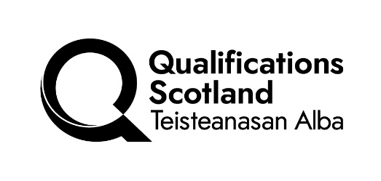 |  |  | GROUP AWARD VALIDATION REPORT

The Qualifications Scotland representative at a centre validation event should return this form, with all sections completed, within one week of the meeting/event.

Group Award Title(s) including product type ie. HNC/ PDA etc BC.ID _______

VALIDATION MEETING DETAILS

Date of validation meeting

Validation Meeting Host – Qualification Scotland / Centre

PANEL MEMBERSHIP
Name |  | Education / Industry / Other |  | Contact address / telephone /  e-mail

VALIDATION PANEL OUTCOME

Panel Decision (tick as appropriate)
Validated - Proceed to Operationalisation
Not validated until conditions have been met - do not proceed to Operationalisation

DD MM YY
Conditions to be met by: / /

DD MM
Recommended review date: Session /

DETAILS of CONDITION(S) - Where conditions have been set, they should be listed in the validation report under the appropriate criterion heading. Please use additional pages as required. Supplementary sheets should be titled as per the award and numbered as supplementary pages ie. 1 of _ etc).

 | Yes | No
- The qualification conforms to our design rules and principles and other technical requirements which are current at the time of its validation.
- There is a demonstrable need for the qualification which fills a gap in the qualifications framework and makes a valuable and unique contribution to our portfolio of qualifications.
- The qualification is accessible to all candidates who could potentially achieve it.
- The qualification requires a candidate to demonstrate significant, achievable outcomes in a recognised curricular or vocational area.

- The qualification is coherent and its title accurately reflects its content.

Graded Units (HN only) - The content meets the aims of the Group Award to which it contributes.

Mechanism agreed for lifting conditions.
A revised Validation Proposal Document being considered by:

the Qualifications Scotland Officer only
or
the Qualifications Scotland Officer and chairperson

RECOMMENDATIONS – this section should be used to record any suggestions made by the validation panel that are not essential to the integrity of the Group Award but may be helpful to include in the validated document. Please note, unlike conditions, these do not have to be met before the qualification can be validated.

SIGN-OFF – written confirmation must be provided by the listed people to confirm it was an accurate record of the decisions agreed by the validation panel. This can either be on the form itself or an e-mail attachment.
Report drafted by:

Chairperson |  | Date
Centre rep (if host) |  | Date
QualScot Officer |  | Date

This form, with all sections completed, should be returned within one week of the validation panel meeting to:

The Qualifications Scotland Lead Officer

and
Qualifications Portfolio Management Team
Scottish Qualifications Authority
The Optima Building
58 Robertson Street
Glasgow
G2 8DQ
or e-mail to qpmteam@qualifications.gov.scot

LIFTING CONDITIONS - upon receipt of the Group Award specification, the original validation report should be sent along with the document to the person(s) responsible for lifting conditions.
Date revised Group Award specification received
I do agree to conditions being lifted /I do not agree to conditions being lifted for the reason(s) below (*delete as appropriate)

QualScot Officer |  |  | Date
Chairperson |  |  | Date
Please return completed form to the Qualifications Scotland Lead Officer and Qualifications Portfolio Management Team

Template: February 2026

