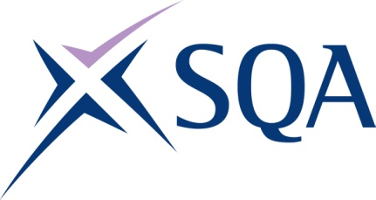
GV2D 46 | Diploma in Digital Technology: Software Development at SCQF Level 6

To attain the qualification candidates must complete 9 Units in total. This comprises:

- 9 mandatory Units

Please note the table below shows the SSC identification codes listed alongside the corresponding SQA Unit codes. It is important that the SQA Unit codes are used in all your recording documentation and when your results are communicated to SQA.

Mandatory Units: Candidates must complete all 4 Units from this group
SQA code | SSC code | Title | SCQF level | SCQF credits
J7FD 46 | SDS261 | Applying Problem Solving Approaches | 6 | 6
J7FF 46 | SDS262 | Producing Documentation to Support Organisational Process Delivery | 6 | 7
J7FG 46 | SDS263 | Defining Requirements to Support Project Delivery | 6 | 7
J7FH 46 | US0194 | Developing Meta-Skills and Personal Practice | 6 | 5

Software development pathway - TOTAL 9 Units, complete all five mandatory units
SQA code | SSC code | Title | SCQF level | SCQF credits
J7FX 46 | SDS242 | Supporting Software Design | 6 | 10
J7FY 46 | SDS240 | Contributing to Implementing Software Development Methodologies | 6 | 9
J7GB 46 | SDS243 | Supporting Software Solution Development | 6 | 14
J7G0 46 | SDS241 | Providing Support for Deployed Software Solutions | 6 | 8
J7G1 46 | SDS239 | Contributing to Deploying Software Solutions | 6 | 10

