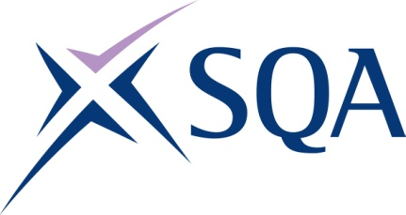

Group Award Title: SVQ Beauty Therapy at
SCQF level 5

Group Award Code: GW2E 22

SCQF overall credit: Minimum: 61 Maximum: 69
To attain the qualification, candidates must complete nine units and one optional unit. This consists of:
- eight mandatory units, and
- one unit from optional section
Please note the following tables show the SSC identification codes listed alongside the corresponding SQA unit codes. It is important that SQA unit codes are used in all your recording documentation, and when your results are communicated to SQA.
Mandatory units: Candidates must complete eight units:
SQA code | SSC code/  SDS code | Title | SCQF  level | SCQF  Credit points | SQA  Unit credits
J7N7 04 | SKAHDBRBNST1 | Implement and Maintain Safe, Hygienic and Effective Working Practices | 6 | 1 | 7
J7N5 04 | SKAHDBRBNS1 | Consult, Assess, Plan and Prepare for Hair, Barbering, Beauty, Nails, Wellbeing and Holistic Services | 6 | 1 | 7
J9D6 04 | SKABBR2 | Provide Facial Skincare Treatments | 5 | 1 | 10
J9D7 04 | SKAB1 | Provide Eyelash and Eyebrow Treatments | 5 | 1 | 6
J9D8 04 | SKAB2 | Provide Customised Make-up Services | 5 | 1 | 6
J9D9 04 | SKABBR1 | Provide Waxing Treatments for the Face and Body | 5 | 1 | 7
J9DA 04 | SKABN1 | Provide Manicure Treatments | 5 | 1 | 7
J9DC 04 | SKABN2 | Provide Pedicure Treatments | 5 | 1 | 7
Optional section: the candidate must select one unit from the optional section.
SQA code | SSC code/  SDS code | Title | SCQF  level | SCQF  Credit points | SQA  Unit credits
J9DD 04 | SKAB7 | Provide Threading Treatments | 5 | 1 | 7
J7NP 04 | SKAHDBRBNS2 | Provide Basic Business Support and Services | 5 | 1 | 10
J9DF 04 | SKABBR3 | Provide Non-Strip Waxing Treatments for Nostrils, Ears and Eyebrow Hair | 5 | 1 | 9
J7NR 04 | SKAHDBRBNS3 | Instruct and Advise on Products and Services | 5 | 1 | 8
J9DM 04 | SKAB4 | Provide Body Massage Treatments Using Fundamental Techniques | 6 | 1 | 12
J9DJ 04 | SKAB8 | Provide Manual and Spray Tanning Treatments | 5 | 1 | 4
J9DK 04 | SKAB3 | Provide Semi-Permanent Eyelash Lifting and Brow Lamination Procedures | 5 | 1 | 7
J9DL 04 | SKABN3 | Provide UV Cured Nail Product Services | 5 | 1 | 9

Additional credit rating information
SVQ consists of eight mandatory units plus one optional unit. Mandatory section — six units at level 5 = 43 credits and two units at level 6 = 14 credits. (Mandatory section total 57 credits). Plus one optional unit -— minimum 4 credits and maximum 12 credits. Overall minimum 61 credits and overall maximum 69 credits. The majority of the credits from the mandatory section are at SCQF level 5, giving an overall level of SCQF level 5.
Template version: May 2025

