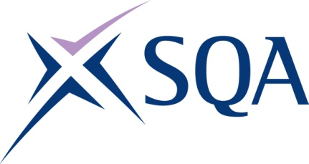

Group Award Title: SVQ Beauty Therapy at
SCQF level 6

Group Award Code: GW2F 23

SCQF overall credit: Minimum: 71 Maximum: 82
To attain the qualification, candidates must complete eight units and three optional unit. This consists of:
- five mandatory units, and
- three optional units
Please note the following tables show the SSC identification codes listed alongside the corresponding SQA unit codes. It is important that SQA unit codes are used in all your recording documentation, and when your results are communicated to SQA.
Mandatory units: Candidates must complete five units:
SQA code | SSC code/  SDS code | Title | SCQF  level | SCQF  Credit points | SQA  Unit credits
J9D4 04 | SKAHDBRBNST1 | Implement and Maintain Safe, Hygienic and Effective Working Practices | 6 | 1 | 7
J9D5 04 | SKAHDBRBNS1 | Consult, Assess, Plan and Prepare for Hair, Barbering, Beauty, Nails, Wellbeing and Holistic Services | 6 | 1 | 7
J9DH 04 | SKAB4 | Provide Body Massage Treatments Using Fundamental Techniques | 6 | 1 | 12
J9DN 04 | SKABS2 | Provide Facial Electrical Therapy Treatments | 6 | 1 | 12
J9DP 04 | SKABS1 | Provide Body Electrical Therapy Treatments | 6 | 1 | 12
Optional section: the candidate must select three units from the optional section.
SQA code | SSC code/  SDS code | Title | SCQF  level | SCQF  Credit points | SQA  Unit credits
J9DR 04 | SKAHDBRBNST2 | Contribute to the Financial Effectiveness of the Business | 6 | 1 | 8
J9DT 04 | SKAHDBRBNST3 | Plan, Implement and Evaluate Promotional Activities | 7 | 1 | 12
J9DV 04 | SKABT15 | Plan and Provide Airbrush Make-Up | 6 | 1 | 6
J9DW 04 | SKABT13 | Design and Create Fashion and Photographic Make-Up | 7 | 1 | 9
J9DX 04 | SKABS7 | Provide Therapeutic Wellbeing and Holistic Treatments Blending Essential Oils | 6 | 1 | 10
J9DY 04 | SKABS5 | Provide Holistic Head, Neck and Shoulder Massage Treatments | 6 | 1 | 7
J9E0 04 | SKABS6 | Provide Body Massage Using Thermal Therapy Techniques | 6 | 1 | 10
J9E1 04 | SKAB6 | Provide Intimate Waxing Treatments | 6 | 1 | 9
J9E2 04 | SKAB10 | Provide Electrical Epilation | 6 | 1 | 10

Additional credit rating information
The qualification consists of eight units — five mandatory plus three optional. Mandatory section five units at level 6 = 50 credits. Plus three optional units — minimum 21 credits and 32 maximum. Overall minimum credit = 71 and maximum 82 credits. All the units and credits in the mandatory section are at SCQF level 6, giving an overall level of SCQF level 6.
Template version: May 2025

