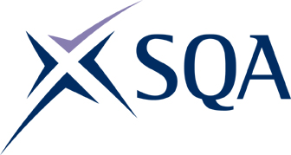
I

SQA Health and Safety update 2023

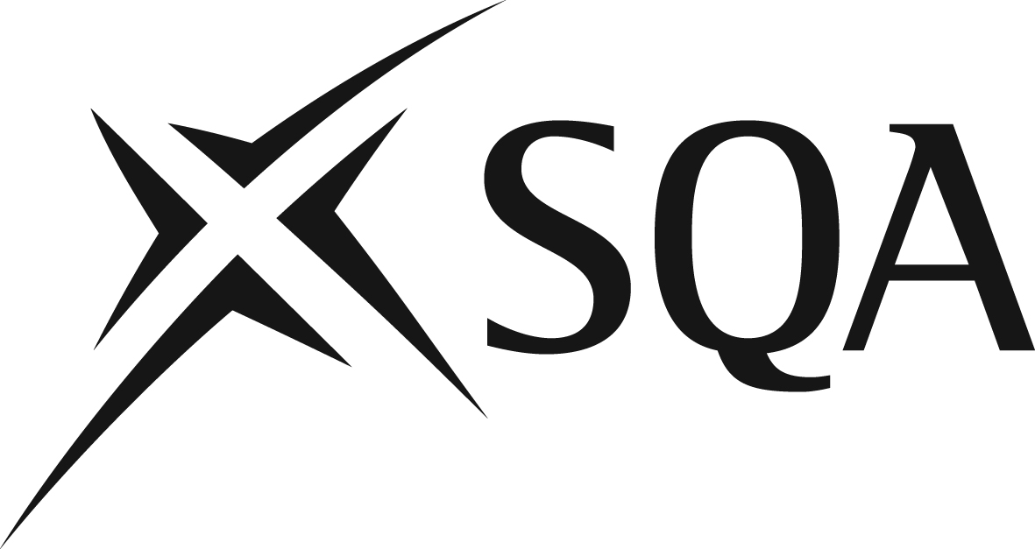

SQA Health and Safety update

2023

Publication date: August 2023

Published by the Scottish Qualifications Authority
The Optima Building, 58 Robertson Street, Glasgow G2 8DQ
Lowden, 24 Wester Shawfair, Dalkeith, EH22 1FD

www.sqa.org.uk

The information in this publication may be reproduced in support of SQA qualifications. If it is reproduced, SQA should be clearly acknowledged as the source. If it is to be used for any other purpose, written permission must be obtained from SQA. It must not be reproduced for trade or commercial purposes.

© Scottish Qualifications Authority

This document can be produced, on request, in alternative formats, including large type, Braille and numerous community languages. For further details telephone SQA’s Customer Contact Centre on 0845 279 1000.
SQA is committed to using plain English. We will try to make our publications as easy and straightforward to understand as we can and will try to avoid all unnecessary jargon. If there’s any language in this document that you feel is hard to understand, or could be improved, please write to Editor, Editorial Team, at the Glasgow address or email: editor@sqa.org.uk.

Contents
Introduction 1
Looking back at 2022–23 1
COVID-19 1
Smarter Working 2
Health and safety committee 2
Monitoring performance 2
Accident incidence/frequency rate 3
Incidents 4
Health and wellbeing 4
Training 5
Review against targets 5
Campaigns and events 5
Awards 8
Looking forward to 2023–24 9
Campaigns and events 9
Policy updates 9
Appendix 1: Statutory duties 10
Appendix 2: Figures 11
Appendix 3: Formulae 12
Appendix 4: Health and wellbeing 13
Appendix 5: Training 15
Appendix 6: Health and safety campaigns 16

Introduction
SQA is committed to ensuring the health, safety and wellbeing of our employees. Under the Health and Safety at Work Act 1974 we have a statutory duty to our employees and to others (Appendix 1: Statutory duties). The Act is primarily designed to promote safety awareness and an effective safety organisation. It places duties on employers and employees.

SQA recognises its responsibility to:

- provide and maintain equipment, systems of work, places of work and working environments which are safe and where risk to health is minimised, taking into account statutory regulations
- ensure the safety of staff and others, and the absence of risk to their health arising from the use, handling, storage and transport of all articles and substances
- consult with colleagues on matters affecting their health and safety
- provide the information, instruction, training and supervision needed to promote the health and safety at work of all our people
- provide appropriate first aid facilities
- make all colleagues aware of their ongoing statutory obligation to support health and safety at work
- ensure our premises are safe for visitors, with minimal risk to physical and mental health.

SQA allocates the necessary resources and enlists the active support of all colleagues to ensure we meet these responsibilities.

This update outlines some of the things we do to maintain the health, safety and wellbeing of colleagues and others, and how we measure their effectiveness.

Looking back at 2022–23

COVID-19
COVID-19 remained a concern and the facilities team continued to monitor feedback and new government guidance, and adjust procedures as required.
All colleagues wishing to return to Optima were able to do so from April 2022. Our Lowden office was restricted to colleagues and appointees who were required to undertake essential office-based activities to support diet 2022 between April and July. This was to maintain infection prevention controls with regards to social distancing for all the additional colleagues on site during the exam diet. Such controls were reviewed post-diet as part of the smarter working arrangements for expected office-based personnel.

Smarter Working
As colleagues returned to a ‘new normal’, we oversaw the full rollout of smarter working practices.
Colleagues agreed their preferred working arrangements, subject to business requirements, and this provided the flexibility to work in the location that suits them best. This flexible, hybrid approach helps support wellbeing, improves work-life balance, and allows our offices to be used in a more modern and efficient way.
We supported the Smarter Working programme to ensure that appropriate consideration was given to the health and safety of our colleagues, and that measures were put in place to assist them, whatever their working arrangements. This included assistance such as specialist equipment or furniture for colleagues with additional support requirements.

Health and safety committee
SQA has an active health and safety (H&S) committee which meets quarterly.
The H&S committee is chaired by the health, safety and environmental officer, and includes the head of appointee management, facilities manager, and union and staff representatives from across the business.
At the quarterly meetings, any relevant H&S issues are discussed with the staff/union representatives. These typically include:
- scheduled inspections
- reports on accidents, near misses and reportable injuries
- legislative changes which will affect operations
- training given, received and available.

Any planned H&S campaigns or initiatives are also discussed, and the committee members are encouraged to make suggestions about these.
This satisfies SQA’s obligations to consult with colleagues over H&S issues which may affect them. However, to keep colleagues better informed and encourage input, we introduced an update summarising the discussions and actions resulting from the quarterly health and safety committee meetings. These are posted to the intranet following each meeting (an example is shown in Appendix 6: Figure 9).

Monitoring performance
All accidents and near misses on SQA premises or involving SQA colleagues at work must be reported to the health, safety and environmental officer. Where an injury has occurred, an entry must also be made in the accident record book, which is held by facilities management in Optima and Lowden.
Colleagues are strongly encouraged to report all incidents — regardless of the severity of any resulting injury — including specifically under current circumstances when working at home. This positive reporting culture allows for analysis of a larger number of incidents, including reported near misses. This allows us to identify any potential trends so we can take action to mitigate risks. The information is reported and discussed at the quarterly H&S committee meetings where our trade unions are represented.
A range of other statistics are also reported to the H&S committee, including: the number of workstation assessments carried out, pregnant workers risk assessments, and first aiders in place. (Figures are detailed in Appendix 2: Figures)
During 2022–23, no near misses were reported by colleagues. There was one accident in Lowden which was not reportable under the Reporting of Injuries, Diseases and Dangerous Occurrences Regulations (RIDDOR) 2013. An investigation was carried out and new processes implemented involving events, facilities, and the cleaning team. Additionally, all relevant colleagues were refreshed on current processes and the health and safety policy v8.0.
Communications were issued to remind colleagues of the importance of reporting incidents, even when working from home.

Accident incidence/frequency rate
The accident incident rate (AIR) gives the number of injuries occurring in a year per 100,000 employees. The accident frequency rate (AFR) is the number of injuries per 1,000,000 employee-hours worked. These figures indicate the state of health and safety in the organisation and reflect the effectiveness of efforts to protect colleagues from work-related hazards.
The figures below show the incidence and frequency rates for SQA over recent years.
 | 2018–19 | 2019–20 | 2020–21 | 2021–22 | 2022–23
Accident incidence rate (AIR) | 1,608.4 | 440.4 | 0 | 106.4 | 99.08
Accident frequency rate (AFR) | 8.8 | 2.4 | 0 | 0.6 | 0.1
Table 1 AIR and AFR figures over the past five financial years

(You can see the formulae for calculating these figures in Appendix 3: Formulae.)

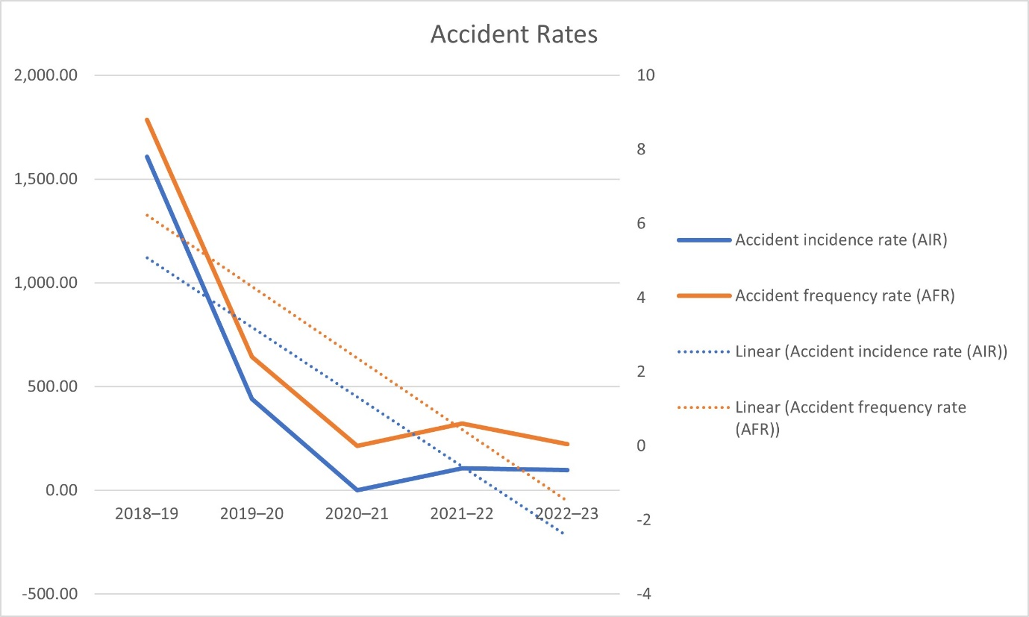
Figure 1 AIR and AFR figures over the past five financial years

Over the last five years, there have been fluctuations in both the AIR and the AFR, with 2022–23 showing an AFR of 0.05 per 1,000,000 hours worked.

Incidents
The COVID-19 pandemic became a major consideration from March 2020. Government directives were followed, and appropriate protective measures were implemented as health guidance was issued.
One accident was reported involving a trip from a missing floor grommet cover. An investigation was carried out and new processes implemented involving events, facilities, and the cleaning team. Additionally, all relevant colleagues were refreshed on current processes and the health and safety policy v8.0.
There were no other H&S incidents.

Health and wellbeing
Beyond the typical Employment Assistant Programmes and Occupational Health services, we strive to support and engage colleagues on their health at work throughout the year with campaigns run by our community networks, including our award winning Making A Change (MAC) group (examples available in Appendix 4: Health and wellbeing).
Our wellbeing strategy — ‘Investing in You’ — was rolled out across the business in January 2023. This strategy offers a broad range of help for social, financial, physical and psychological wellbeing (see Appendix 4: Health and wellbeing).

Training
Following the implementation of the Smarter Working programme, many former volunteers who undertook first aid/fire marshal roles moved to hybrid working. With colleagues returning to the office, a need was identified for a new cohort of predominantly office-based colleagues who could provide an adequate support function and cover while working within our new Smarter Working programme.
We received an enthusiastic response and were able to select enough colleagues to cover all days and areas of both buildings. Required training was delivered to all relevant colleagues. (sample intranet articles available in Appendix 5: Training).

Review against targets
The estates and facilities management strategy set the following targets, which were achieved during the reporting year:
- 100% compliance with the health and safety inspection schedule
- all incidents and accidents investigated within two days

Campaigns and events
Several health and safety campaigns and initiatives were run during the year. (There are some examples of campaign materials in Appendix 4: Campaigns)

- World Day for Safety and Health at Work
- Child Safety Week
- Gas Safety Week
- National Eye Health Week
- Back Care Awareness Week
- National Work Life Week
- Firework Safety
- Road Safety Week
- Christmas Safety
- Safe Winter Driving
- Workstation set-up reminder
- Safe and Healthy Journeys (Spring)

- World Day for Safety and Health at Work
An annual international campaign to promote safe, healthy and decent work. The theme was ‘Let's Act Together’, and we celebrated the many colleagues who have worked behind the scenes keeping us all safe and supported during the pandemic (see Appendix 6: Health and safety campaigns).

- Child Safety Week
A community education campaign run annually by the Child Accident Prevention Trust (CAPT). The aim is to help families build confidence and skills in managing the risks to children's safety. We published an article which included helpful resources for parents.

- Gas Safety Week
The week-long annual campaign raises public awareness of gas safety and the importance of taking care of your gas appliances, and is coordinated by Gas Safe Register. We support this annually with an article and screensaver.

- SQA joins ‘The Circuit’
The Circuit — the national defibrillator network provides a national overview of where defibrillators can be found for emergency services. Our Lowden device has been registered as accessible 24/7.

- National Eye Health Week
This year, we focused on eye health and technology, promoting the importance of good eye health and the need for regular eye tests for all. We published an article with links to advice and guidance for maintaining healthy eyes and avoiding eye strain, as well as to our optical allowance application.

- Back Care Awareness Week
An article was published which focused on preventing back pain by promoting safe and healthy working practices and signposting the support and resources we have available.

- National Work Life Week
This is an annual campaign to highlight the importance of flexible and family-friendly practices in the workplace. Its aim is to get both employers and employees talking about wellbeing at work and work-life balance, and we used the week to showcase our flexible working policies and practices.

- Celebrate Safely this Autumn (Fire Display Safety)
Diwali, Halloween and Bonfire Night mean autumn is one of the most exciting and dangerous times of the year for children, so we published safety advice with a focus on families and fire.

- Road Safety Week
The 2022 theme was ‘Safe Roads for All’, bringing people together to raise awareness that every life on our roads matters, and every death and injury is preventable. Our article provided information on mindful and considerate road use.

- Christmas Safety (Hot Bargains and Killer Deals)
Tips on being responsible and taking steps to stay safe when buying second-hand toys and electrical items.

- Safe Winter Driving
Our annual reminder to colleagues to prepare their vehicles for poor weather. These are published when the Met Office first advises there is inclement weather due.

- Workstation self-assessment reminder
Our annual reminder to check over your desk set-up before settling into those bad habits. Our article provides guidance and resources to help colleagues remain safe and productive when carrying out day-to-day tasks. They are also asked to complete a self-assessment to help us to take any necessary steps to ensure their prolonged safety and comfort.

- Safe and Healthy Journeys (Spring)
Information, advice and guidance to help in making safe and healthy journey choices.

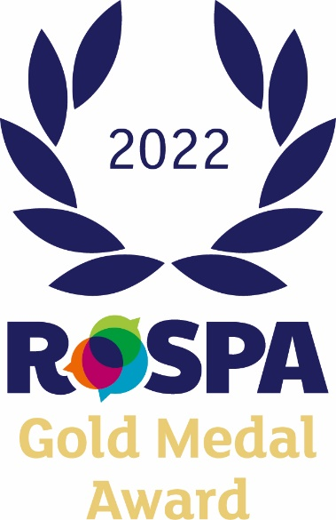
Awards
SQA was awarded the Royal Society for the Prevention of Accidents (RoSPA) Gold Medal Award, which continues our run to eight successive Gold Awards.
The RoSPA Health and Safety Awards is an annual scheme that recognises excellence in health and safety management.

Looking forward to 2023–24

Campaigns and events
The following campaigns and initiatives are planned in 2023–24:
- Accident and near misses at home
- World Day for Safety and Health at Work
- Roadmap to Safe and Healthy Journeys (Spring)
- Child Safety Week
- Gas Safety Week
- National Eye Health Week
- Back Care Awareness Week
- National Work Life Week
- Firework Safety
- Road Safety Week
- Christmas Safety
- Safe and Healthy Journeys (Winter)
- Safe and Healthy Journeys (Spring)

Policy updates
There were no policy updates due in 2022–23.

Appendix 1: Statutory duties
The Health and Safety at Work Act 1974 provides a legislative framework to promote, stimulate and encourage high standards of health and safety at work. In particular, it requires organisations to provide and maintain:
- a health and safety policy
- a system to manage and control risks in connection with the use, handling, storage and transport of articles and substances
- a safe and secure working environment, including provision and maintenance of access to and egress from premises
- safe and suitable plant, work equipment and systems of work that are without risks
- information, instruction, training and supervision as is necessary
- adequate welfare facilities.
The legislation is enforced by the Health and Safety Executive, who have far-reaching powers to ensure health and safety within organisations.

Appendix 2: Figures
 | 2018–19 | 2019–20 | 2020–21 | 2021–22 | 2022–23
Incidents | 19 | 7 | 0 | 1 | 1
RIDDOR reportable | 3 | 0 | 0 | 1 | 0
Near misses reported | 4 | 2 | 0 | 0 | 0
Workstation self-assessments | 142 | 161 | 67 | 173 | 172
H&S appointments | 77 | 68 | 145 | 9 | 20
Pregnant workers assessments | 15 | 17 | 8 | 10 | 13
Annual inspections | 9 | 7 | 4 | 9 | 9
Manual handling training | 21 | 44 | 0 | 30 | 61
Suspicious packages training | 17 | 0 | 0 | 0 | 9
First aiders in place | 21 | 21 | 19 | 8 | 18
Floor marshals in place | 35 | 34 | 33 | 20 | 25
Personal evacuation plans | 6 | 6 | 6 | 6 | 6
Table 2 Health and safety statistics over the last five financial years

 | 2018–19 | 2019–20 | 2020–21 | 2021–22 | 2022–23
Accidents * | 15 | 4 | 0 | 1 | 1
Ill health | 3 | 3 | 0 | 0 | 0
Road accidents | 1 | 0 | 0 | 0 | 0
* RIDDOR reportable | 3 | 0 | 0 | 1 | 0
FTE | 932.6 | 908.31 | 0 | 939.99** | 1009.27
Accident incidence rate¹ | 1608.4 | 440.4 | 0 | 106.4 | 99.08
Accident frequency rate² | 8.8 | 2.4 | 0 | 0.6 | 0.05
Table 3 Breakdown of reported incidents over the last five financial years

¹ Accident rate per 100,000 employees
² Accident frequency rate per 1,000,000 hours worked
**Estimate

Appendix 3: Formulae
The Health and Safety Executive formulae for calculating the accident incidence rate (AIR) and the accident frequency rate (AFR) are given below:

$${\text{I}}_{\text{R}}=\text{Incidence rate}=\frac{\text{Incidents per year × 100,000}}{\text{Employment }\left(\text{FTE}\right)}$$

$${\text{F}}_{\text{R}}=\text{Frequency rate}=\frac{\text{Incidents per year × 1,000,000}}{\text{Av. hrs per week × weeks per year × employment (FTE)}}$$

Appendix 4: Health and wellbeing
Figure 2 MAC campaigns

Figure 3 Wellbeing strategy article excerpt
Figure 4 Wellbeing intranet site landing page

Appendix 5: Training
Figure 5 First aiders

Figure 6 Fire Marshals

Appendix 6: Health and safety campaigns

Figure 7 example of workstation set-up guidance

Figure 8 example of safety campaigns
Figure 9 example of quarterly health and safety summary excerpt

Figure 10 excerpt world day for safety and health article

