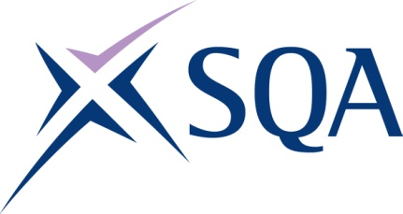

GG1J 47 Diploma in Waste Management Operations: Managing Transfer - Non-Hazardous Waste at SCQF 7 – Structure
To attain the qualification candidates must complete 12 Units in total. This comprises:
- 12 Mandatory Units

Please note the table below shows the SSC identification codes listed alongside the corresponding SQA Unit codes. It is important that the SQA Unit codes are used in all your recording documentation and when your results are communicated to SQA.

Optional Units: Candidates must complete 12 Units from this group
SQA code | SSC code | Title | SCQF level | SCQF credits
H2LF 04 | WM2 | Manage the Movement, Sorting and Storage of Waste | 6 | 7
H2LG 04 | WM64 | Monitor Procedures to Safely Control Work Operations | 6 | 4
H2LH 04 | WM12 | Control Work Activities on a Waste Management Facility | 6 | 9
H2LJ 04 | WM49 | Manage the Environmental Impact of Work Activities | 7 | 5
H2LK 04 | WM9 | Manage Improvements to Waste Management Operations | 7 | 7
H2LM 04 | WM30 | Control Maintenance and Other Engineering Operations | 7 | 13
H2LN 04 | WM23 | Procedural Compliance | 7 | 6
H2M0 04 | WM24 | Manage and Maintain Effective Systems for Responding to Emergencies | 8 | 19
H2LY 04 | WM53 | Organise the Transportation of Loads | 5 | 5
H2LP 04 | WM48 | Manage Physical Resources | 6 | 3
H2LV 04 | WM1b | Manage the Reception of Non-Hazardous Waste | 7 | 7
H37K | WM2b | Manage the Transfer of Outputs and Disposal of Residues from Non-Hazardous Waste Transfer and Recovery Operations | 7 | 4

