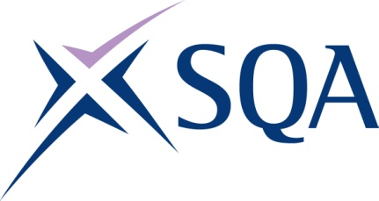
GR8R 23 | SVQ Level 3 Measurement Processes (Maintenance)

SCQF overall credit: Minimum 0 Maximum 0

To attain the qualification candidates must complete 5 units in total. This comprises:

- 4 mandatory units
- 1 optional units

Please note the table below shows the SSC identification codes listed alongside the corresponding SQA unit codes. It is important that the SQA unit codes are used in all your recording documentation and when your results are communicated to SQA.

Mandatory units: Candidates must complete all 4 units from this group
SQA code | SSC code | Title | SCQF level | SCQF credits
DE1C 04 | COGMP1 | Perform Pre-Measurement Processes Operations | Unlevelled | Unlevelled
J578 04 | COGPOH1 | Contribute to the Health and Safety of the Working Environment | Unlevelled | Unlevelled
DE1D 04 | COGMP3 | Establish and Maintain Effective Working Relationships in the Measurement Process Environment | Unlevelled | Unlevelled
DE1E 04 | COGMP4 | Perform Post-Measurement Processes Operations | Unlevelled | Unlevelled

Optional units: Candidates must complete 2 units from this group
SQA code | SSC code | Title | SCQF level | SCQF credits
D7VE 04 | COGMP5 | Inspect and Verify Gas Measurement Systems | Unlevelled | Unlevelled
D7VF 04 | COGMP6 | Inspect and Verify Liquid Measurement Systems | Unlevelled | Unlevelled
D7VG 04 | COGMP7 | Inspect and Verify Bulk Storage Measurement Systems | Unlevelled | Unlevelled

