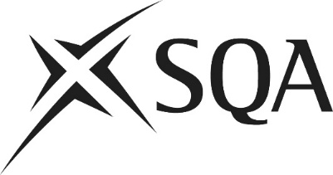
Skills being tested | Marks | 1(a) | 1(b) | 1(c) | 1(d) | 1(e) | 2(a) | 2(b) | 2(c) | 2(d) | 2(e) | 3(a) | 3(b) | 3(c) | 3(d) | 3(e) | Total marks
Methods of cake making* | 12 marks  (+/- 3)
Processing techniques*
Categories of ingredients* | 4 marks  (+/- 3)
Finishing application techniques | 9 marks  (+/- 3)
Finishing decoration techniques
Command words
Name, state, give, identify | 8–12 marks
Describe
Explain | 8–12 marks
Evaluate | 3–7 marks
Grade targeted A | Max 30%  (7–8 marks)
Grade targeted C | Max 50% (12–13 marks)

National 5 Practical Cake Craft question paper setting grid

